# JENKINS – TASK – 04

===============================================

1. Setup Jenkins CICD pipeline using freestyle job using Docker containers using below code. <https://github.com/betawins/hiring-app.git> Stages:  
   Git Clone  
   SonarQube Integration  
   Maven Compilation  
   Nexus Artifactory  
   Slack Notification  
   Deploy On tomcat

* Opened **Jenkins → New Item**
* Entered job name: **BETAWINS-HIRING-APP**
* Selected **Freestyle project**
* Clicked **OK** to create the job

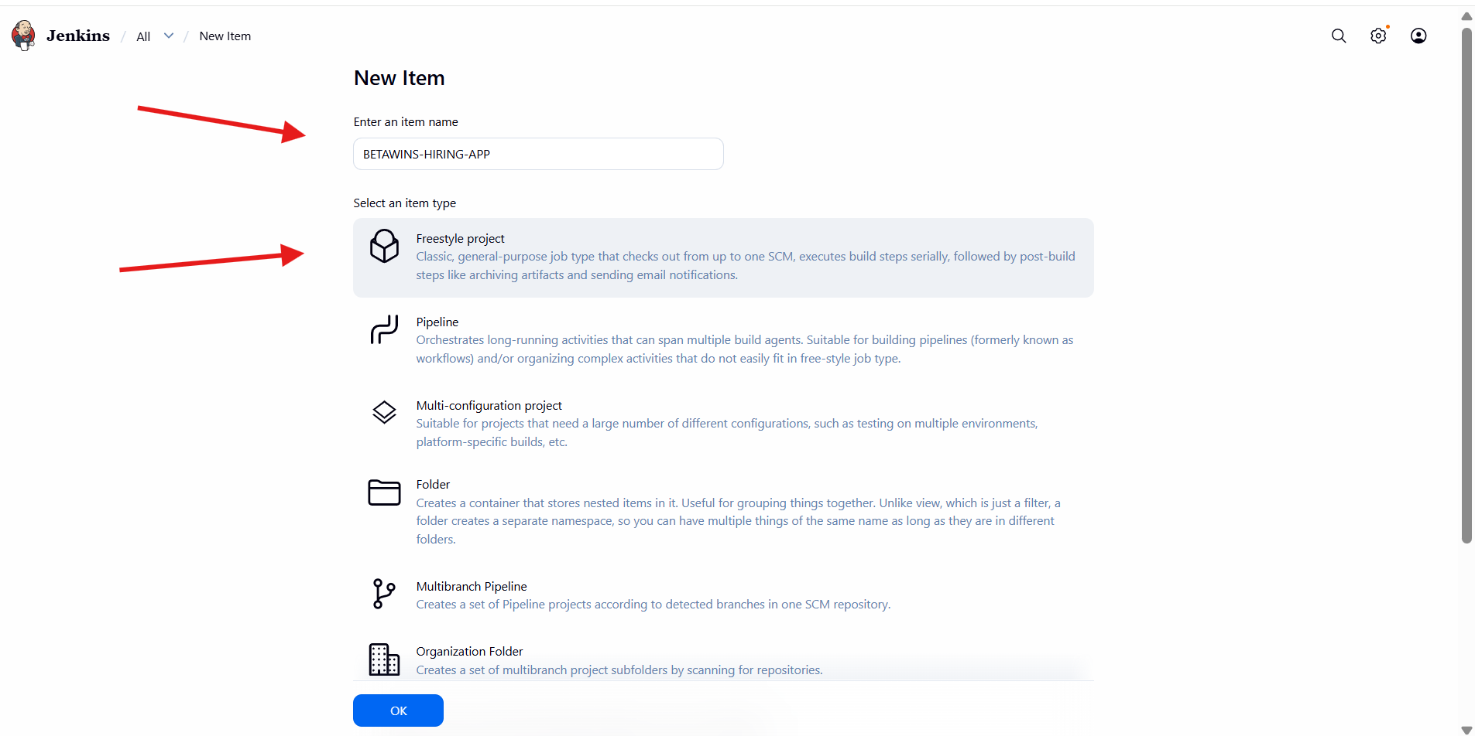

* Restricted the job to run on a specific node using **Label Expression**
* Entered label: master
* Provided GitHub repository URL: https://github.com/betawins/hiring-app.git
* Credentials kept as **none** (public repository)

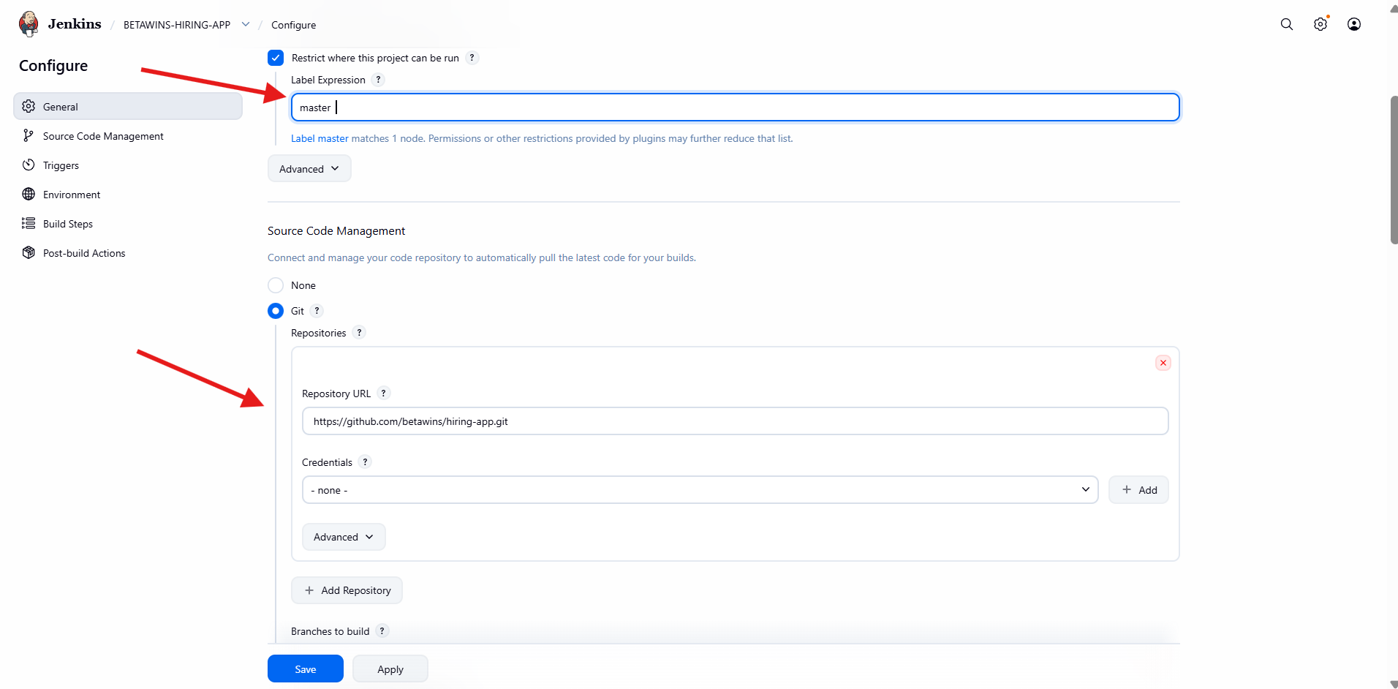

* Configured **Branch Specifier**
* */main
* Repository browser kept as **Auto**
* No build triggers enabled (manual build setup)

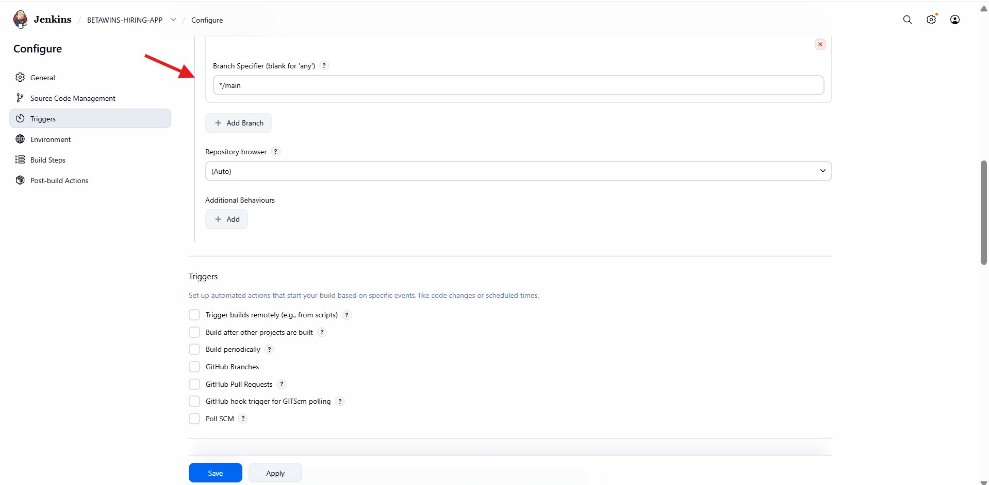

* Added **Build Step → Execute SonarQube Scanner**
* Selected JDK from Jenkins configuration
* Entered **Analysis properties**:
* sonar.projectKey=Test
* sonar.projectName=Test
* This enables static code analysis during the build

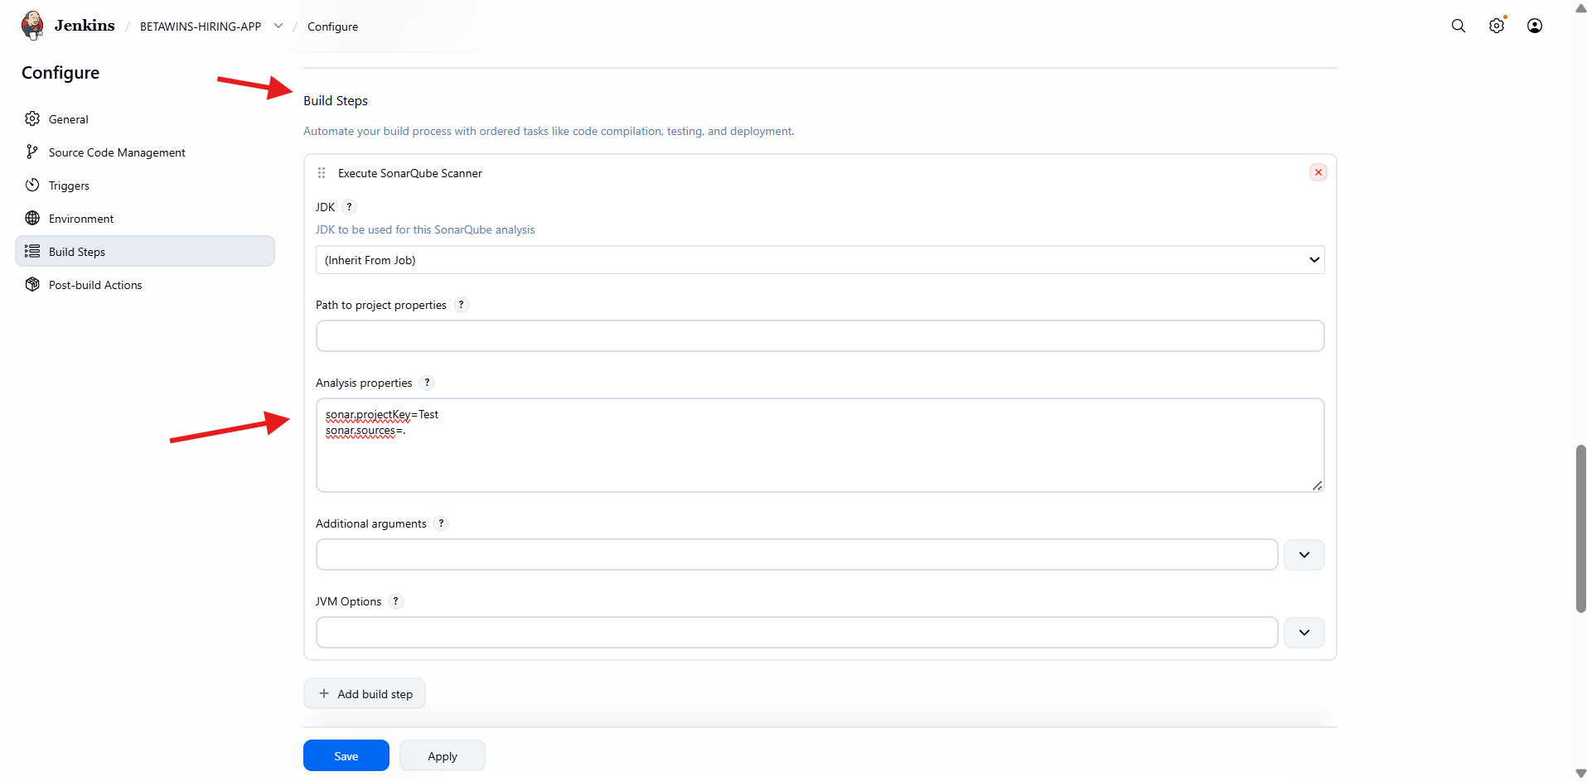

* Added **Post-build Action → Slack Notifications**
* Enabled notifications for:
* Build Started
* Build Success
* Build Failure
* Ensures real-time build status alerts in Slack

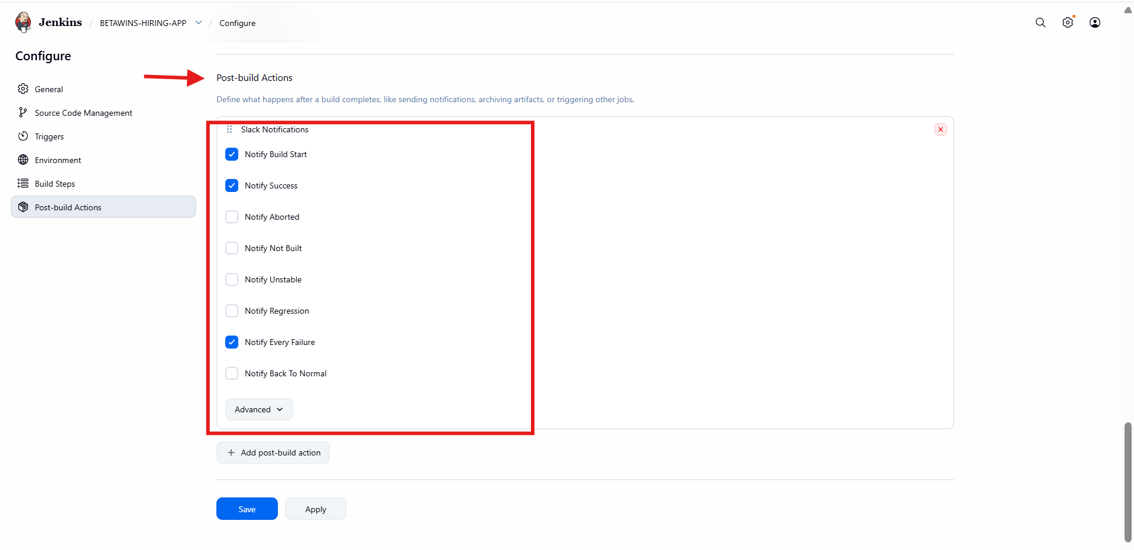

* Navigated to **Manage Jenkins → System**
* Added **SonarQube Server configuration**
* Entered:
  + Name: sonarqube-server
  + Server URL: http://<sonarqube-ip>:9000
* Selected **Server authentication token**
* Saved configuration

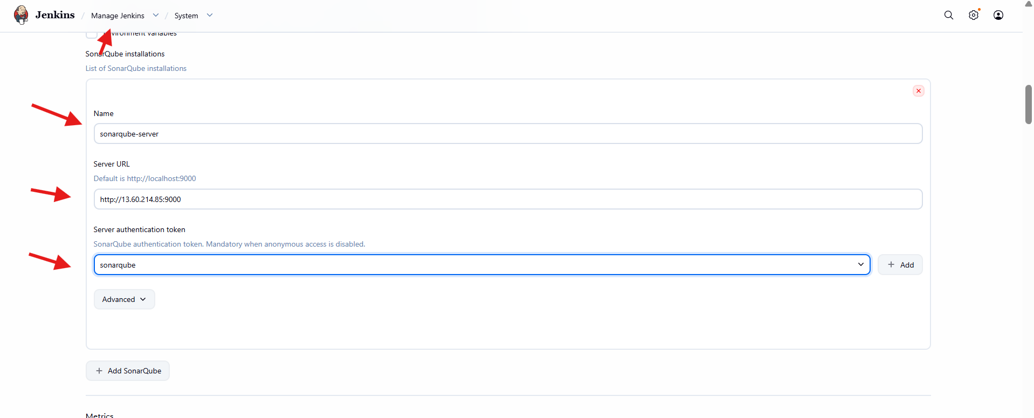

* Build **#1** triggered manually
* Build status: **Failed**
* Git repository and branch detected correctly
* Indicates an initial configuration or connectivity issue

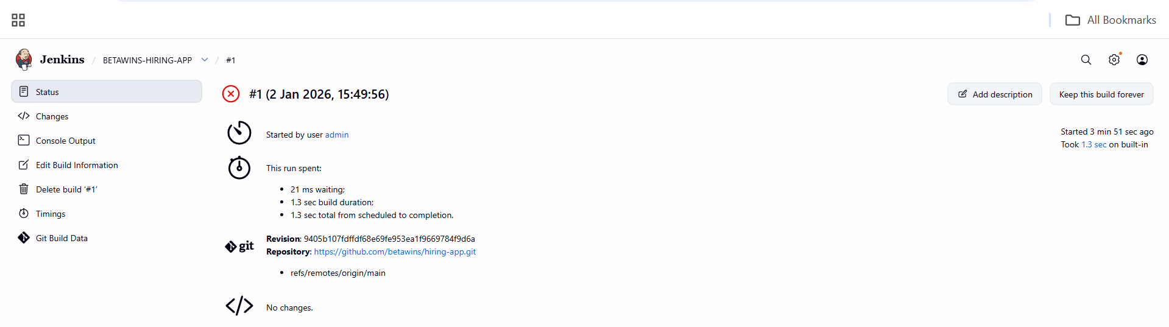

* Logged into SonarQube EC2 instance
* Verified SonarQube service status:
* ./sonar.sh status
* Confirmed SonarQube is listening on port **9000**
* Validated server is running and accessible

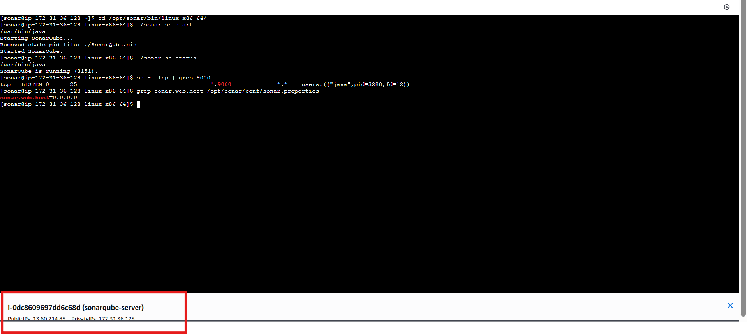

* Build **#2** triggered after fixing issues
* Build status: **Success**
* Git checkout and SonarQube scan completed successfully

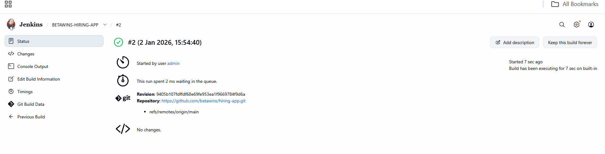

* Opened **SonarQube** web UI
* Two projects displayed (**Test**, **Sabear**)
* Quality Gate status: **Passed**
* Metrics visible:
  + Bugs
  + Vulnerabilities
  + Code Smells
  + Duplications
* Confirms successful Jenkins–SonarQube integration

Top of Form

Bottom of Form

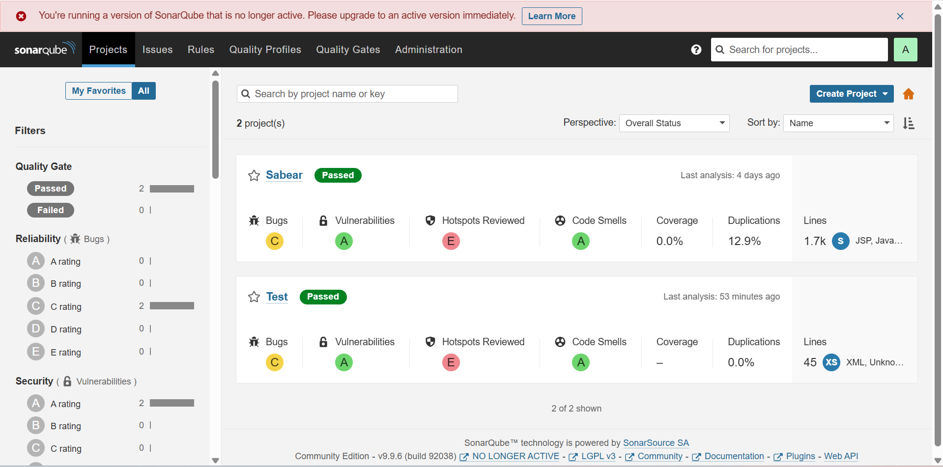

* Logged into the Jenkins EC2 server as **root**
* Navigated to /opt directory
* Downloaded **Apache Maven 3.9.12** using wget https://dlcdn.apache.org/maven/maven-3/3.9.12/binaries/apache-maven-3.9.12-bin.tar.gz
* Verified the Maven archive (apache-maven-3.9.12-bin.tar.gz) was downloaded successfully

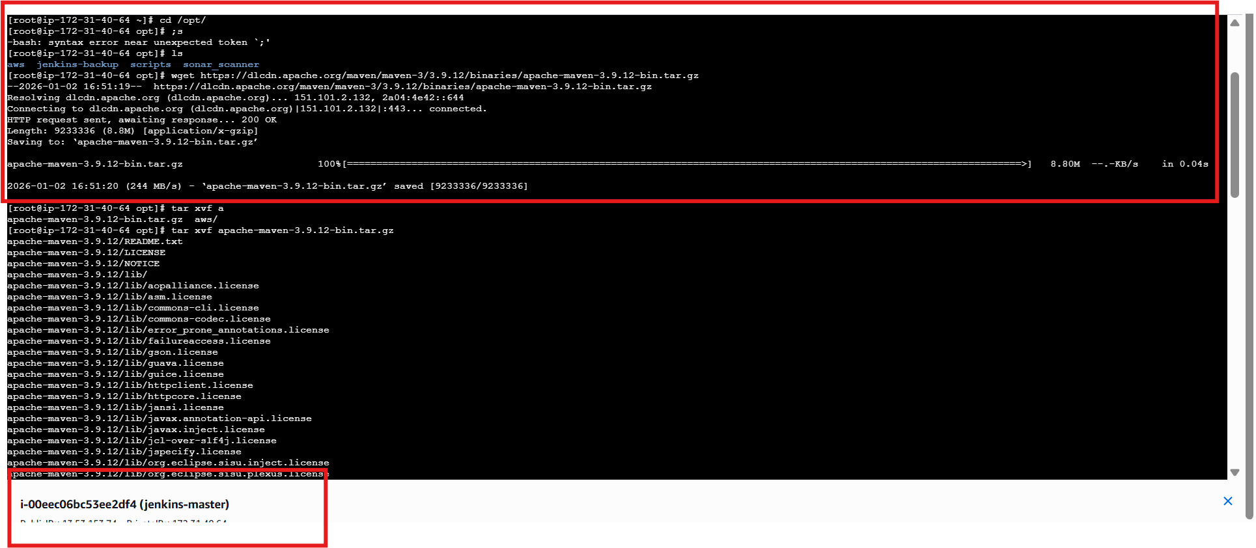

* Extracted Maven archive:
* tar -xvf apache-maven-3.9.12-bin.tar.gz
* Verified extracted directory apache-maven-3.9.12
* Navigated through Maven directories (bin, lib, etc.)
* Opened .bash_profile using vi for environment configuration

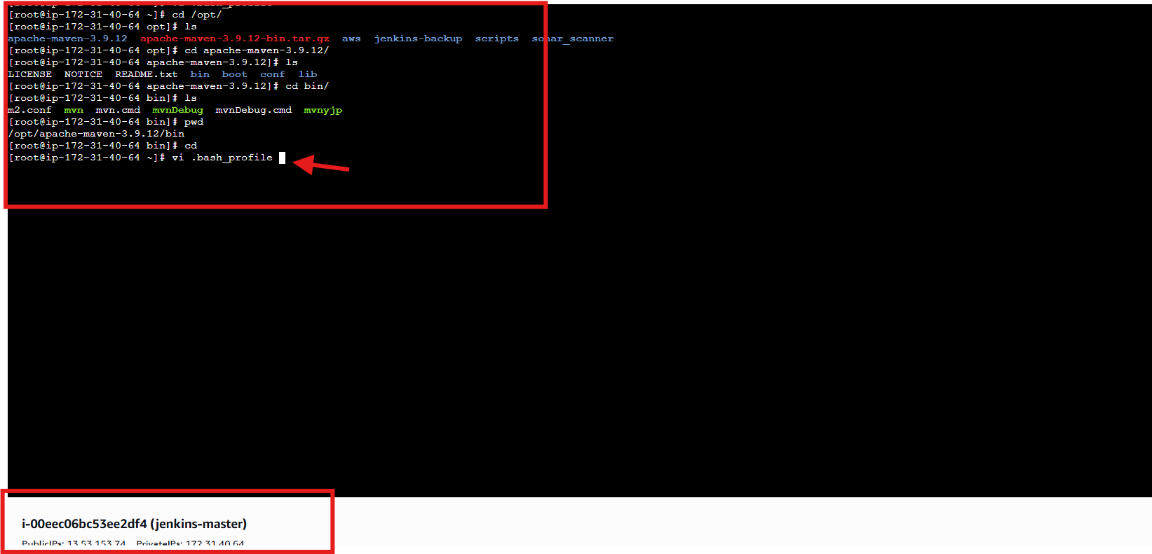

* Edited ~/.bash_profile
* Added Maven environment variables:
* export MVN_HOME=/opt/apache-maven-3.9.12
* export PATH=$PATH:$MVN_HOME/bin
* Prepared the system to recognize mvn command globally

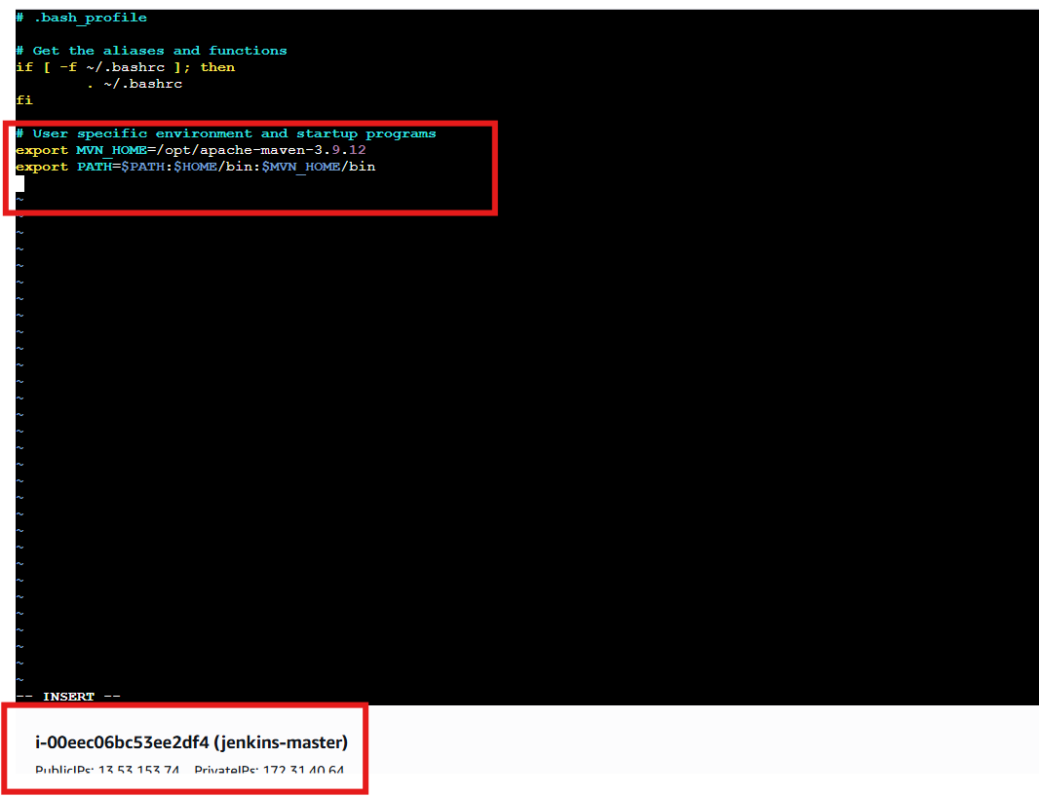

* Reloaded environment variables:
* source ~/.bash_profile
* Verified Maven installation:
* mvn -version
* Confirmed:
  + Apache Maven 3.9.12
  + Java 17 (Amazon Corretto)
  + Linux OS detected correctly

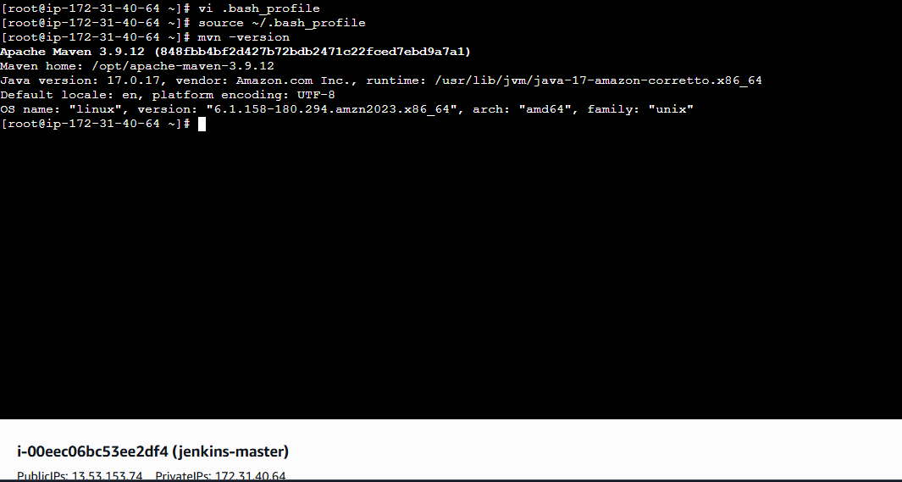

* Opened **Jenkins → Manage Jenkins → Tools**
* Navigated to **Maven installations**
* Added a new Maven installation
* Set:
  + Name: MVN_HOME
  + MAVEN_HOME path: /opt/apache-maven-3.9.12
* Disabled “Install automatically”
* Saved configuration

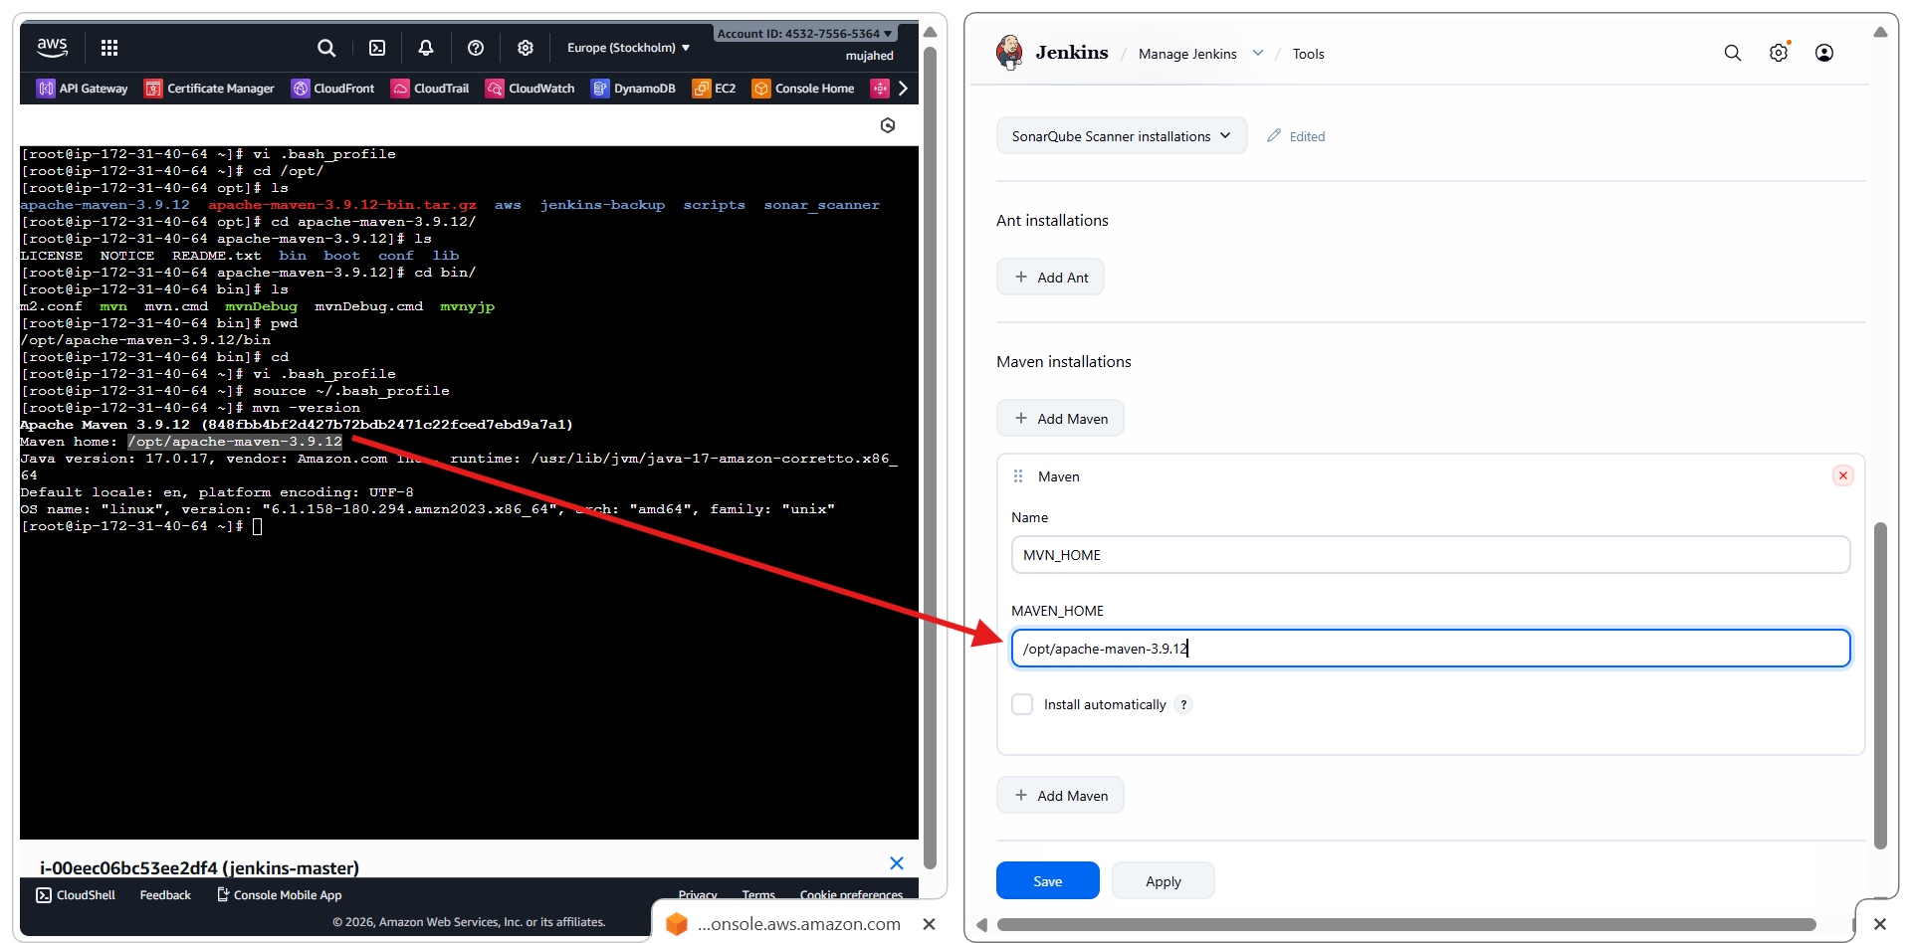

* Opened Jenkins job **BETAWINS-HIRING-APP → Configure**
* Navigated to **Build Steps**
* Clicked **Add build step**
* Selected **Invoke top-level Maven targets**

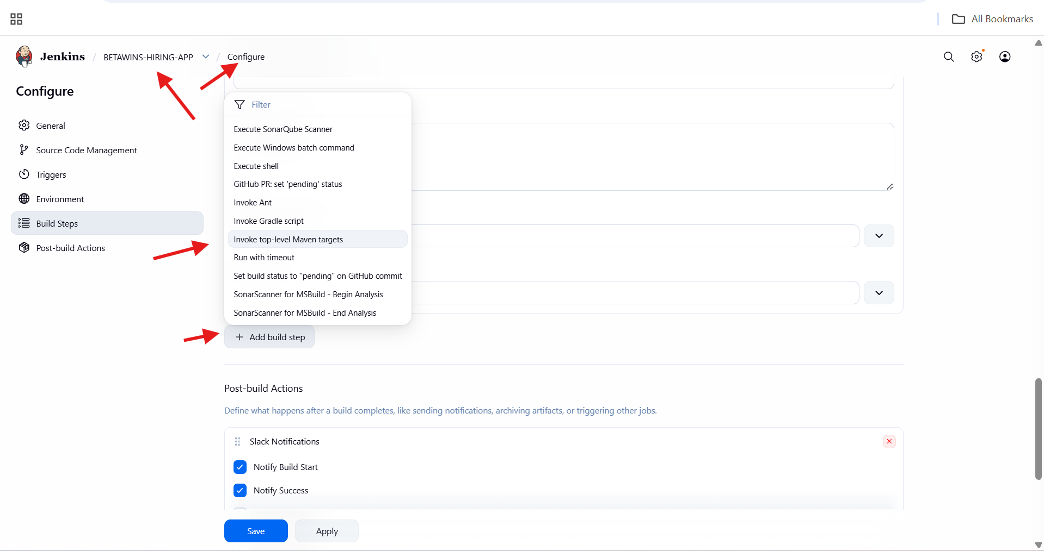

* Selected Maven Version: MVN_HOME
* Entered Maven goals:
* clean install
* This enables:
* Cleaning previous builds
* Compiling code
* Packaging the application (WAR/JAR)

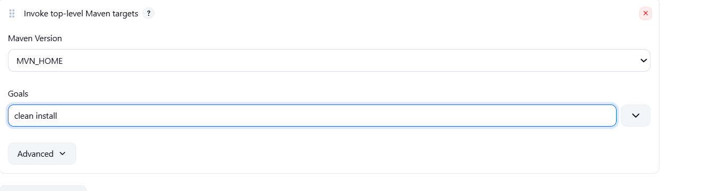

* Build **#3** triggered manually
* Git repository fetched successfully
* Build started without errors

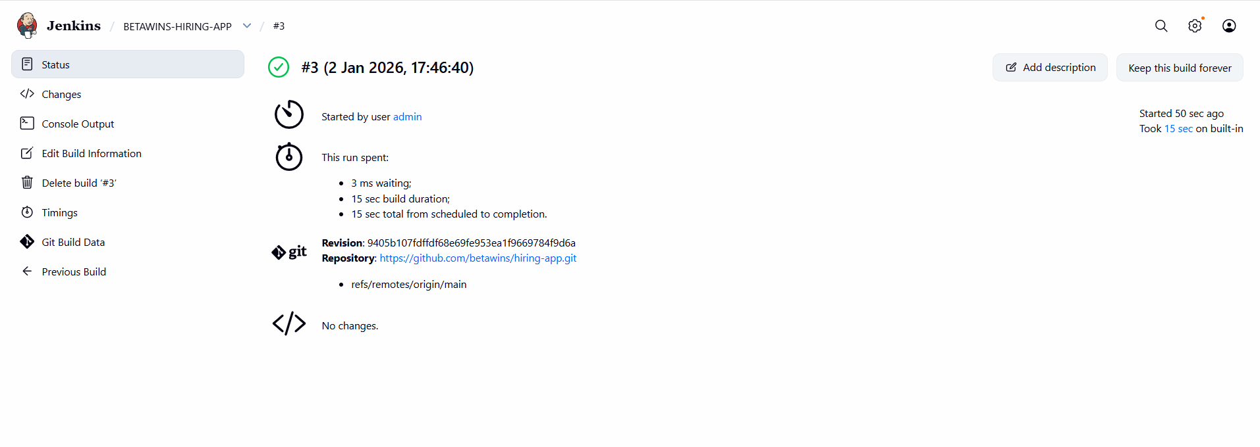

* Maven dependencies downloaded from Maven Central
* Application built successfully
* WAR file generated and installed in Jenkins workspace
* Final build status:
* BUILD SUCCESS

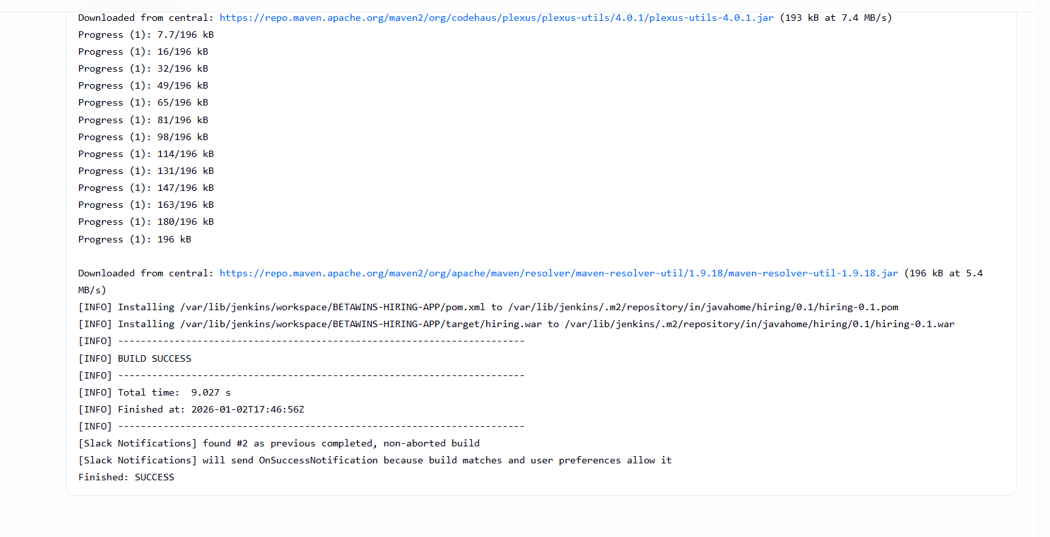

* Slack channel received Jenkins notifications:
* Build #1 – Failed
* Build #2 – Success
* Build #3 – Success
* Confirms Slack–Jenkins integration is working correctly
* Notifications triggered for both failure and success events

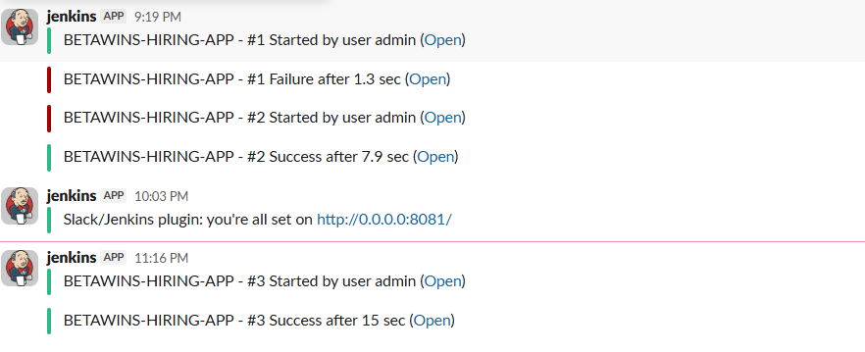

* Logged into the **Jenkins** server as root
* Navigated to Jenkins home directory:
* cd /var/lib/jenkins
* Listed Jenkins configuration and plugin files
* Verified presence of:
  + Jenkins core configuration XML files
  + Plugin configurations
  + workspace/ directory (job workspaces)

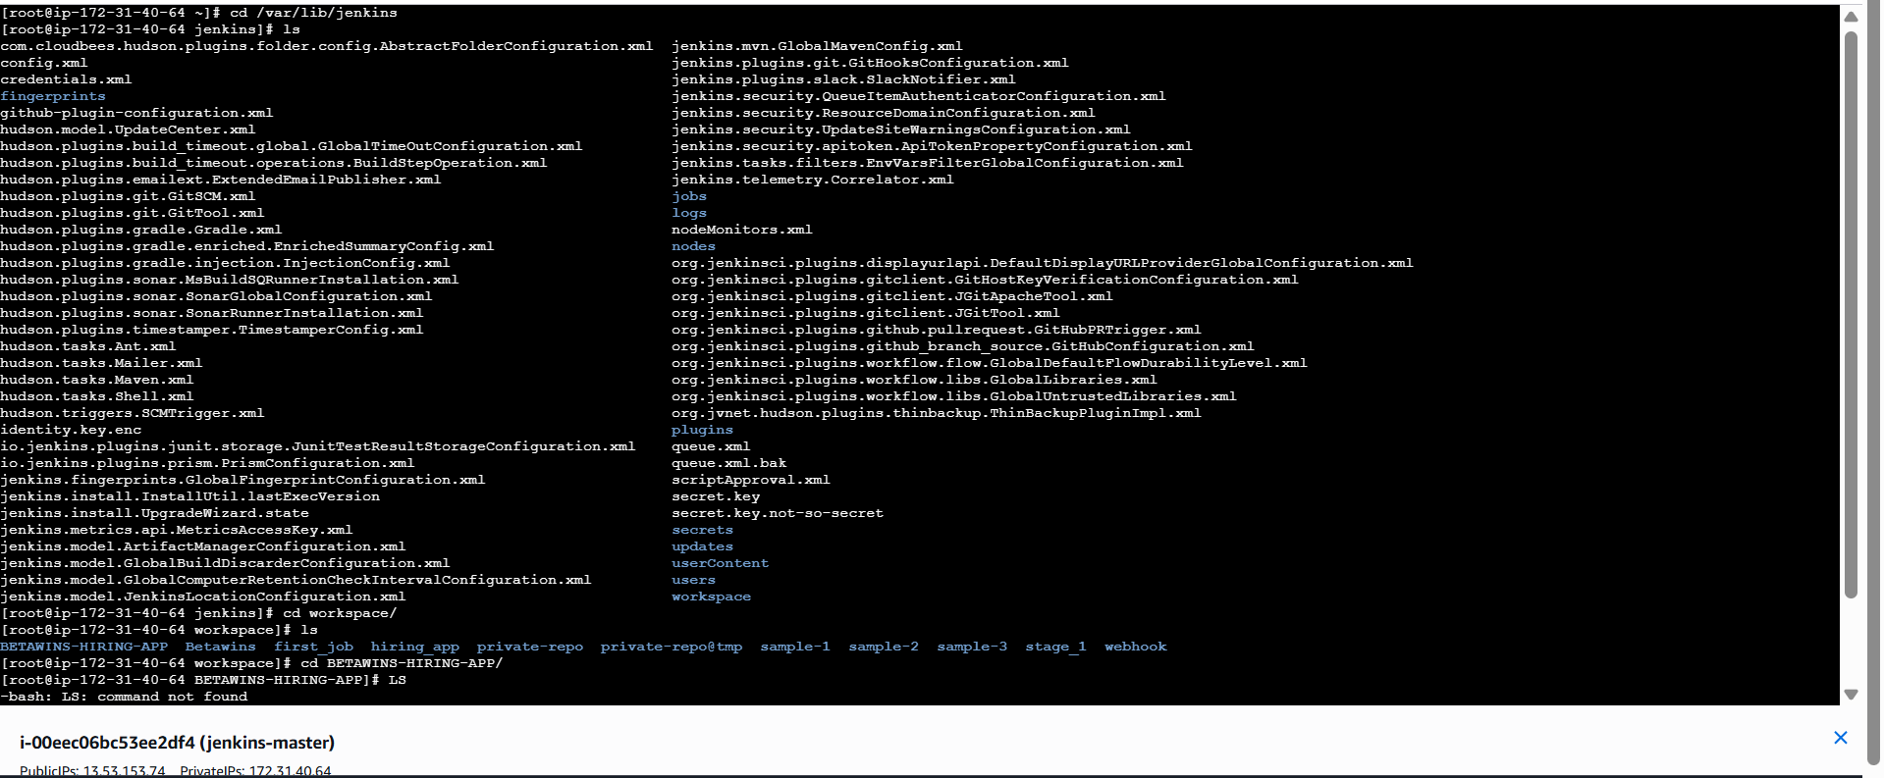

* Navigated to Jenkins workspace:
* cd /var/lib/jenkins/workspace/BETAWINS-HIRING-APP
* Listed project files:
  + Jenkinsfile
  + pom.xml
  + src/
  + target/
* Confirmed Maven build artifacts exist in target/

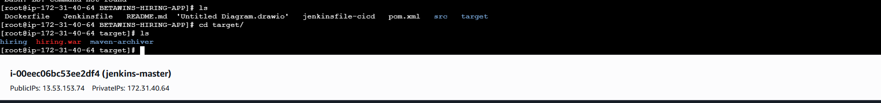

* Navigated to Maven local repository:
* cd /var/lib/jenkins/.m2/repository
* Listed downloaded dependencies:
* org
* junit
* commons-io
* javax
* Confirms Maven dependencies were downloaded successfully during build

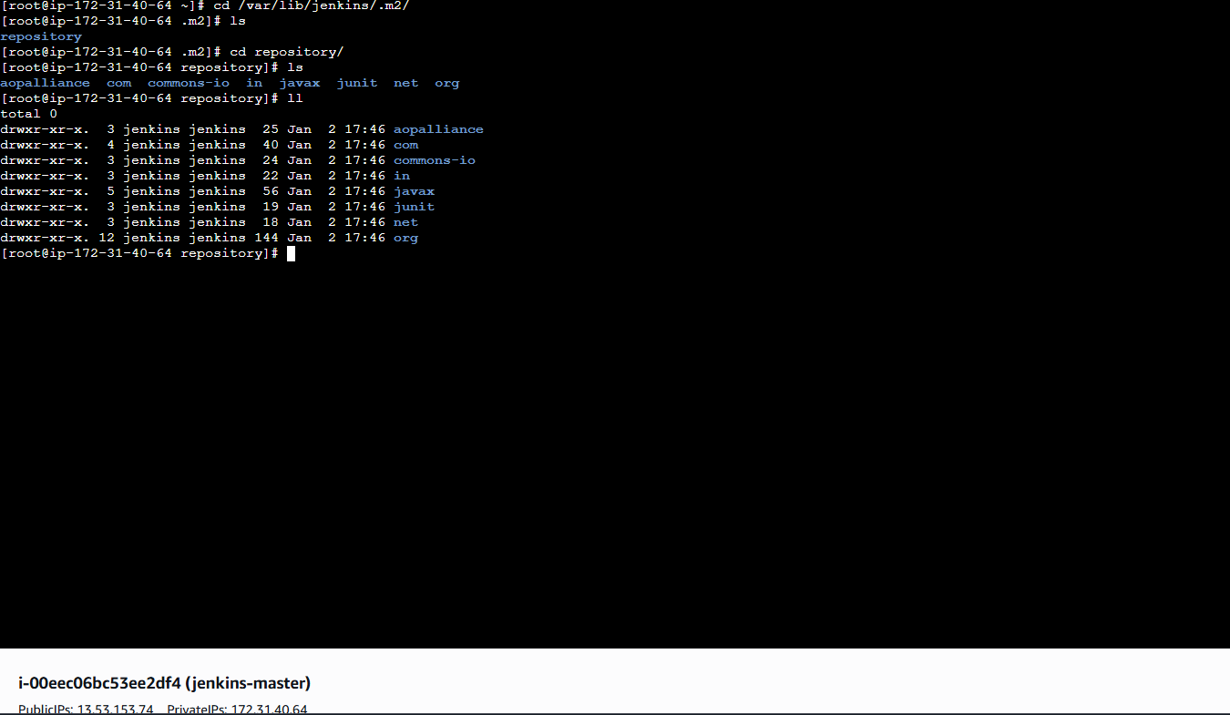

* Opened **Amazon EC2 → Launch Instance**
* Set instance name: **NEXUS-SERVER**
* Selected **Amazon Linux 2023 AMI**
* Chose instance type
* Configured:
* Security Group
* Storage
* Clicked **Launch Instance**

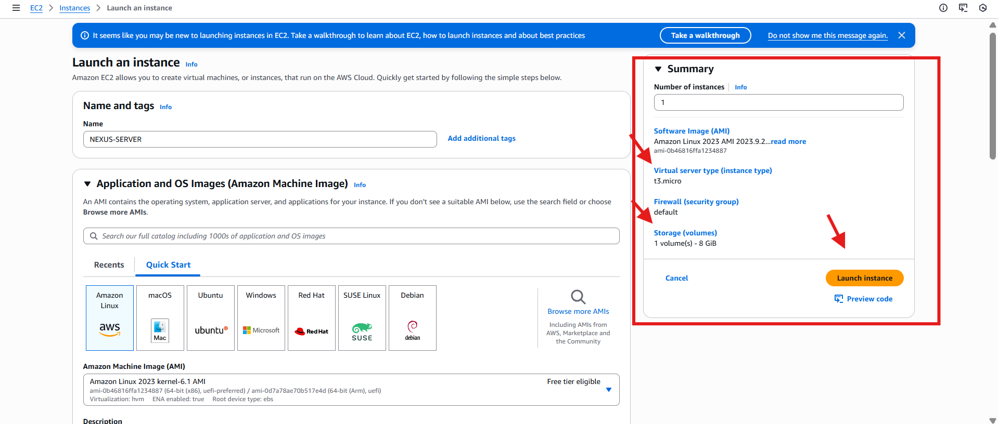

* Logged into **NEXUS-SERVER**
* Installed Java 17 (Amazon Corretto):
* yum install java-17-amazon-corretto -y
* Verified Java packages and dependencies installed successfully
* Java is required to run Nexus Repository Manager

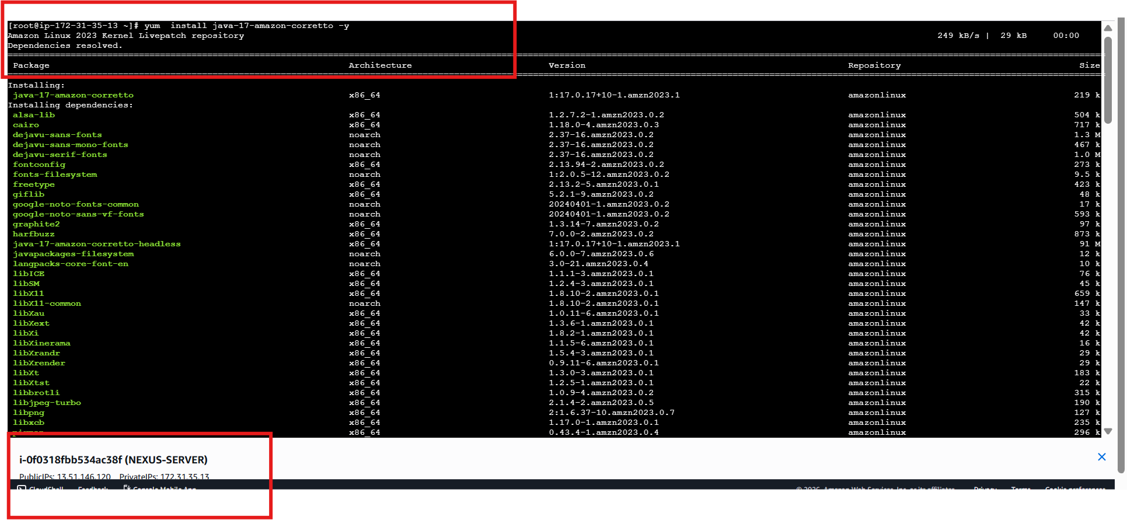

* Navigated to /opt
* Attempted Nexus download from Sonatype URLs
* Wget https://download.sonatype.com/nexus/3/nexus-3.87.1-01-linux-x86_64.tar.gz
* Successfully downloaded:
* nexus-3.87.1-01-linux-x86_64.tar.gz
* Extracted Nexus archive:
* tar -xvf nexus-3.87.1-01-linux-x86_64.tar.gz

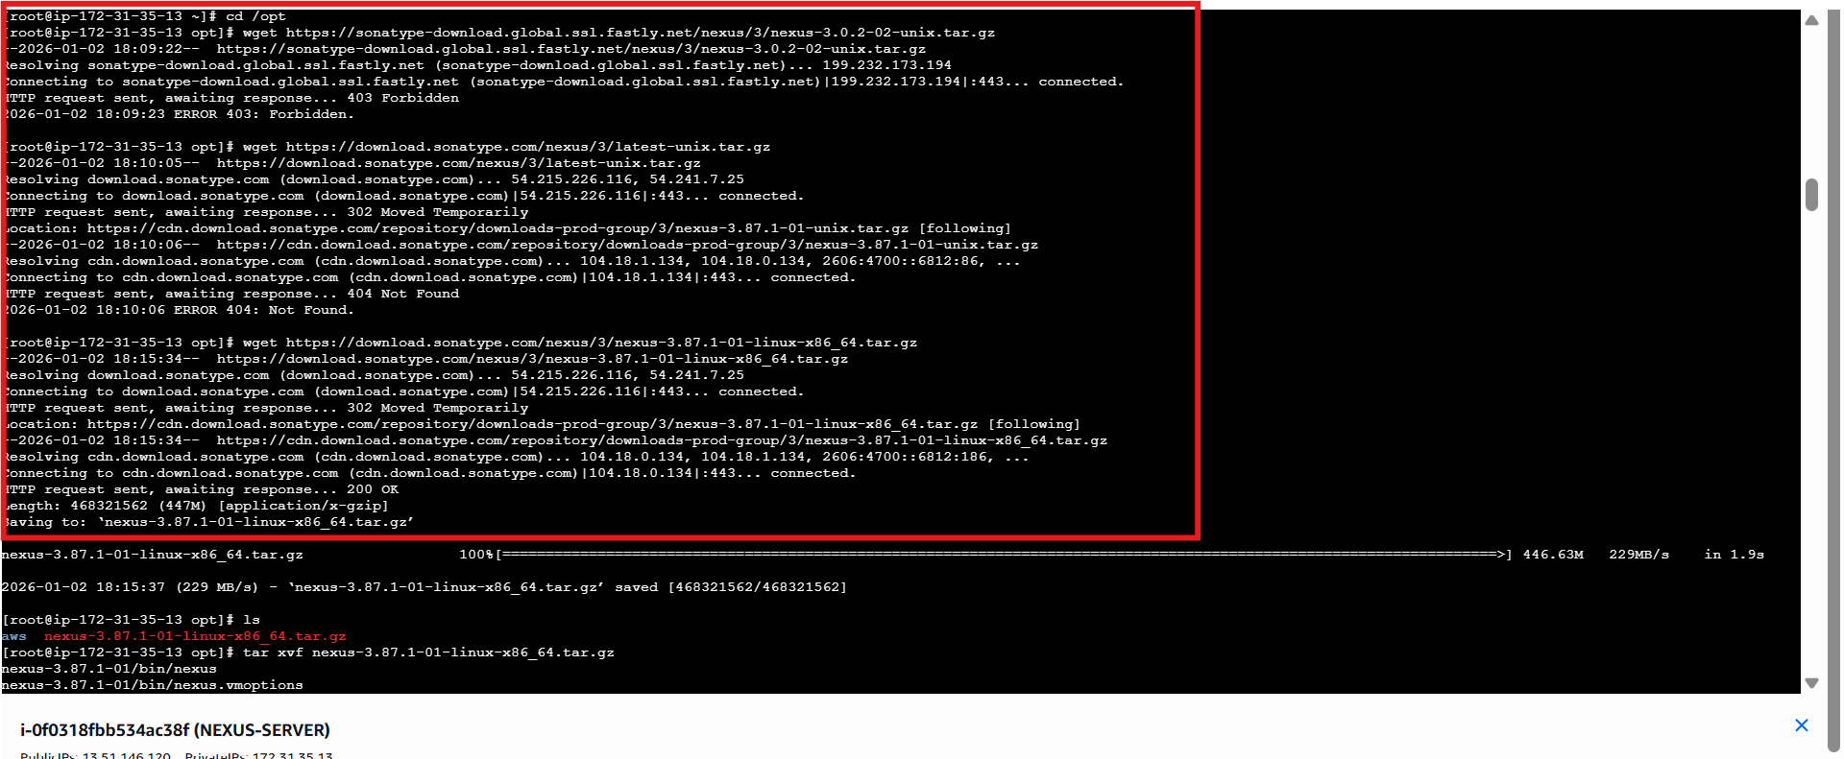

* Renamed extracted folder:
* mv /opt/nexus-3.87.1-01 /opt/nexus
* Verified directories:
  + nexus
  + sonatype-work

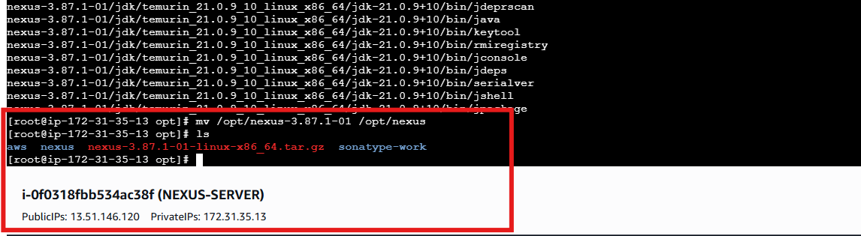

* Created Nexus system user:
* adduser nexus
* Changed ownership of Nexus directories:
* chown -R nexus:nexus /opt/nexus /opt/sonatype-work
* Ensures Nexus runs securely as non-root user

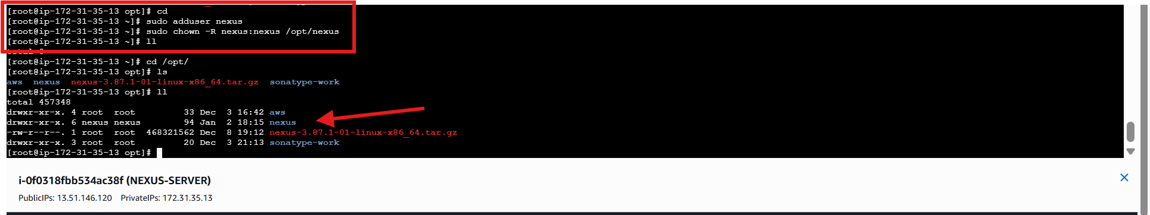

* Opened Nexus runtime configuration file:
* vi /opt/nexus/bin/nexus.rc

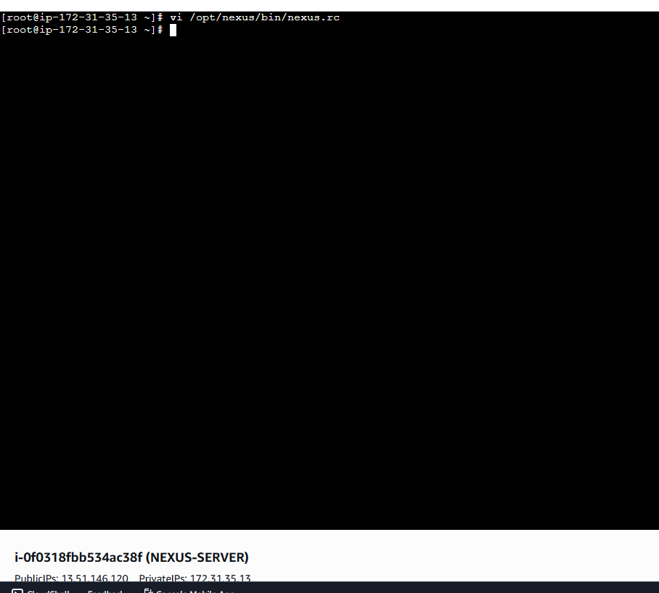

* Edited nexus.rc
* Set: run_as_user="nexus"
* This ensures Nexus runs under the nexus user instead of root
* Saved and exited the file

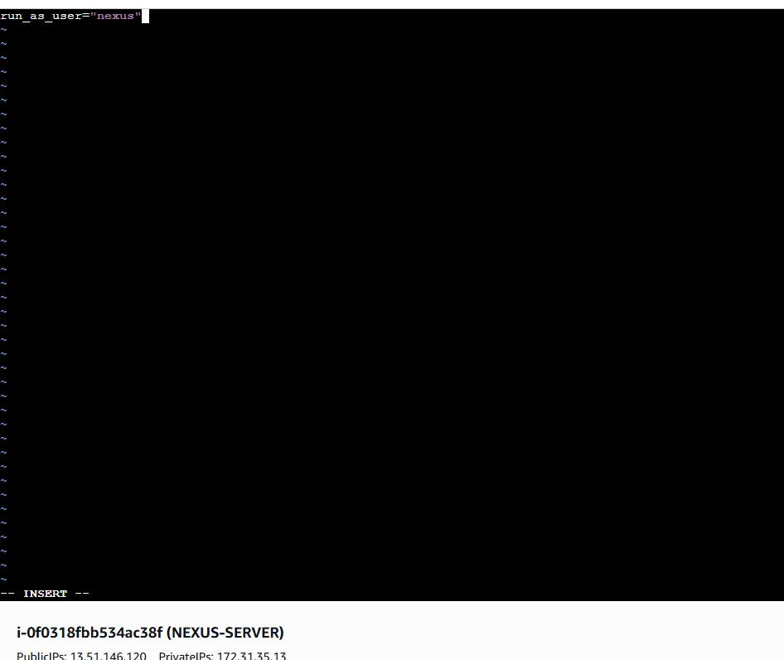

* Logged into **NEXUS-SERVER** as nexus user
* Navigated to Nexus binary directory:
* cd /opt/nexus/bin
* Attempted to start Nexus:
* ./nexus start
* Error encountered:
* Permission denied for sonatype-work/nexus3/nexus.pid
* Indicates ownership/permission issue on Nexus directories

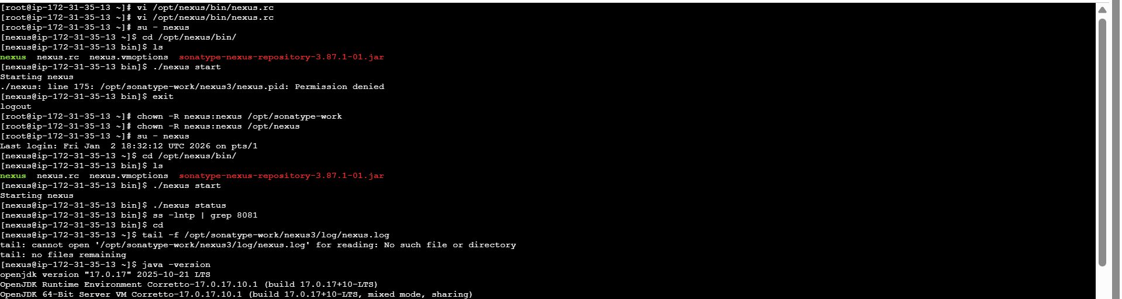

* Opened **Amazon EC2** console
* Selected **NEXUS-SERVER** instance
* Changed instance type:
  + From: t3.micro
  + To: m7i-flex.large
* Purpose: Increase memory and performance for Nexus
* Applied instance type change

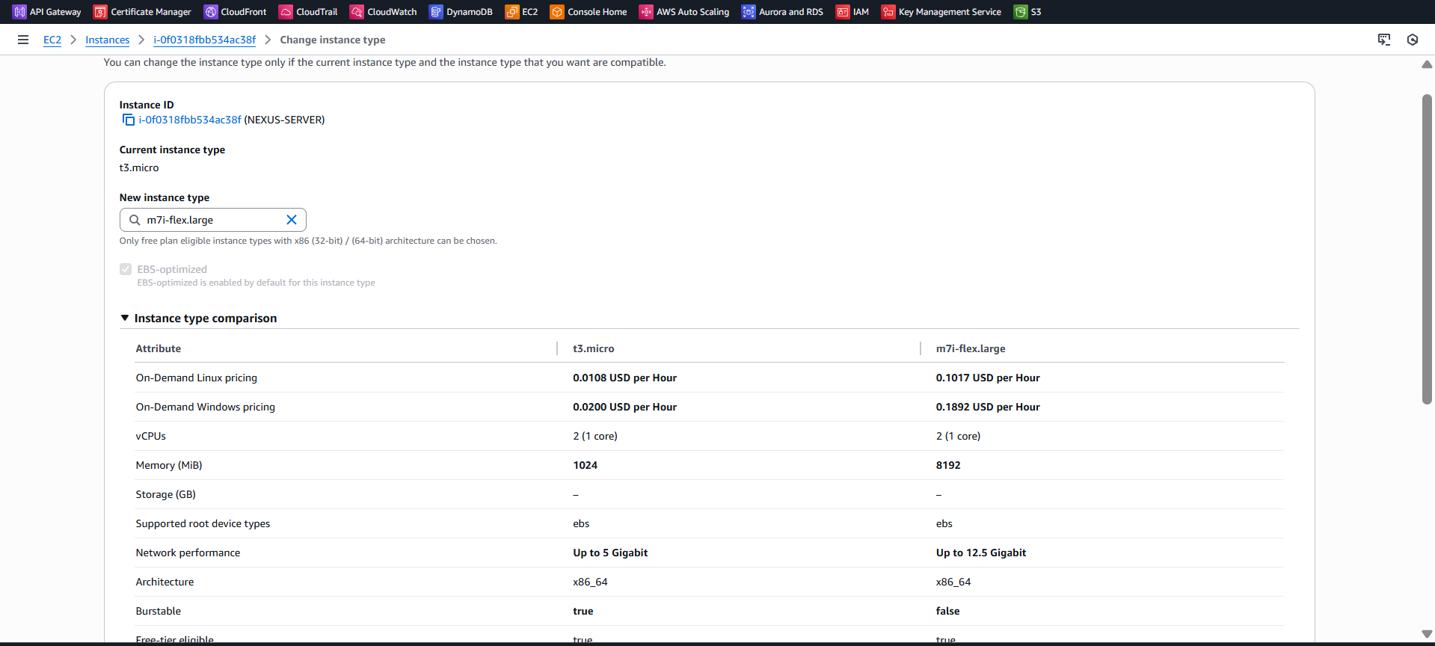

* Logged back into **NEXUS-SERVER**
* Navigated to Nexus bin directory
* Started Nexus:
* ./nexus start
* Verified Nexus status:
* ss -lntp | grep 8081
* Confirmed Nexus is listening on **port 8081**

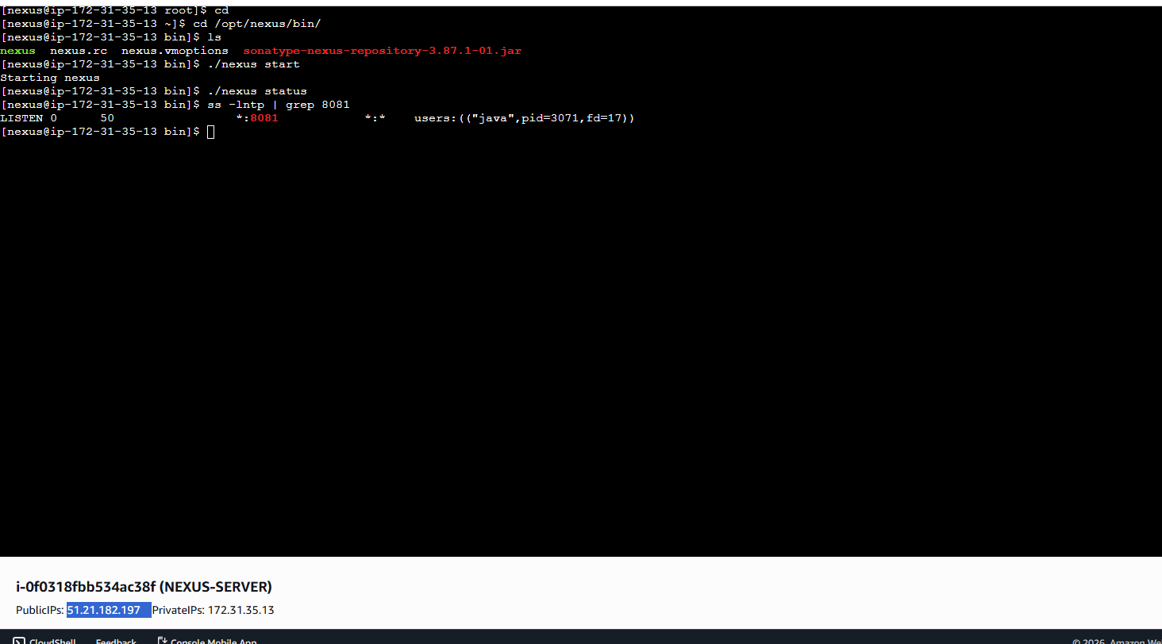

* Opened browser and accessed:
* http://<public-ip>:8081
* Nexus Repository Manager login page displayed
* Prompt indicates first-time login requires admin password from:
* /opt/sonatype-work/nexus3/admin.password

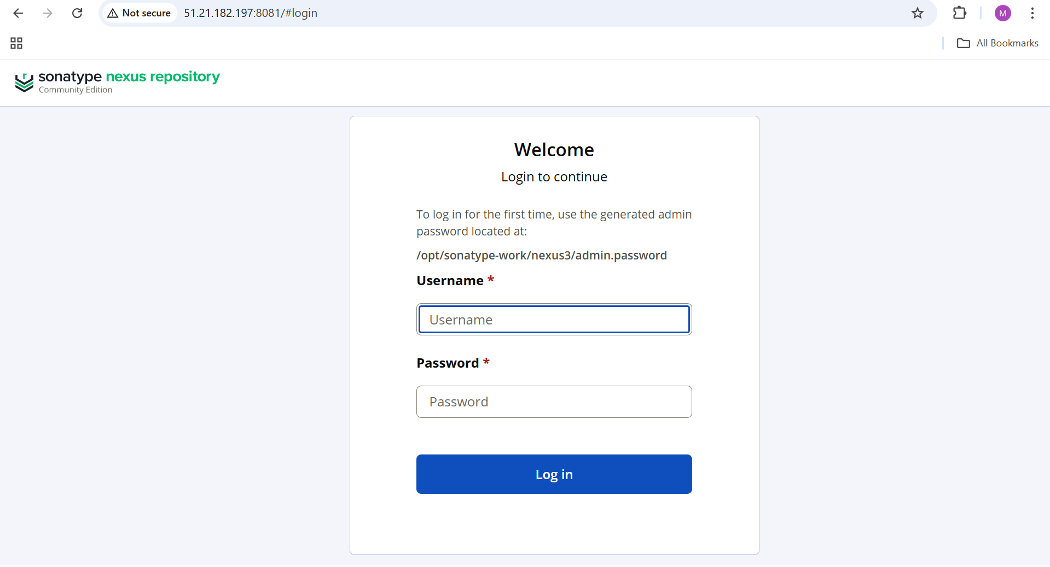

* Logged into Nexus server terminal
* Displayed admin password:
* cat /opt/sonatype-work/nexus3/admin.password
* Copied generated password
* Entered credentials in browser:
  + Username: admin
  + Password: (copied value)

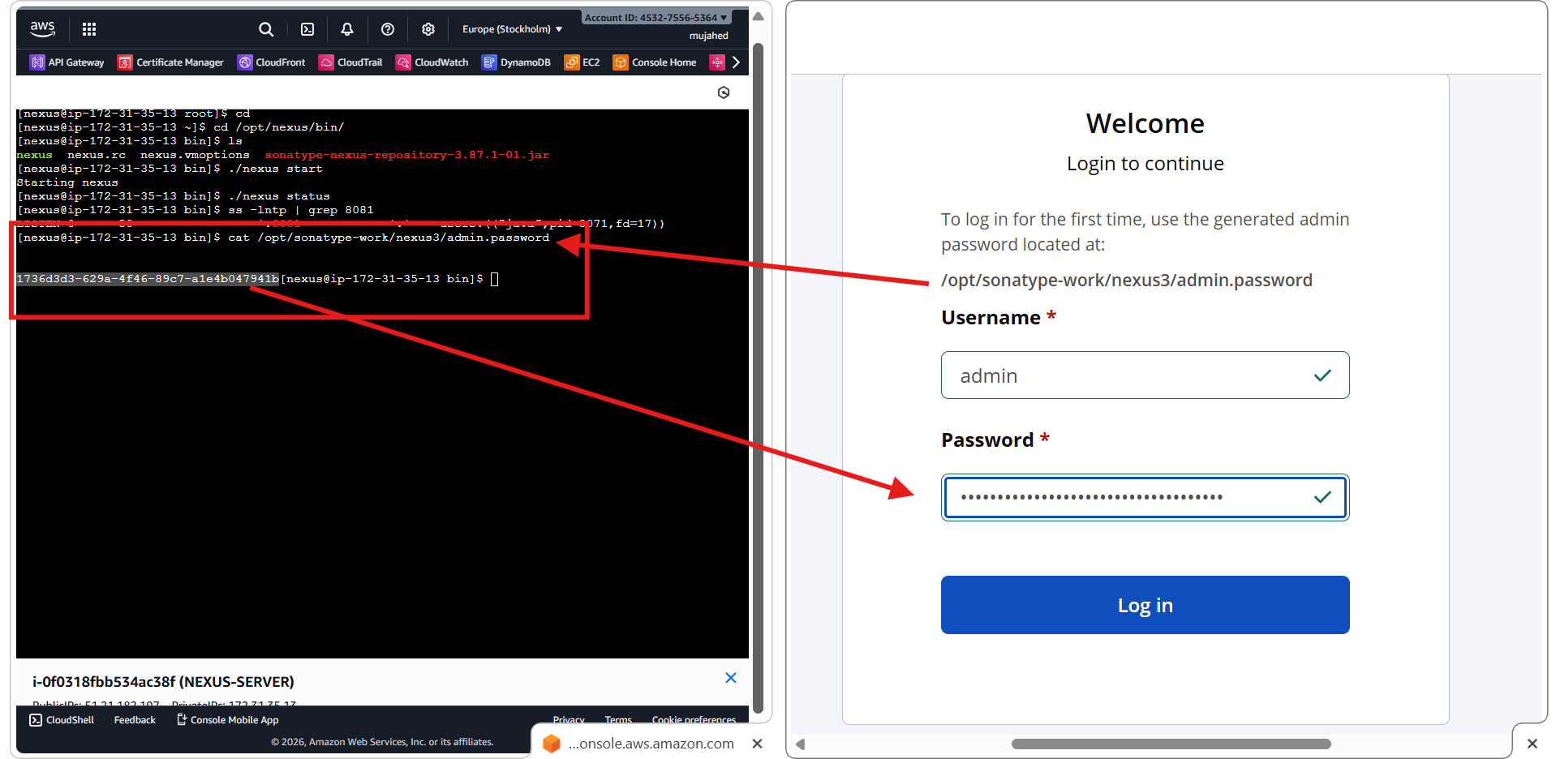

* Successfully logged into **Nexus Repository Manager**
* Nexus dashboard loaded

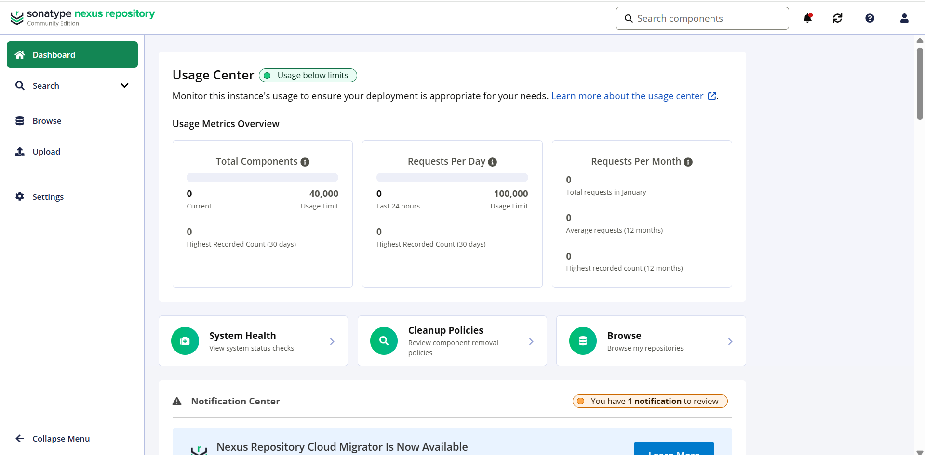

* Opened **Jenkins → Manage Jenkins → Plugins**
* Searched for **nexus**
* Selected **Nexus Artifact Uploader** plugin
* Installed the plugin successfully

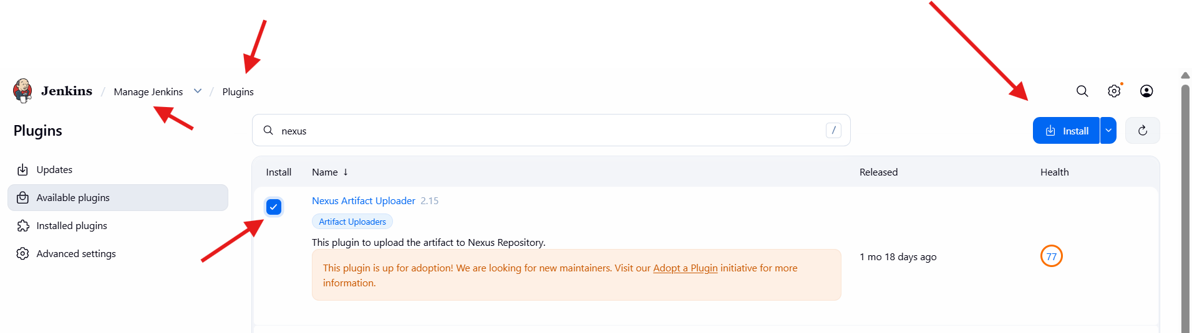

* Opened Jenkins job **BETAWINS-HIRING-APP → Configure**
* Navigated to **Build Steps**
* Clicked **Add build step**
* Selected **Nexus artifact uploader**

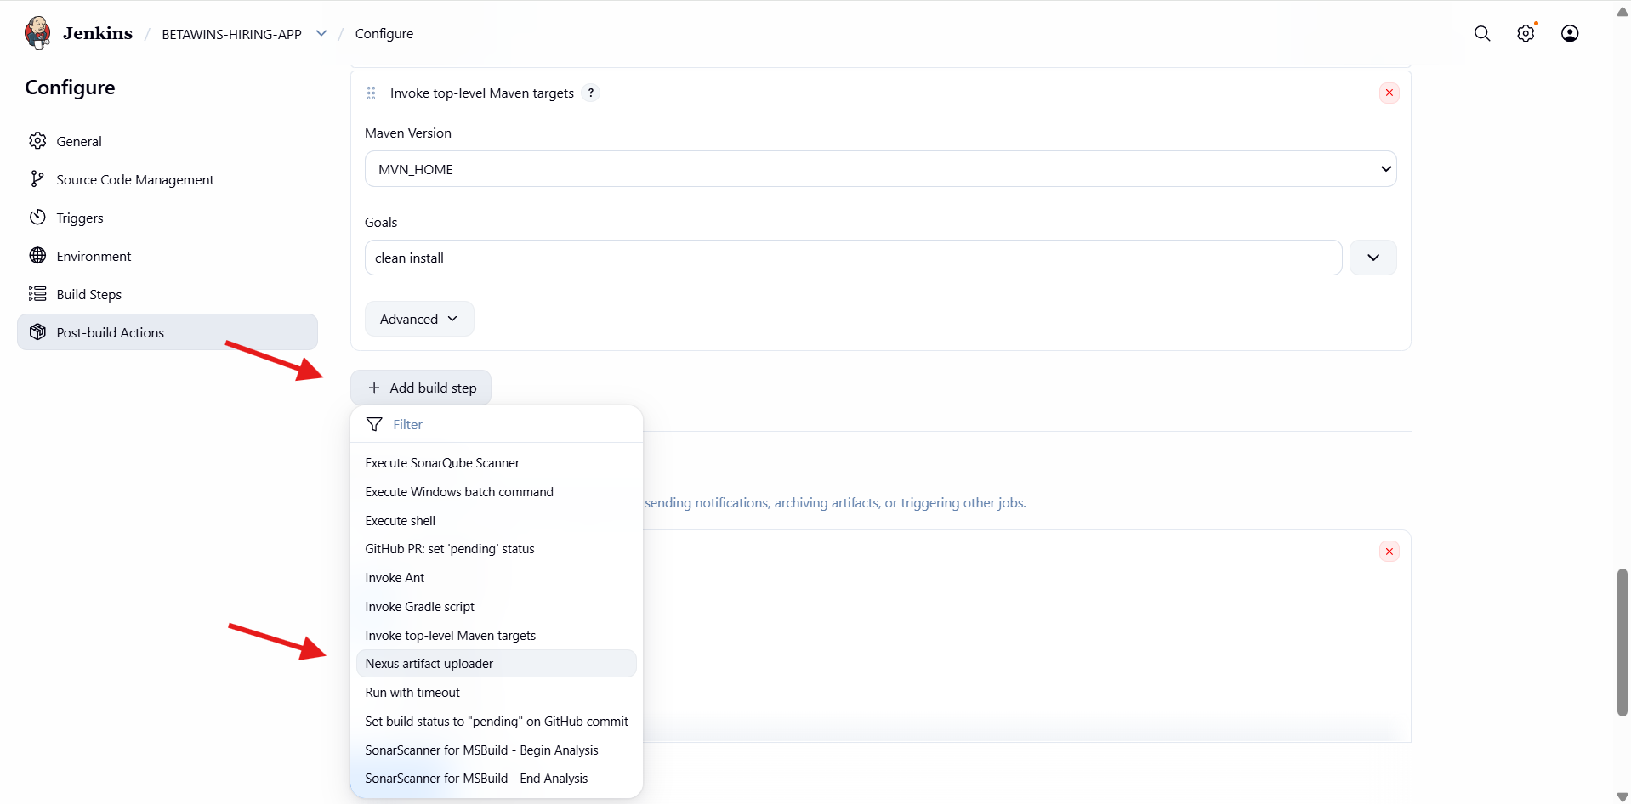

* Set **Nexus Version**: NEXUS3
* Selected **Protocol**: HTTP
* Entered **Nexus URL**:51.21.182.197:8081
* Observed validation error:
* “GroupId must not be empty”
* Indicates required Maven coordinates not yet filled

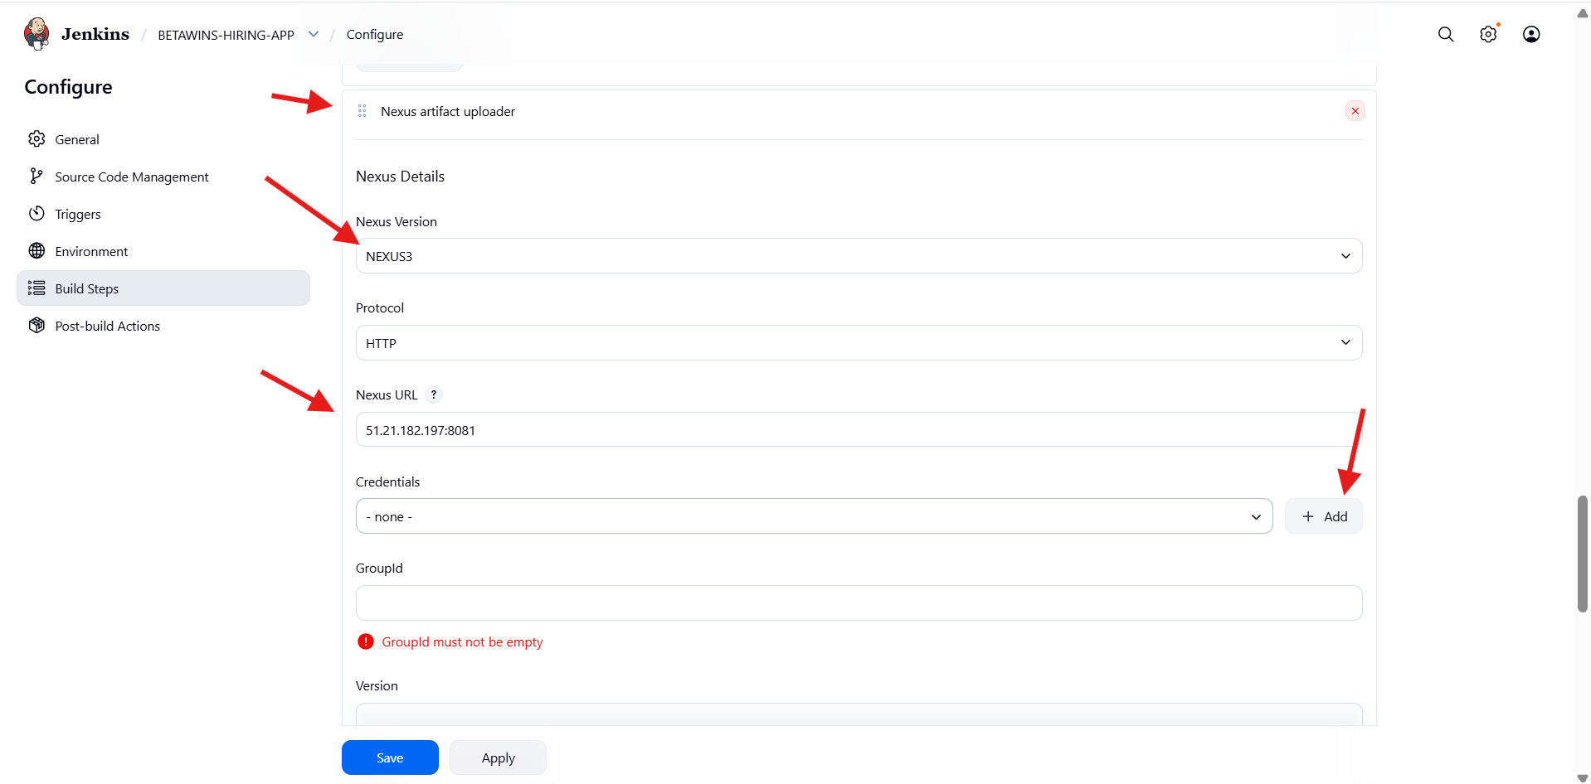

* Clicked **Add → Jenkins Credentials**
* Selected:
* Kind: Username with password
* Scope: Global
* Entered:
* Username: admin
* Password: Nexus admin password
* ID: NEXUS_SERVER
* Description: NEXUS_SERVER
* Saved credentials for Nexus authentication

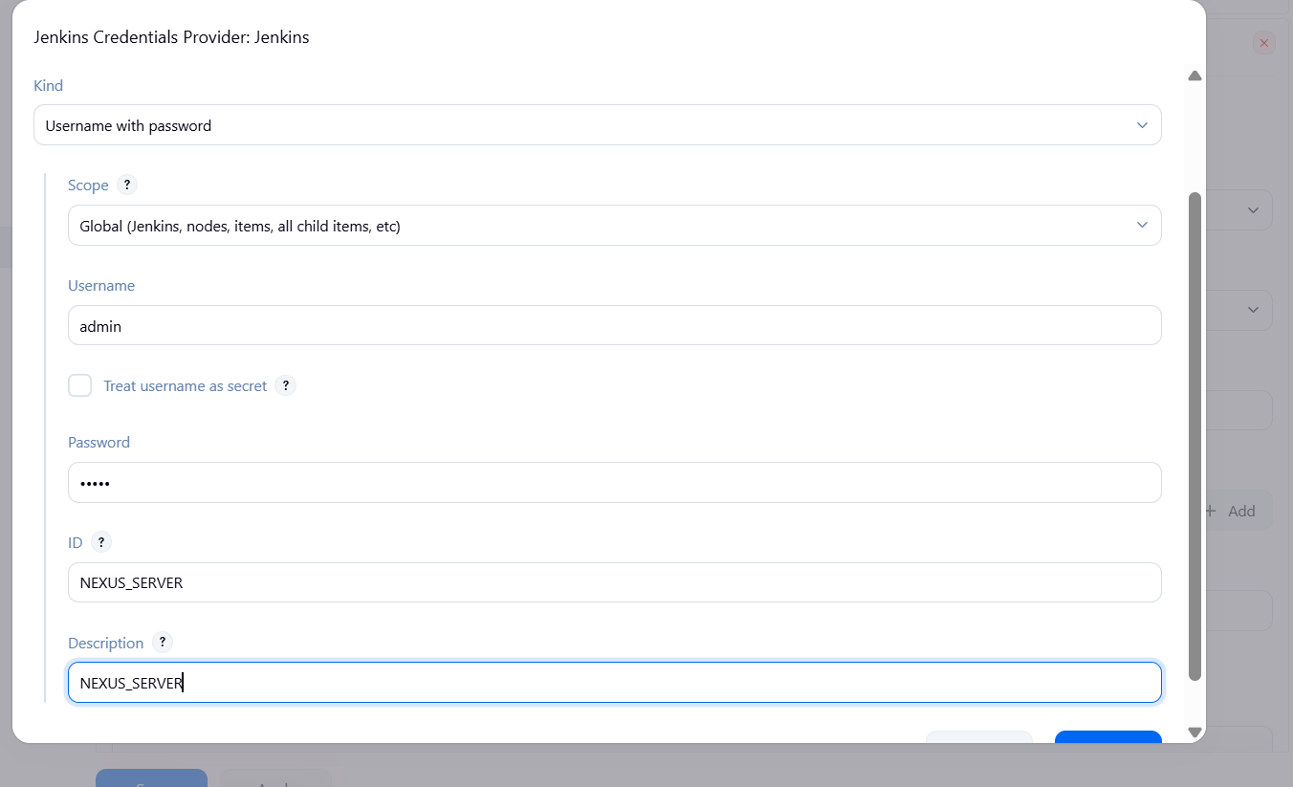

* Opened the project **pom.xml** in **GitHub**
* Identified Maven coordinates:
  + groupId
  + artifactId
  + version
* In **Jenkins → Nexus artifact uploader**, entered:
  + **GroupId**: in.javahome
  + **Version**: 0.1
* Error shown: **Repository must not be empty** (repository not yet created/selected)

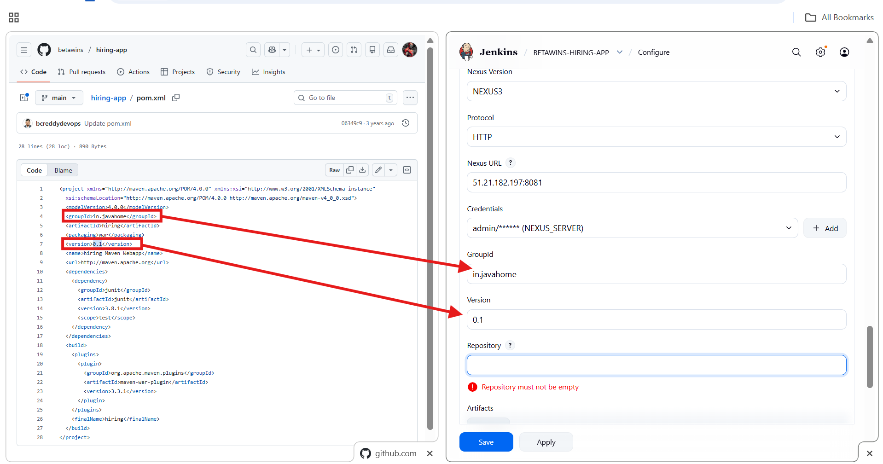

* Logged into **Nexus Repository Manager**
* Navigated to **Settings → Repository → Repositories**
* Viewed existing repositories:
  + maven-central (proxy)
  + maven-releases (hosted)
  + maven-snapshots (hosted)
* Confirmed no project-specific hosted repo exists yet

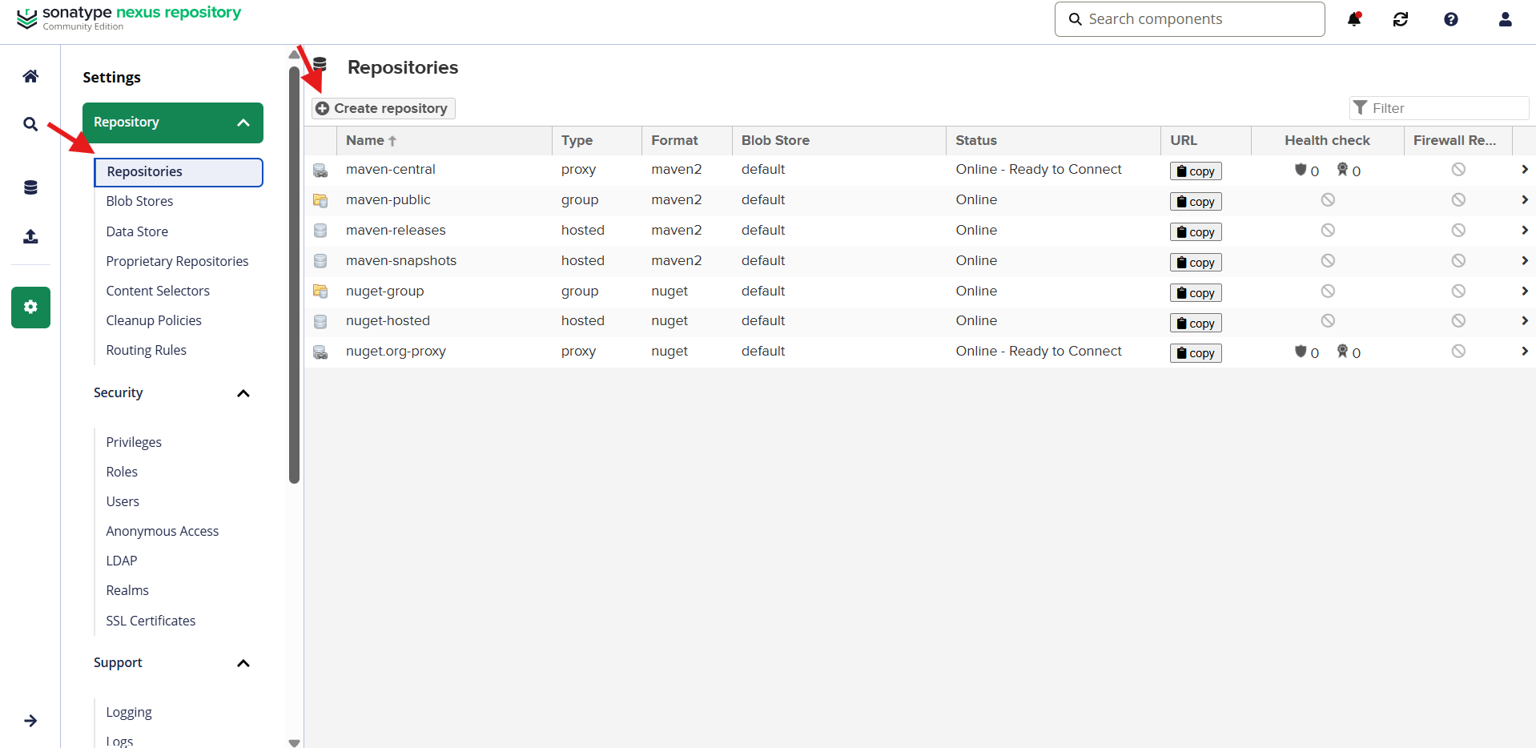

* Clicked **Create repository**
* Selected **maven2 (hosted)**
* This type is required to **upload artifacts from Jenkins**

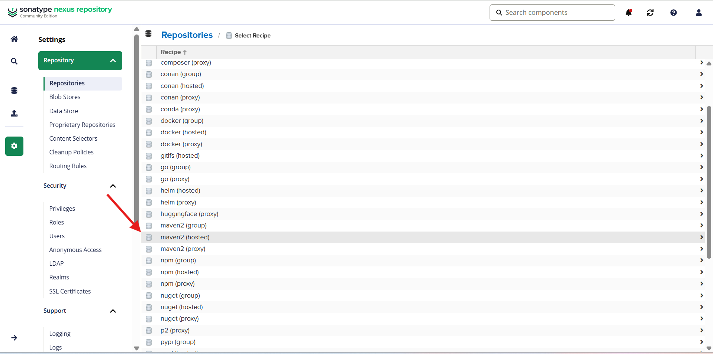

* Entered repository details:
  + **Name**: hiring-app
  + **Version policy**: Release
  + **Layout policy**: Permissive
  + **Blob store**: default
  + **Deployment policy**: Allow redeploy
* Saved the repository
* Nexus hosted repository hiring-app created successfully

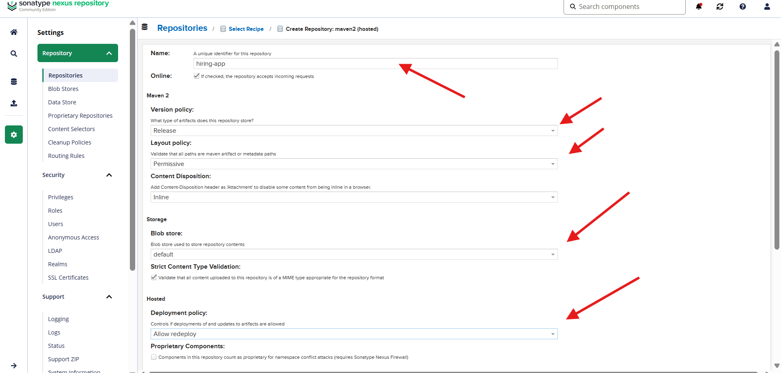

* Returned to **Jenkins → Job → Configure → Nexus artifact uploader**
* Entered:
  + **Repository**: hiring-app
* Verified repository URL in Nexus UI
* Jenkins and Nexus repository names now match

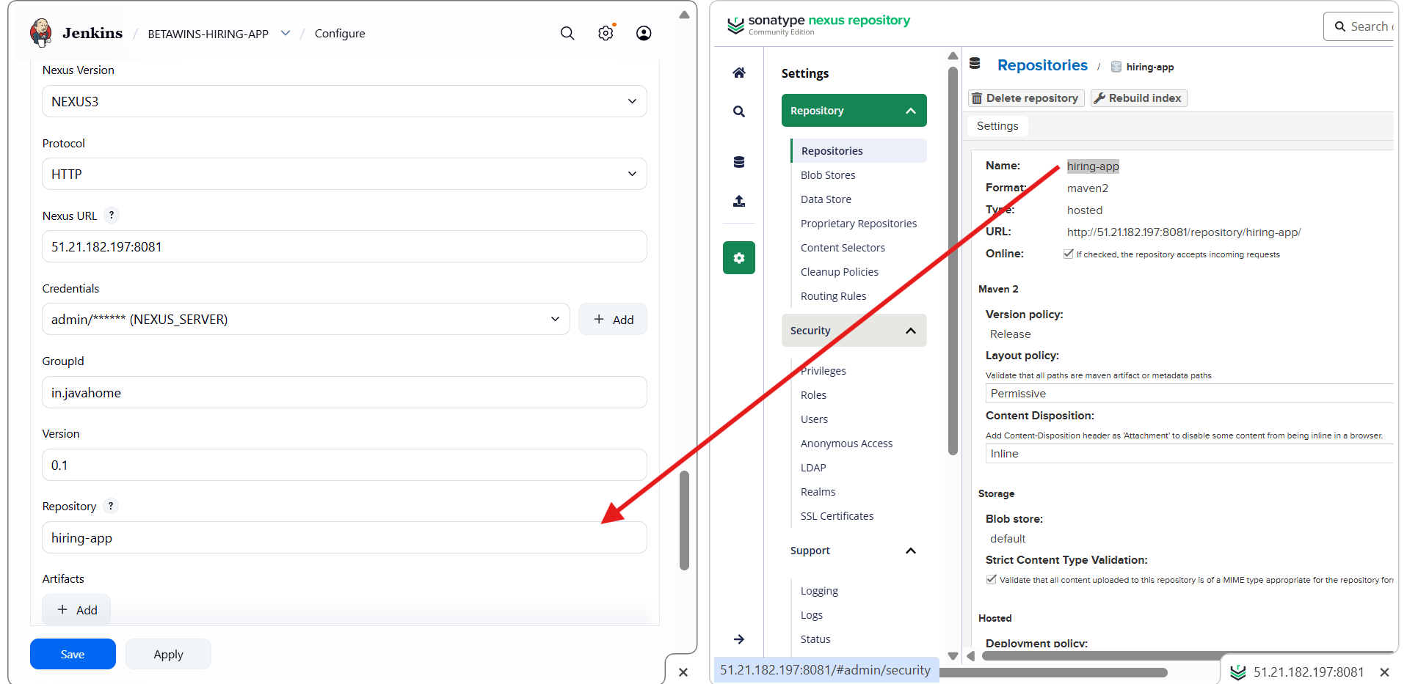

Reopened **pom.xml** in GitHub

Copied:

* artifactId: hiring

In Jenkins **Artifacts** section:

* **ArtifactId**: hiring
* **Type**: war

Error shown: **File must not be empty**

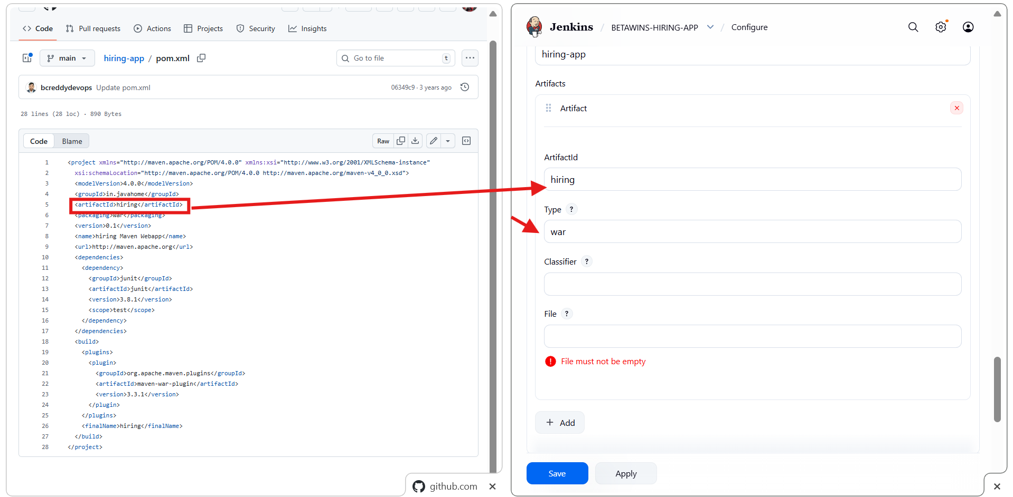

* In Jenkins **Nexus artifact uploader → Artifacts**
* Entered file pattern:
* *.war
* Saved the configuration
* Jenkins job ready to upload WAR file

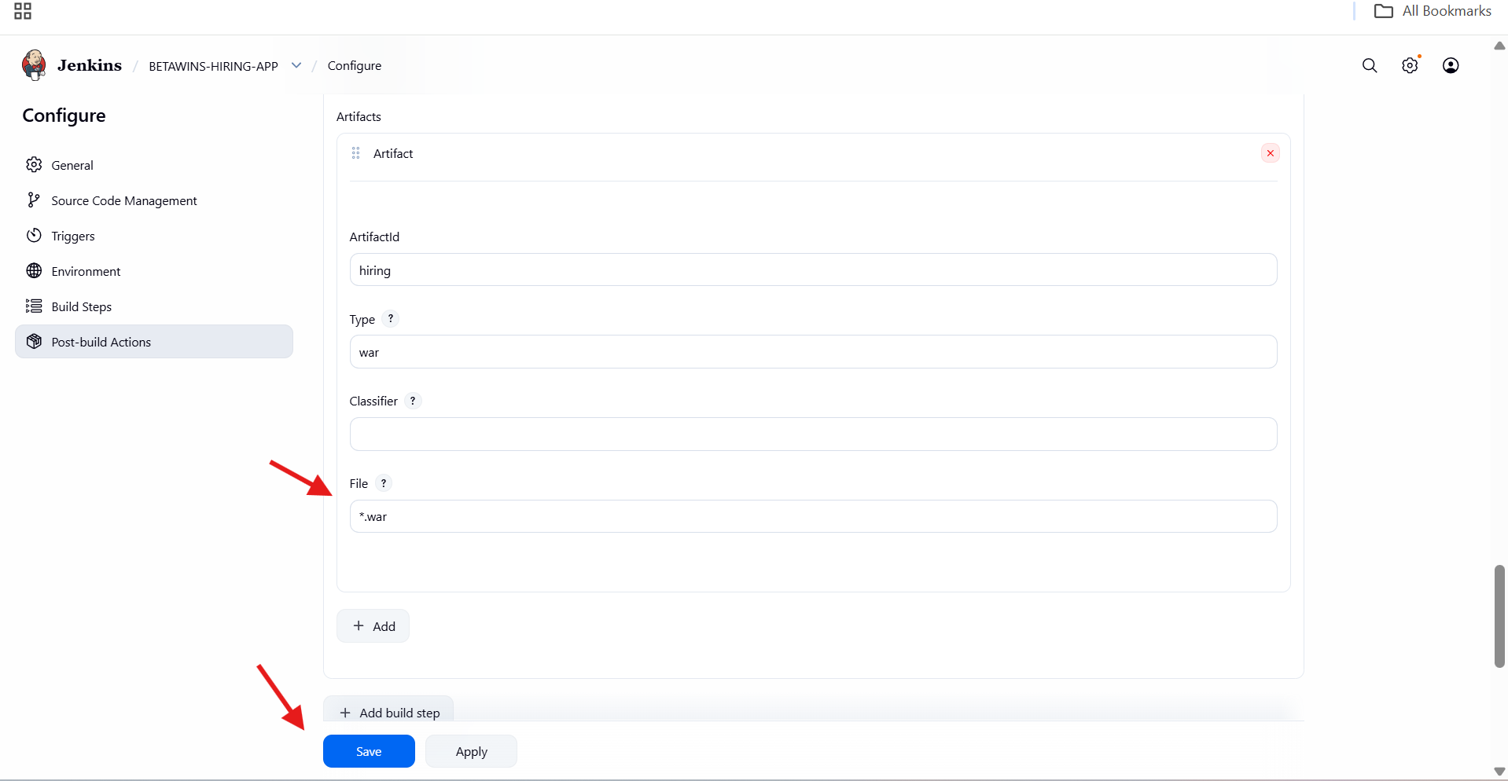

* Triggered **Build #4**
* Git repository checked out successfully
* Build started without SCM issues

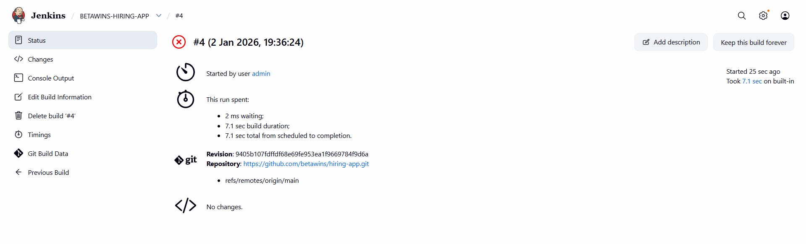

* Maven build succeeded (BUILD SUCCESS)
* Nexus upload step failed with error:
* *.war file doesn't exist
* Root cause:
  + Jenkins could not locate the WAR file using wildcard

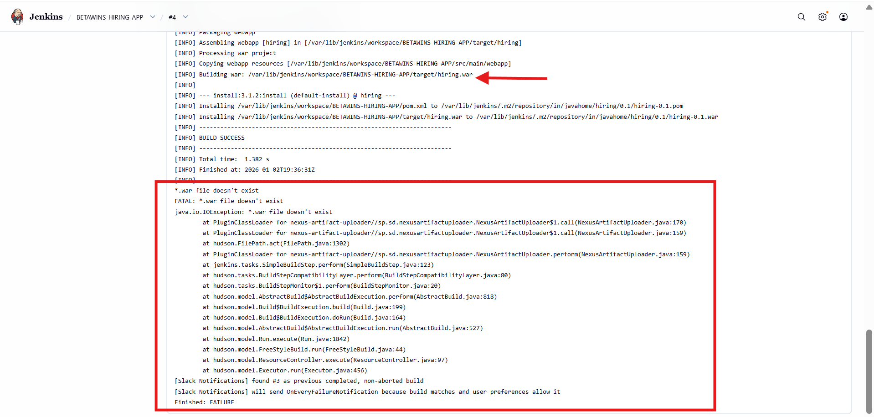

* Updated Jenkins **Artifacts → File** field with full path:
* /var/lib/jenkins/workspace/BETAWINS-HIRING-APP/target/hiring.war
* This matches the actual WAR file generated by Maven
* Saved the configuration

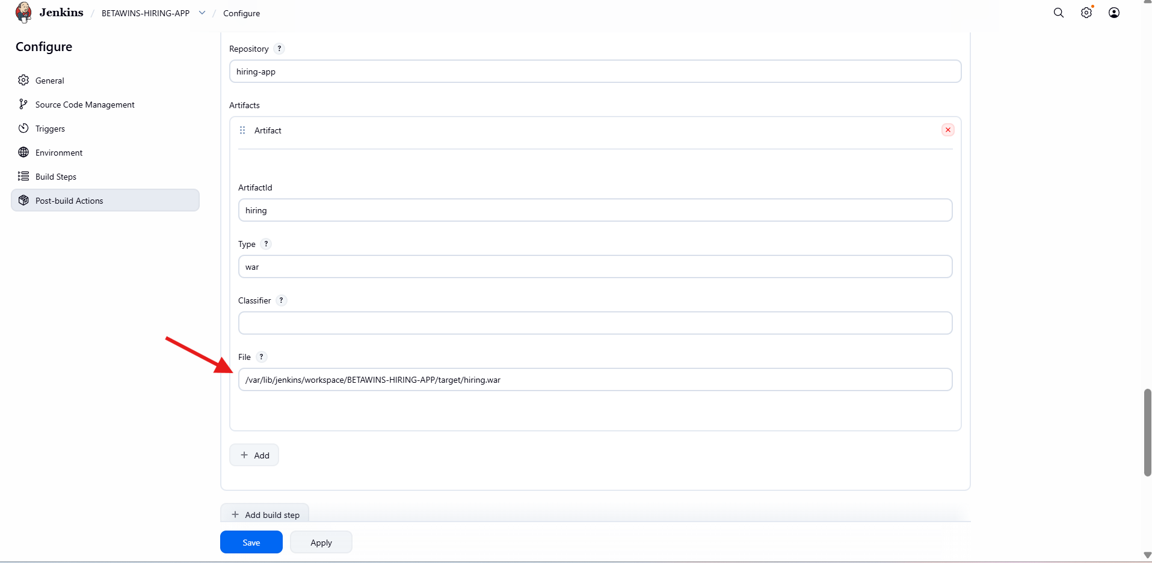

* Opened **Jenkins → BETAWINS-HIRING-APP**
* Build **#5** triggered manually
* Git repository fetched successfully from main branch
* Build duration ~8 seconds
* Final build status:  **SUCCESS**
* Confirms Maven build + Nexus upload completed without errors

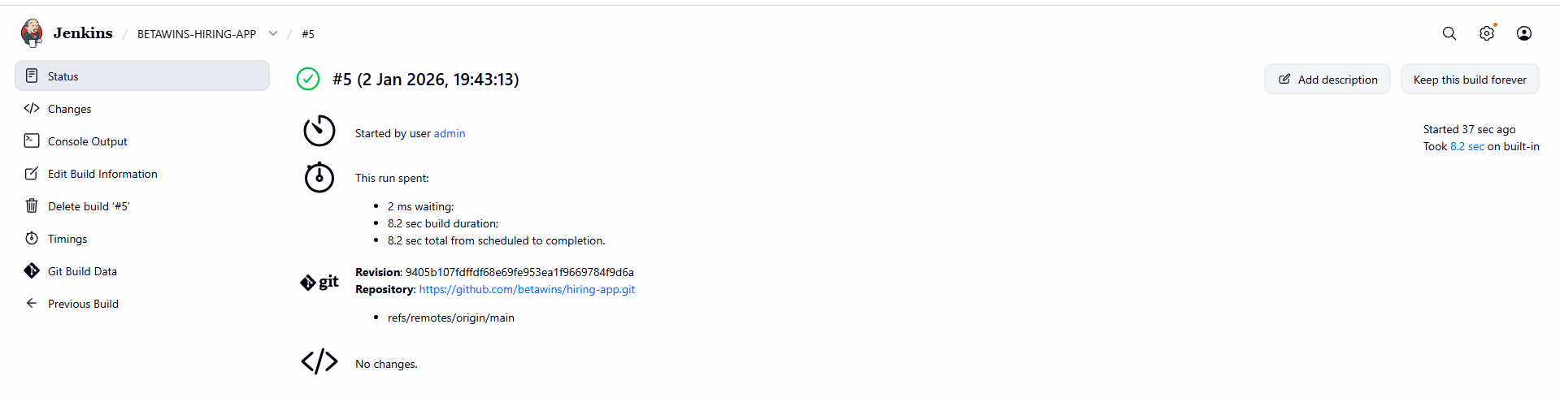

* Logged into **Sonatype Nexus Repository Manager**
* Navigated to **Browse**
* Opened repository: **hiring-app**
* Navigated through Maven coordinates:
* in/
* └── javahome/
* └── hiring/
* └── 0.1/
* Verified uploaded artifacts:
  + hiring-0.1.war
  + hiring-0.1.war.md5
  + hiring-0.1.war.sha1
* Confirms artifact upload to Nexus was successful

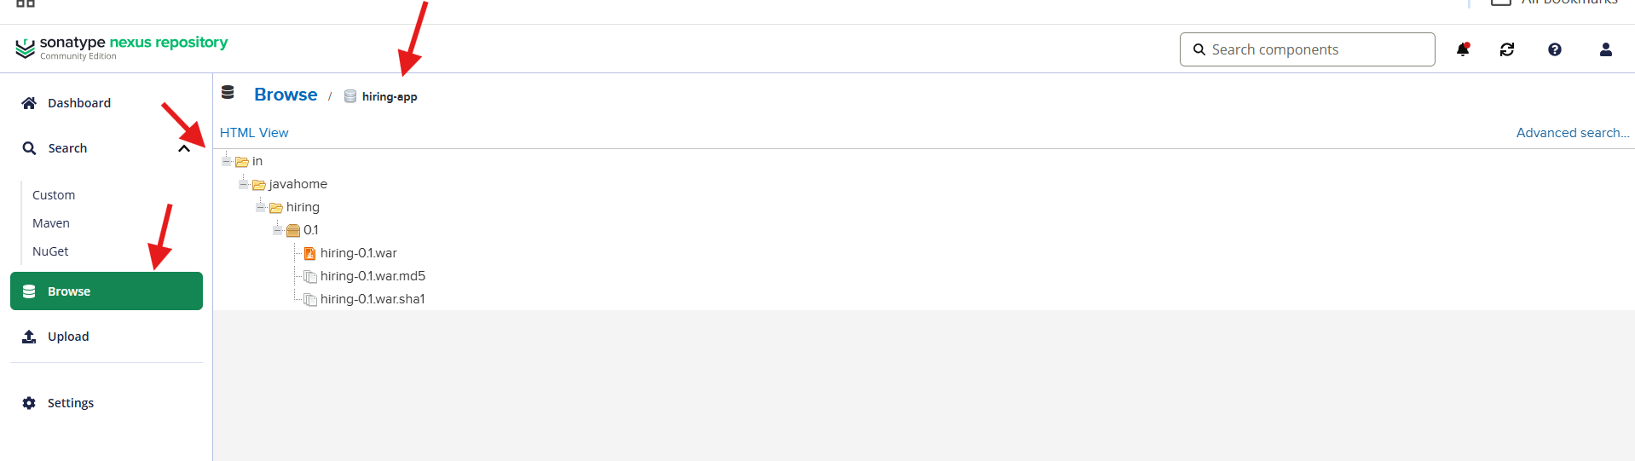

Slack channel received Jenkins notifications:

* Build #4 – Failed
* Build #5 – Success

Confirms:

* Jenkins–Slack integration is working

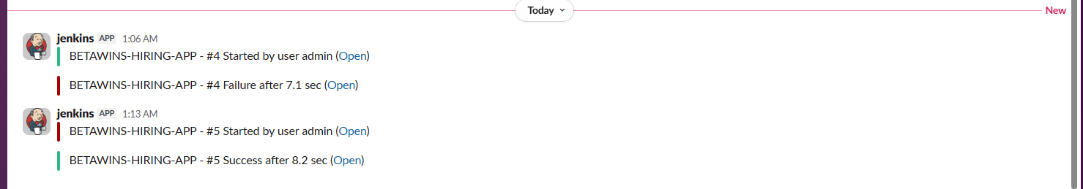

* Opened **Jenkins**
* Navigated to **Manage Jenkins → Plugins → Available plugins**
* Searched for **deploy**
* Selected **Deploy to container** plugin
* Clicked **Install**
* Plugin installed successfully for WAR deployment

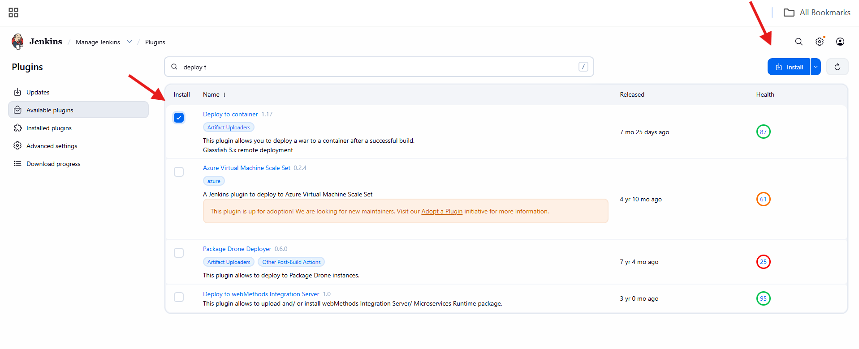

* Opened Jenkins job **BETAWINS-HIRING-APP**
* Clicked **Configure**
* Navigated to **Post-build Actions**
* Clicked **Add post-build action**
* Selected **Deploy war/ear to a container**

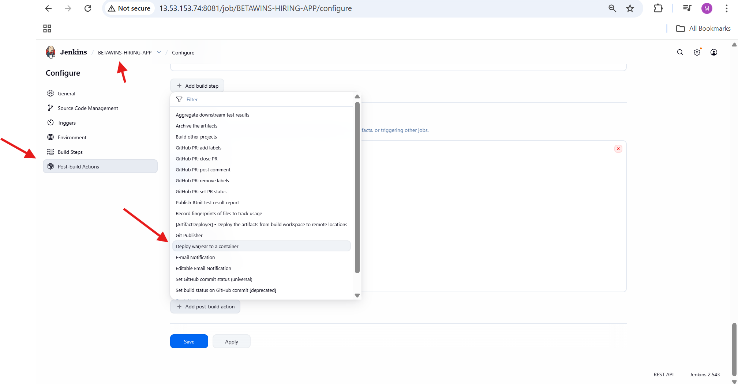

* Opened **Deploy war/ear to a container** section
* Configuration pending (Tomcat not yet set up

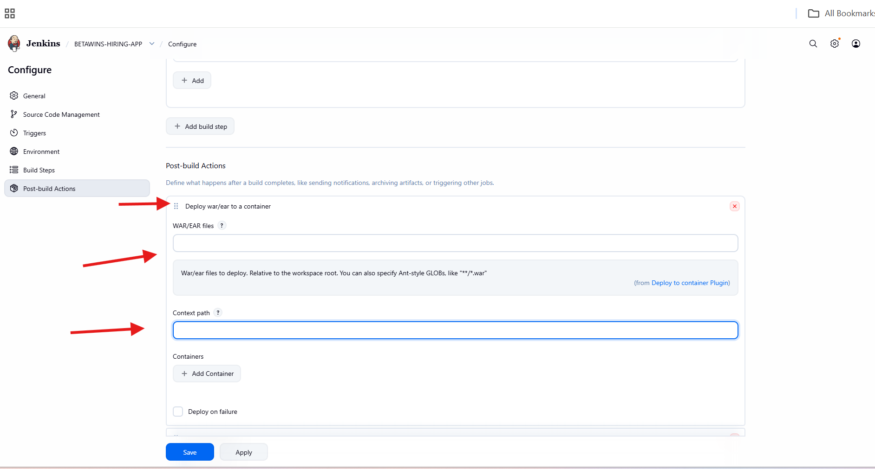

* Opened **Amazon EC2 → Launch instance**
* Set instance name: **tomcat**
* Clicked **Launch instance**

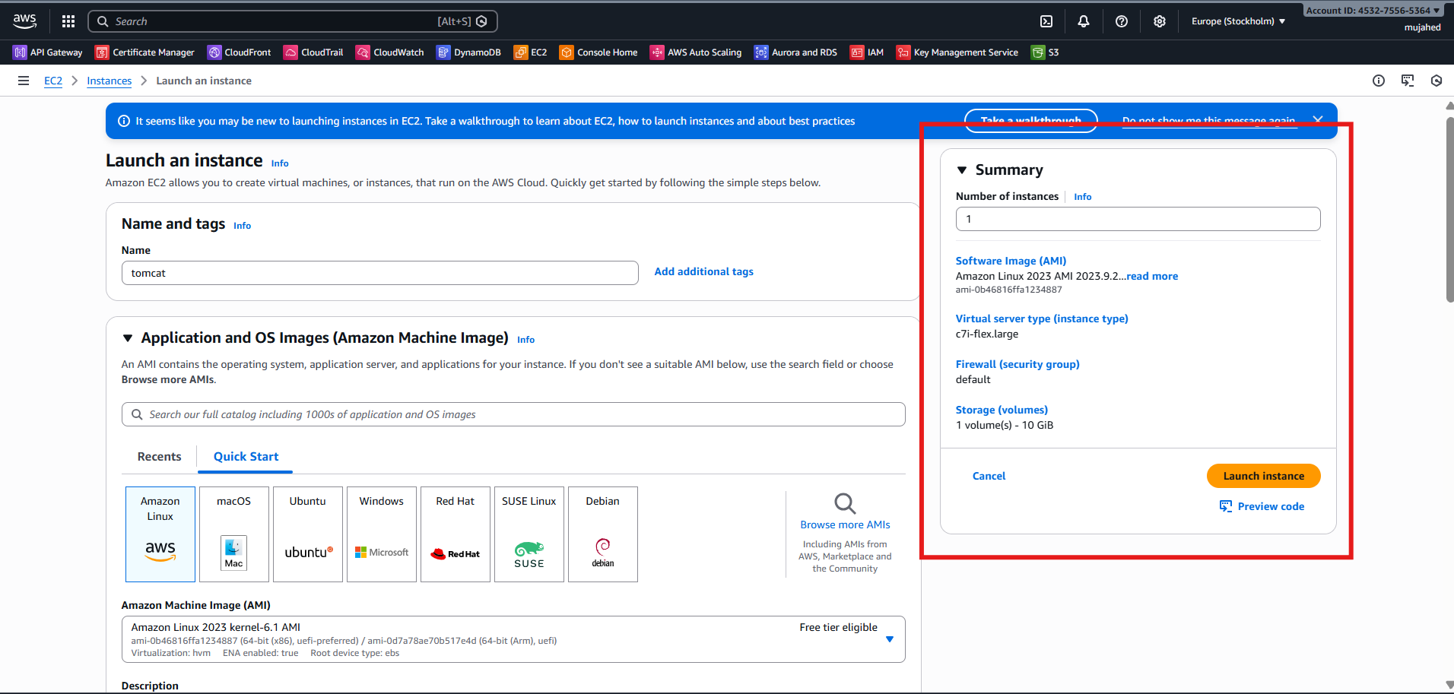

* Logged into **tomcat EC2 instance**
* Installed Java 17 (Amazon Corretto):
* yum install java-17-amazon-corretto -y
* Verified Java packages installed
* Java required for Tomcat runtime

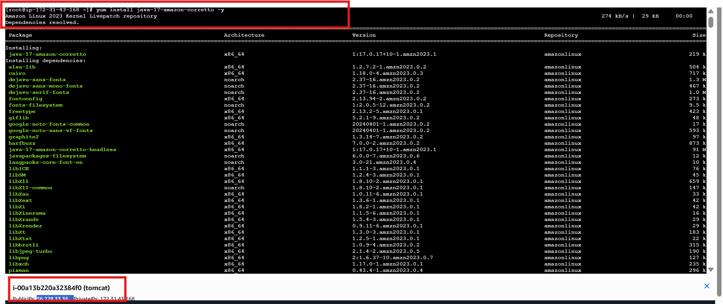

* Navigated to /opt
* Downloaded Tomcat archive:
* wget https://dlcdn.apache.org/tomcat/tomcat-9/v9.0.113/bin/apache-tomcat-9.0.113.tar.gz
* Extracted the archive:
* tar -xvf apache-tomcat-9.0.113.tar.gz
* Tomcat directory created successfully

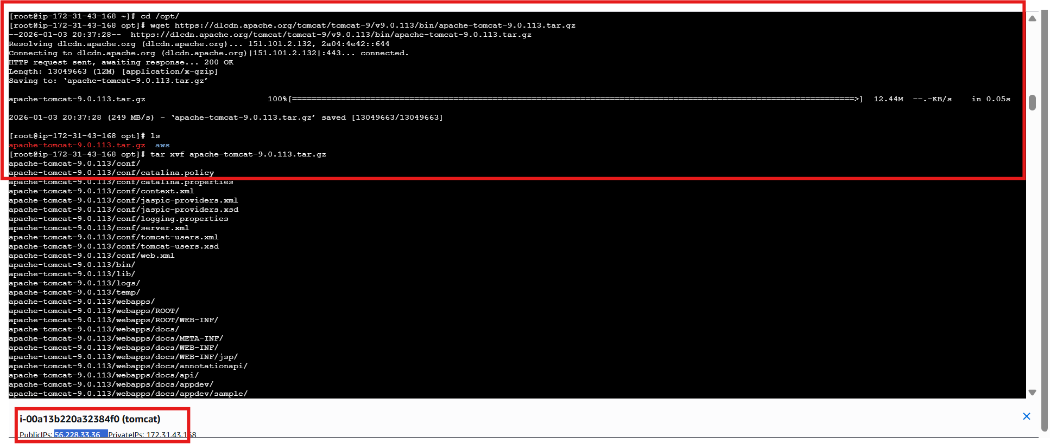

* Navigated to Tomcat bin directory:
* cd /opt/apache-tomcat-9.0.113/bin
* Started Tomcat:
* ./startup.sh
* Tomcat started without errors

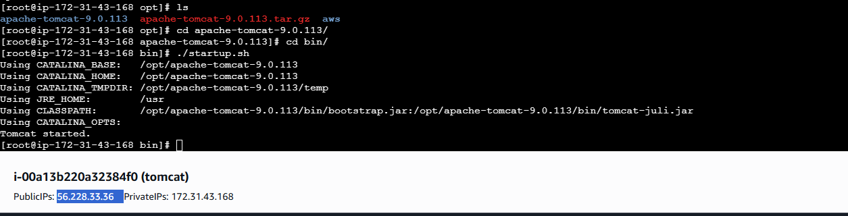

* Opened browser
* Accessed:
* http://<tomcat-public-ip>:8080
* Apache Tomcat welcome page displayed
* Confirms Tomcat is running successfully

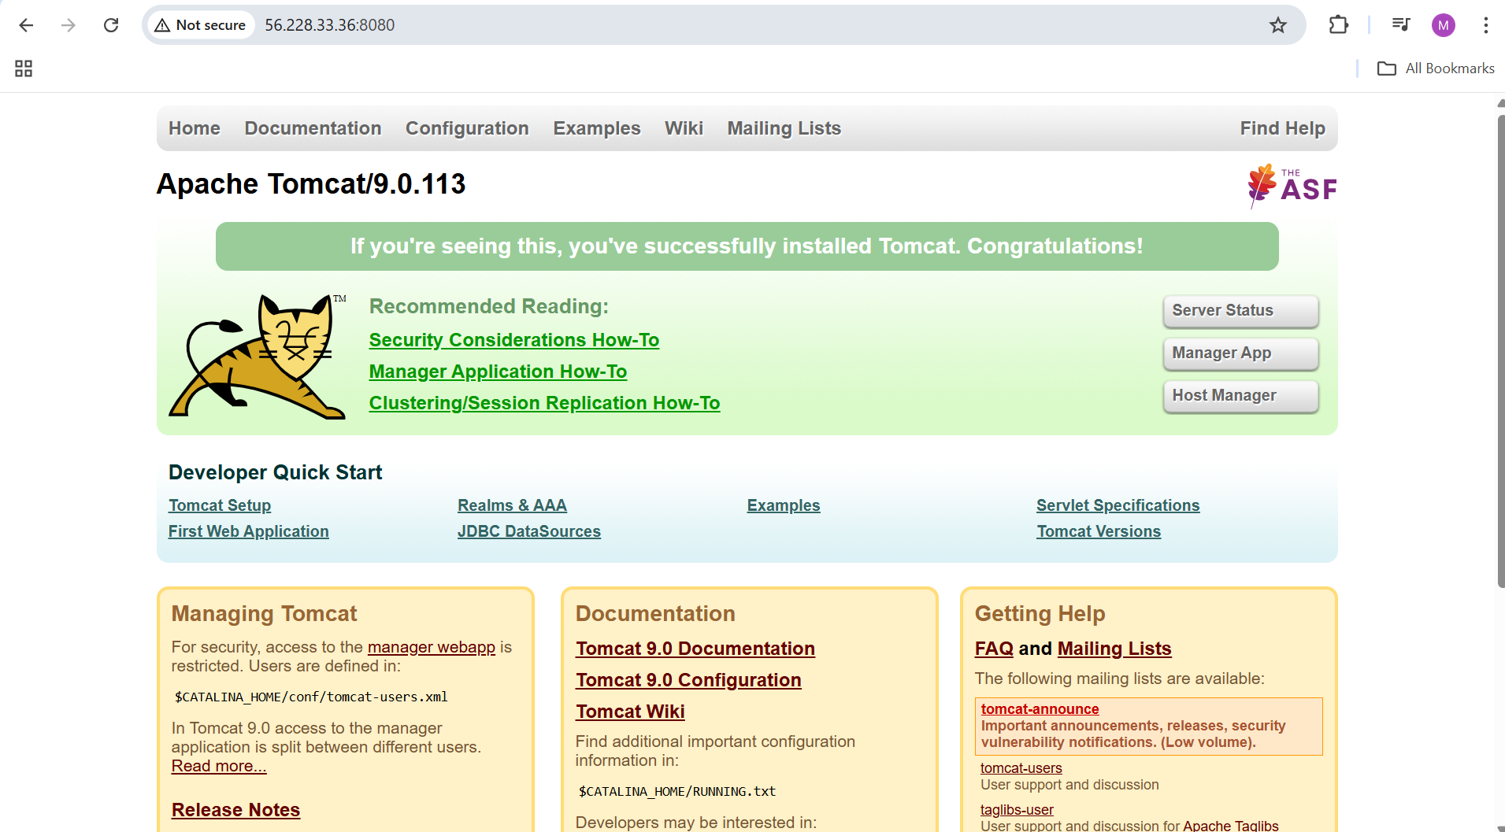

* Searched for context.xml files:
* find /opt/apache-tomcat-9.0.113 -name context.xml
* Identified multiple context.xml locations
* Required for manager access configuration

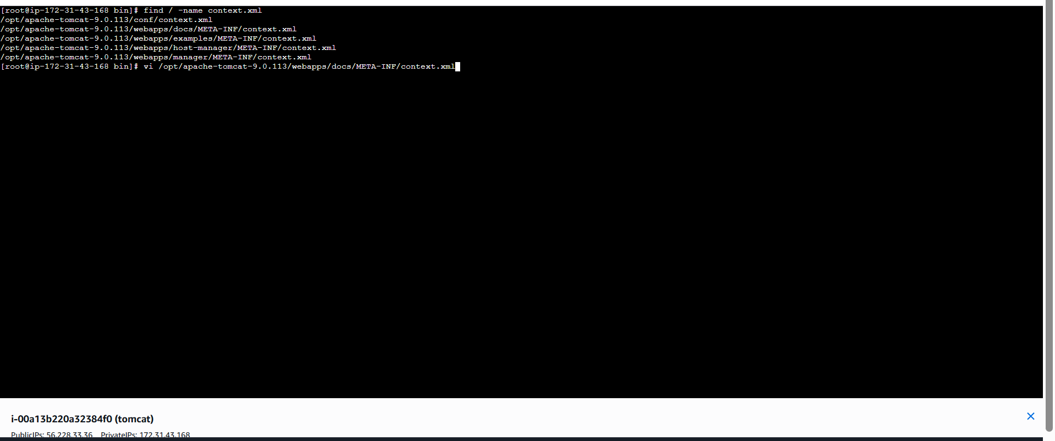

* Edited context.xml
* Commented or modified **RemoteAddrValve**:
* <!-- <Valve className="org.apache.catalina.valves.RemoteAddrValve"
* allow="127\.0\.0\.1|::1|.*" /> -->
* Allows Jenkins server to deploy remotely
* Saved configuration

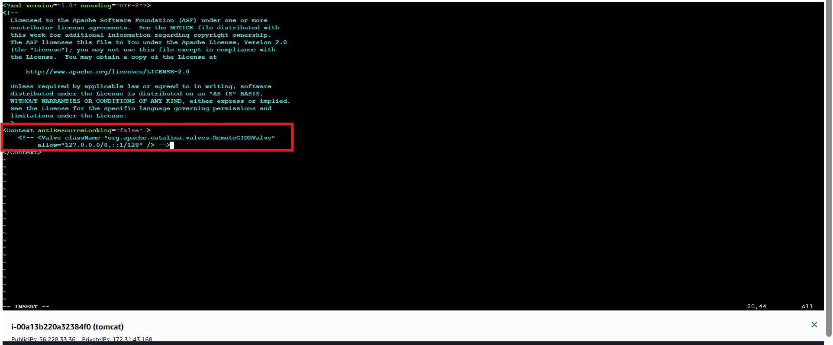

* Ran:
* find /opt/apache-tomcat-9.0.113 -name context.xml
* Identified multiple context.xml locations under:
  + webapps/docs/
  + webapps/examples/
  + webapps/host-manager/
  + webapps/manager/
  + vi /opt/apache-tomcat-9.0.113/webapps/examples/META-INF/context.xml
* Purpose: locate files that restrict remote access for Tomcat manager apps.

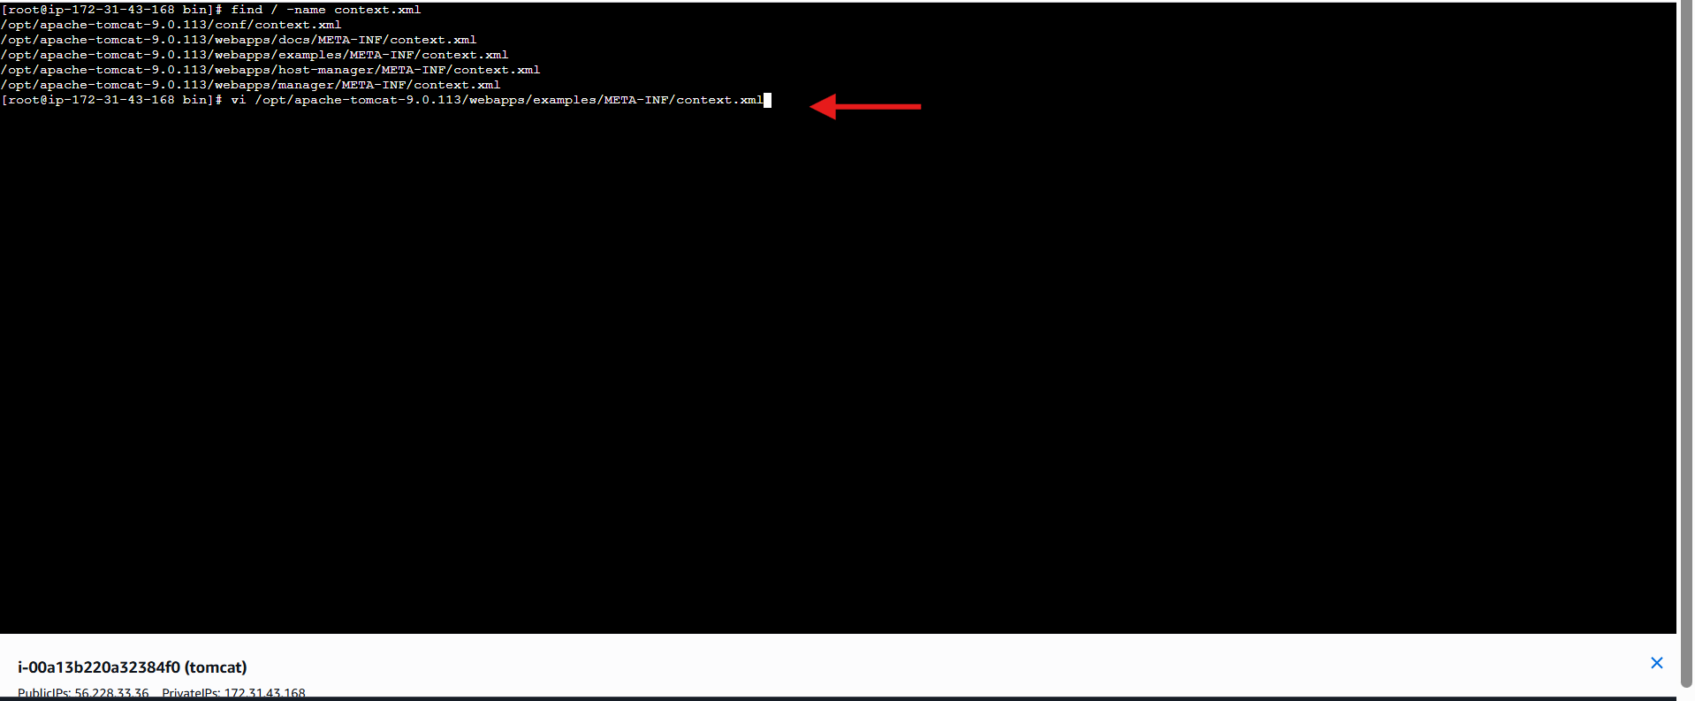

* Opened:
* vi /opt/apache-tomcat-9.0.113/webapps/examples/META-INF/context.xml
* Found **RemoteAddrValve** entry that limits access to localhost.
* This valve blocks remote deployments by default.

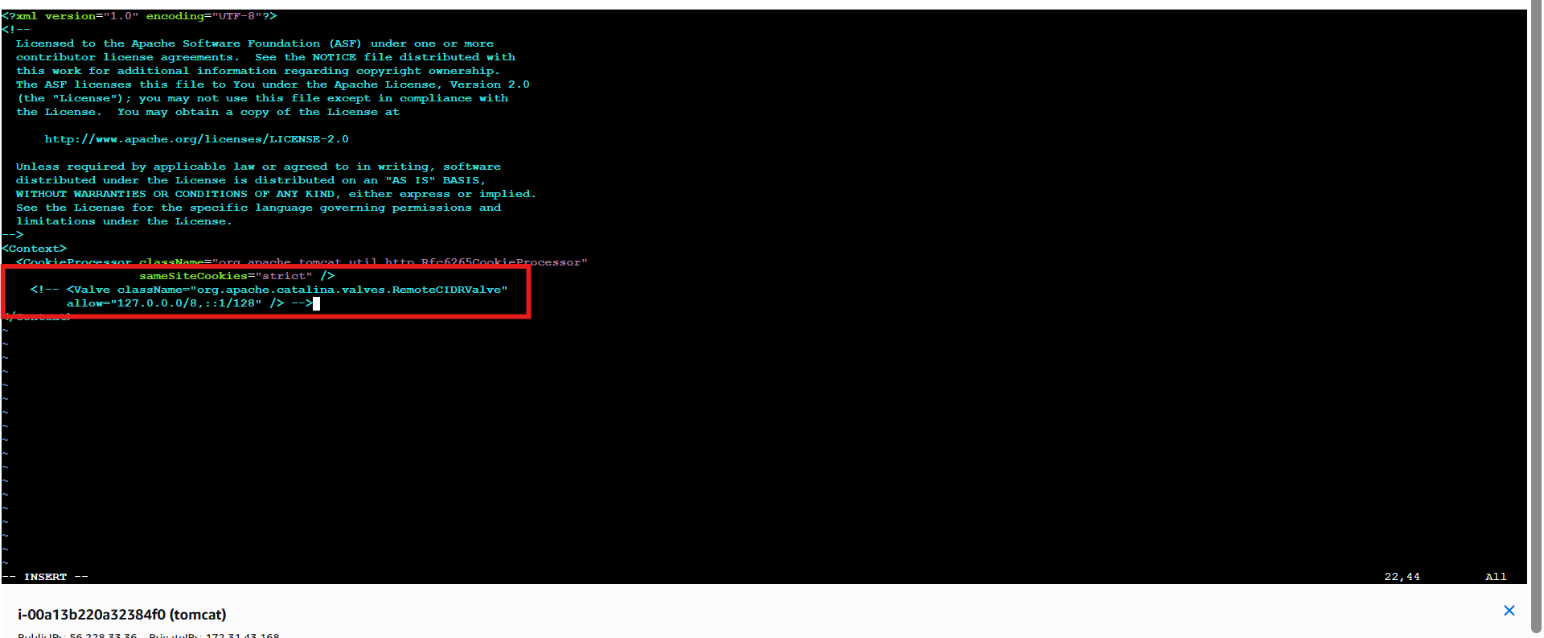

* Opened:
* vi /opt/apache-tomcat-9.0.113/webapps/host-manager/META-INF/context.xml
* Located the same **RemoteAddrValve** restriction.
* Required for Jenkins to access Tomcat host-manager remotely

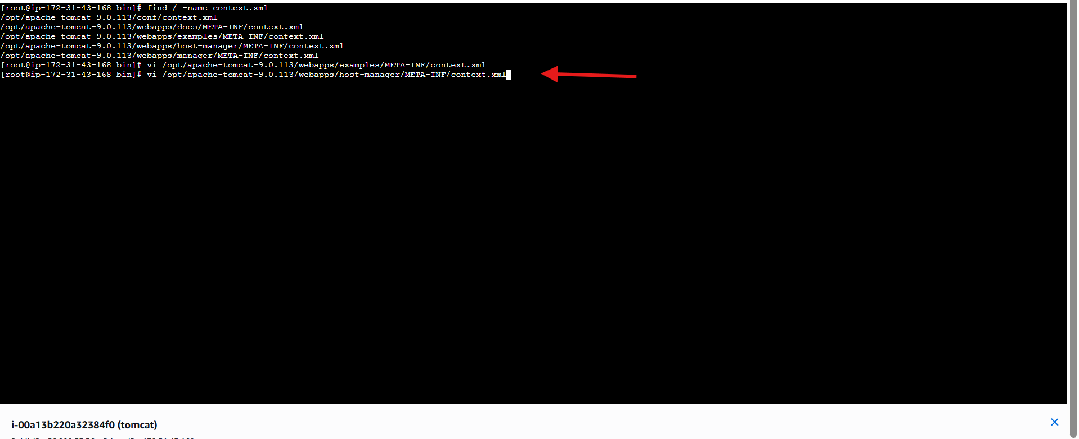

* Commented or changed:
* <!-- <Valve className="org.apache.catalina.valves.RemoteAddrValve"
* allow="127\.0\.0\.1|::1|.*" /> -->
* Allowed remote IPs (including Jenkins server).
* Saved the file.

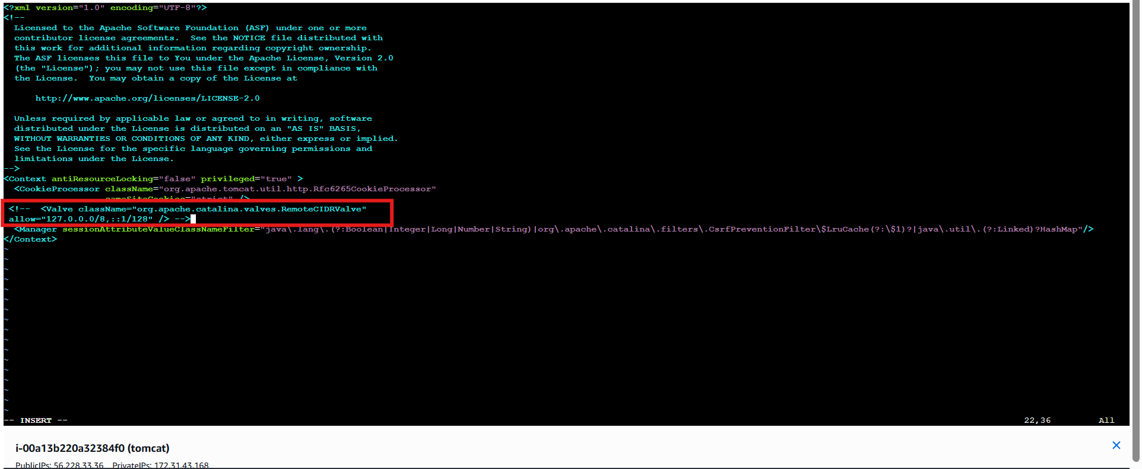

* Opened:
* vi /opt/apache-tomcat-9.0.113/webapps/manager/META-INF/context.xml
* Manager app is required for **Deploy to container** plugin

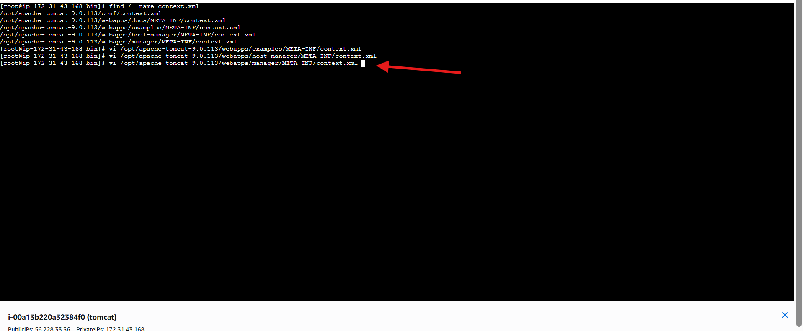

* Edited the valve to allow remote access:
* <!-- <Valve className="org.apache.catalina.valves.RemoteAddrValve"
* allow="127\.0\.0\.1|::1|.*" /> -->
* Saved the file.
* Jenkins can now deploy WAR files remotely.

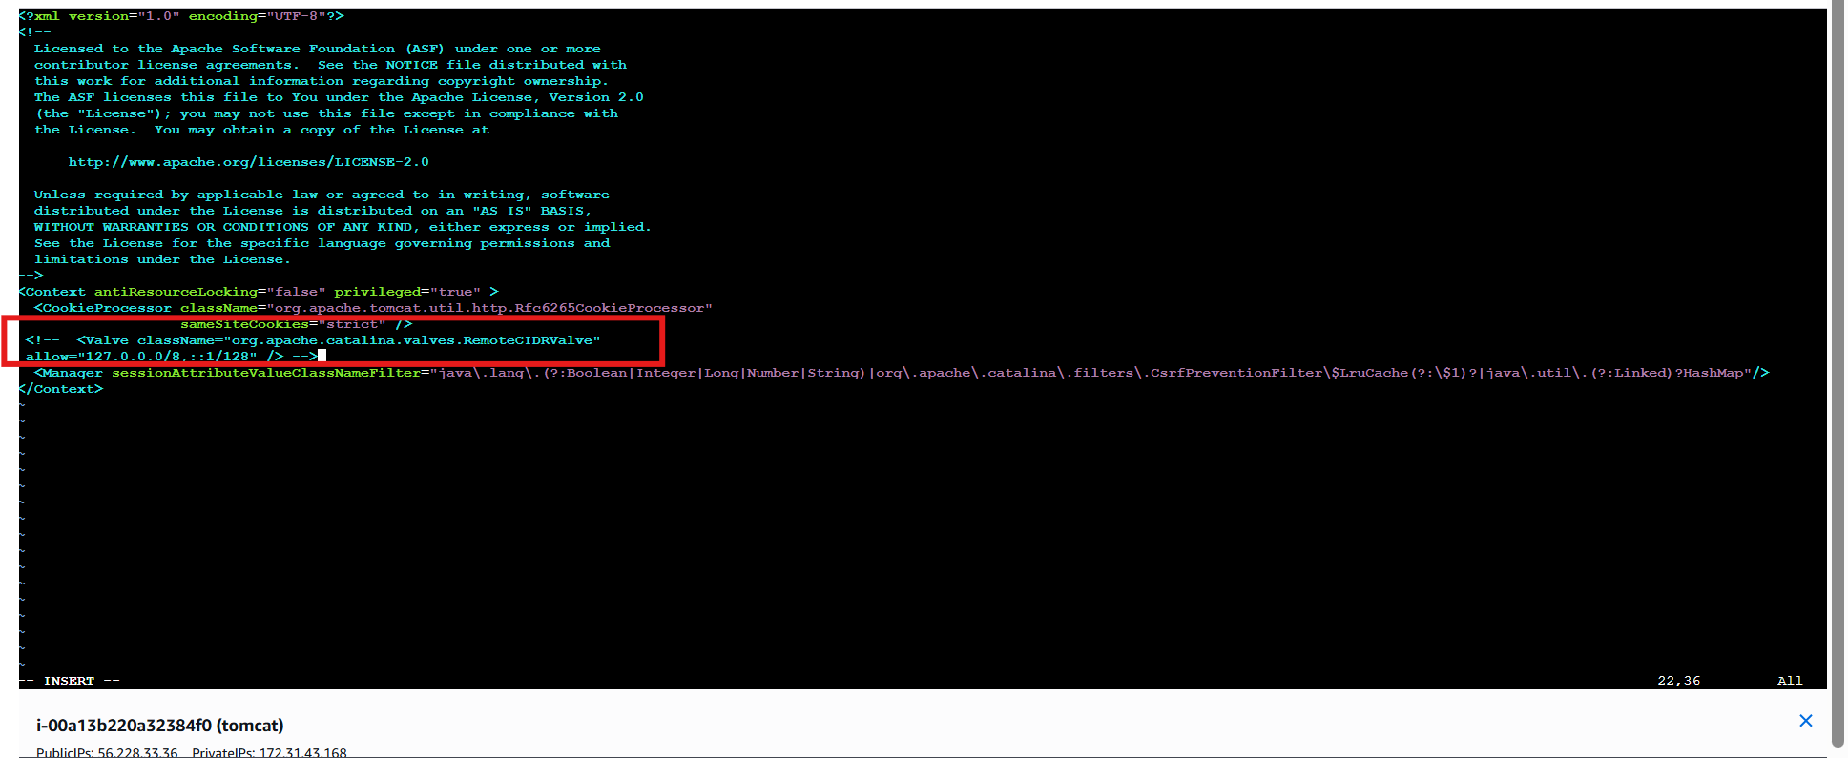

* Ran:
* cd /opt/apache-tomcat-9.0.113/conf
* ls
* Verified presence of:
  + server.xml
  + web.xml
  + tomcat-users.xml

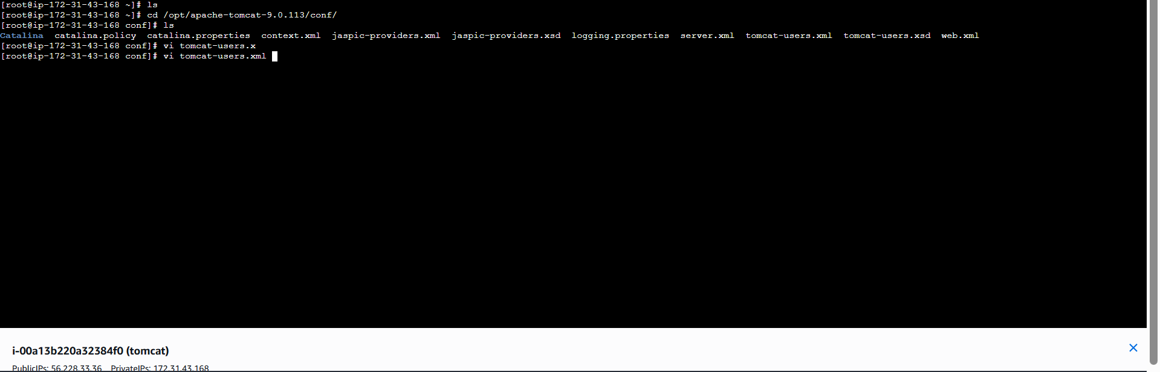

* Opened:
* vi tomcat-users.xml
* Prepared to configure users and roles for manager access.
* Added roles:
* <role rolename="manager-gui"/>
* <role rolename="manager-script"/>
* <role rolename="manager-status"/>
* Added user for Jenkins:
* <user username="deployer" password="deployer"
* roles="manager-gui,manager-script,manager-status"/>
* Saved the file.

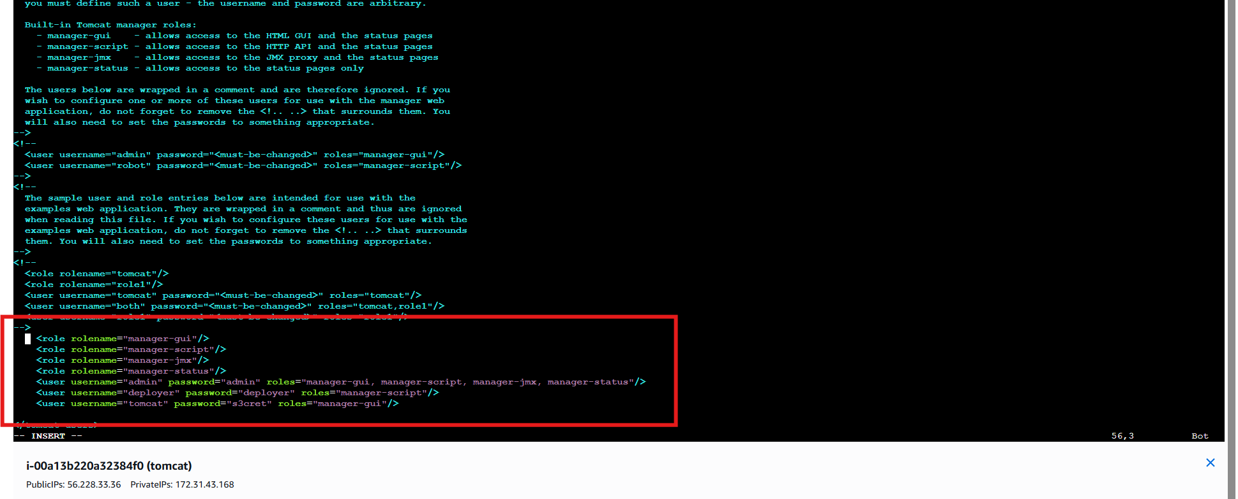

* Restarted Tomcat to apply changes:
* cd /opt/apache-tomcat-9.0.113/bin
* ./shutdown.sh
* ./startup.sh
* Tomcat started successfully with updated access rules

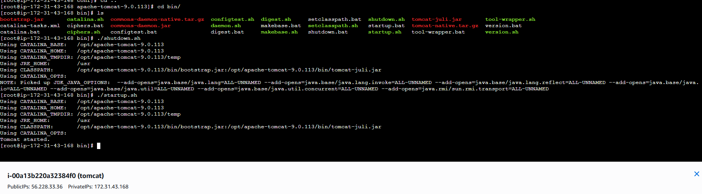

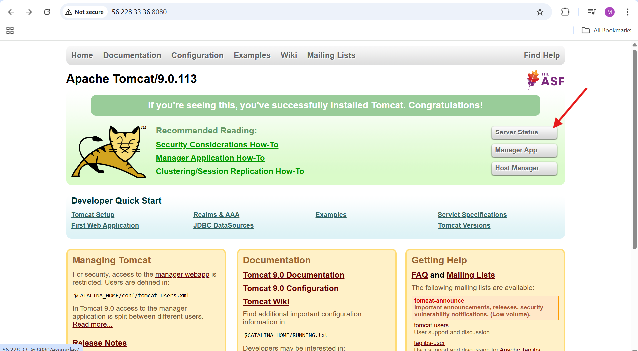

**Open Tomcat Server Status**

* Click **Server Status** on Tomcat home page
* Browser redirects to:

http://56.228.33.36:8080/manager/status

* Enter credentials:
* Username: deployer
* Password: deployer
* Login successful

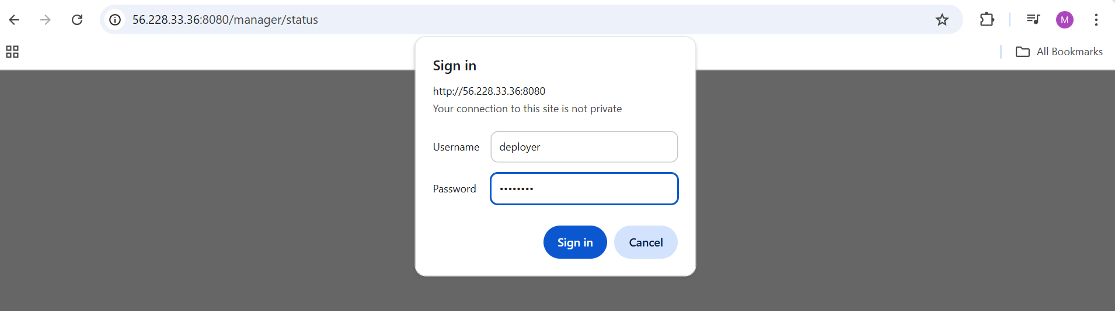

* Server Status page loads with JVM and memory details

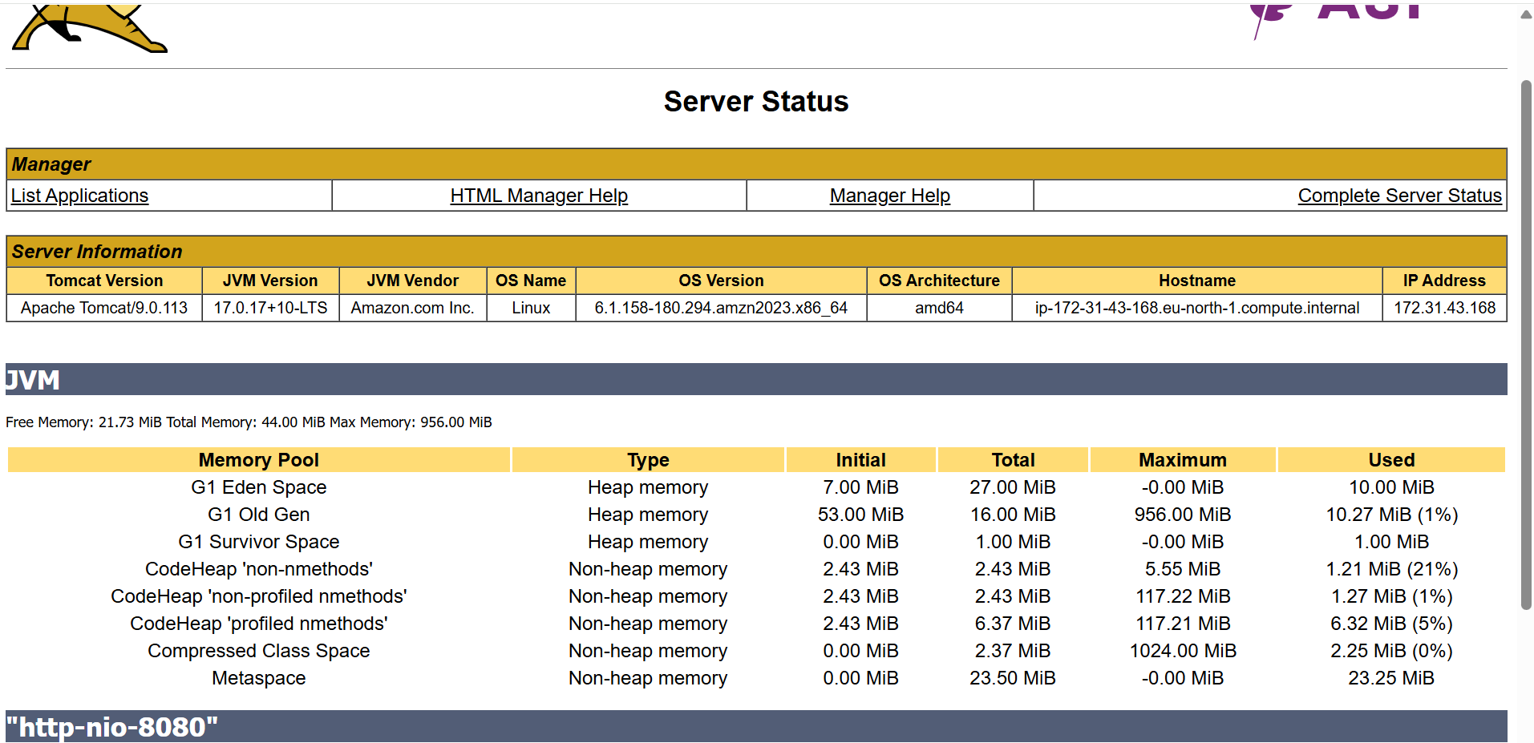

* Open Jenkins dashboard
* Select job **BETAWINS-HIRING-APP**
* Click **Configure**
* Scroll to **Post-build Actions**
* Click **Add post-build action**
* Select **Deploy war/ear to a container**
* In **WAR/EAR files** field, enter:**/*.war
* Under **Containers**
* Click **Add Container**
* Select **Tomcat 9.x Remote**

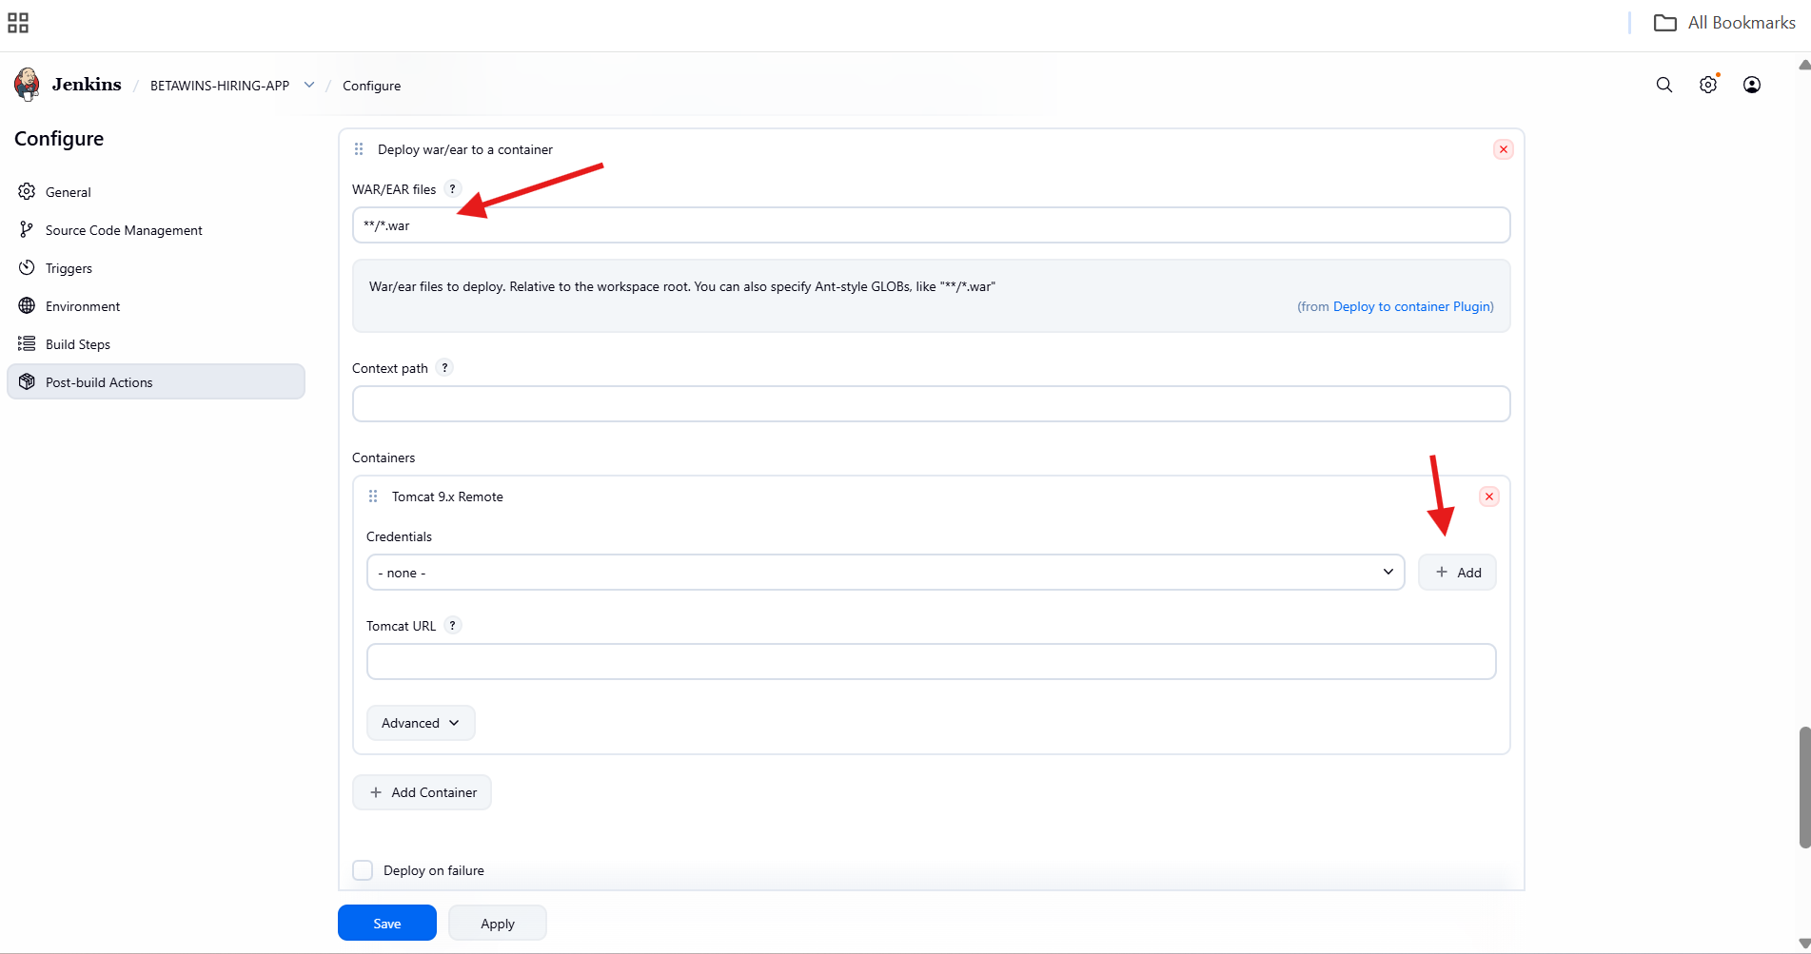

* Click **Add → Jenkins**
* Select **Username with password**
* Enter:
  + Username: deployer
  + Password: deployer
  + ID: tomcat_credentials
  + Description: tomcat_credentials
* Click **Add**
* Select this credential in container configuration

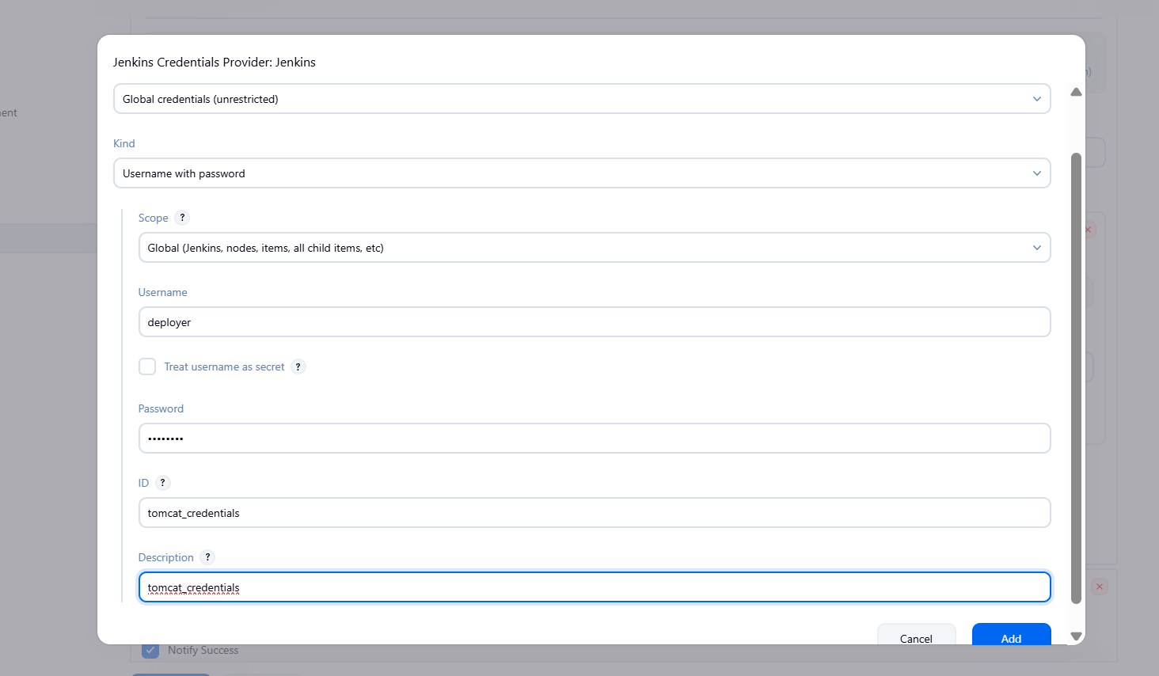

* In **Tomcat URL**, enter:

http://56.228.33.36:8080

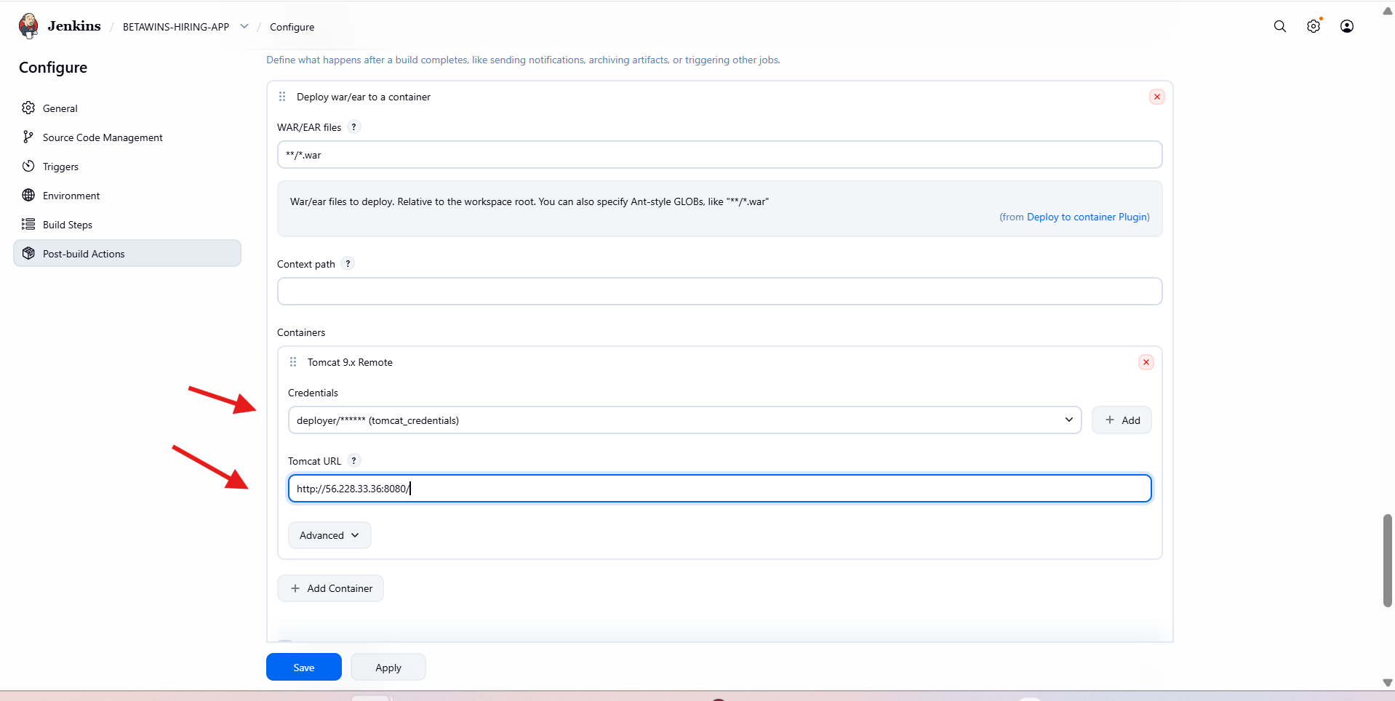

* Click **Build Now**
* Build starts successfully
* Build **#6** shows **SUCCESS**

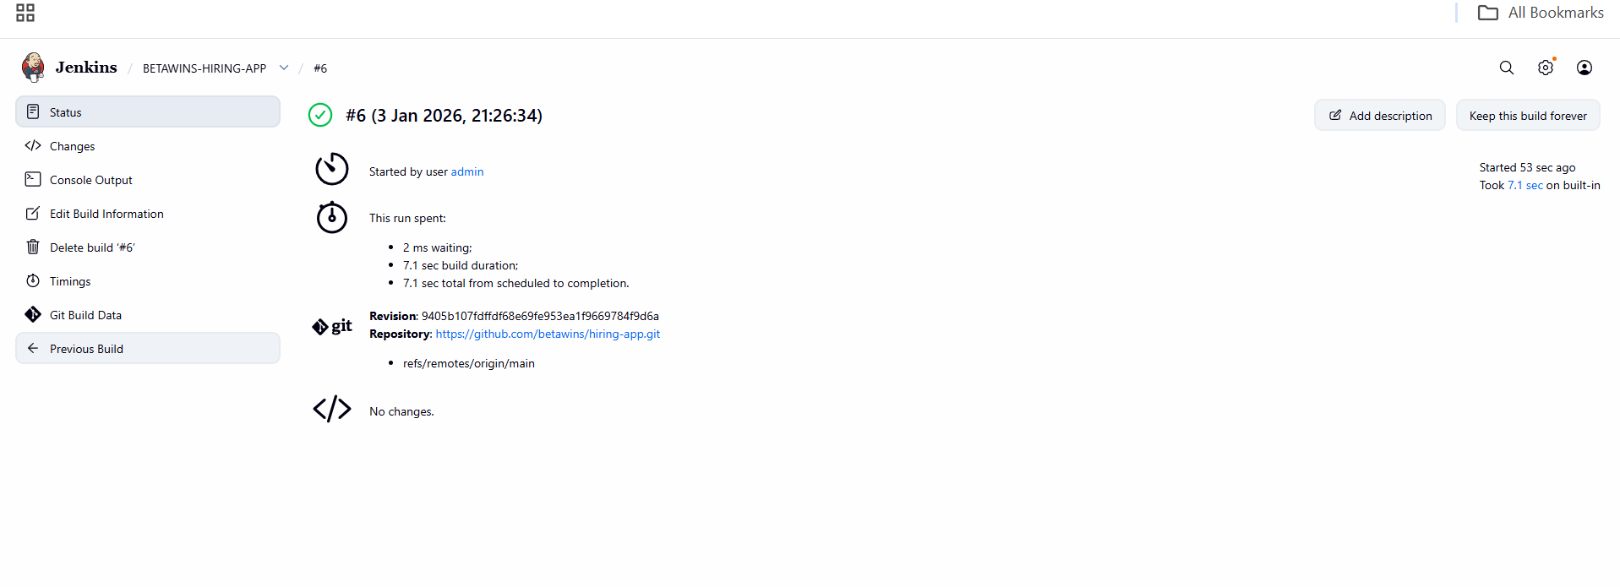

* Console output confirms:
* WAR built successfully
* WAR uploaded
* WAR deployed to Tomcat

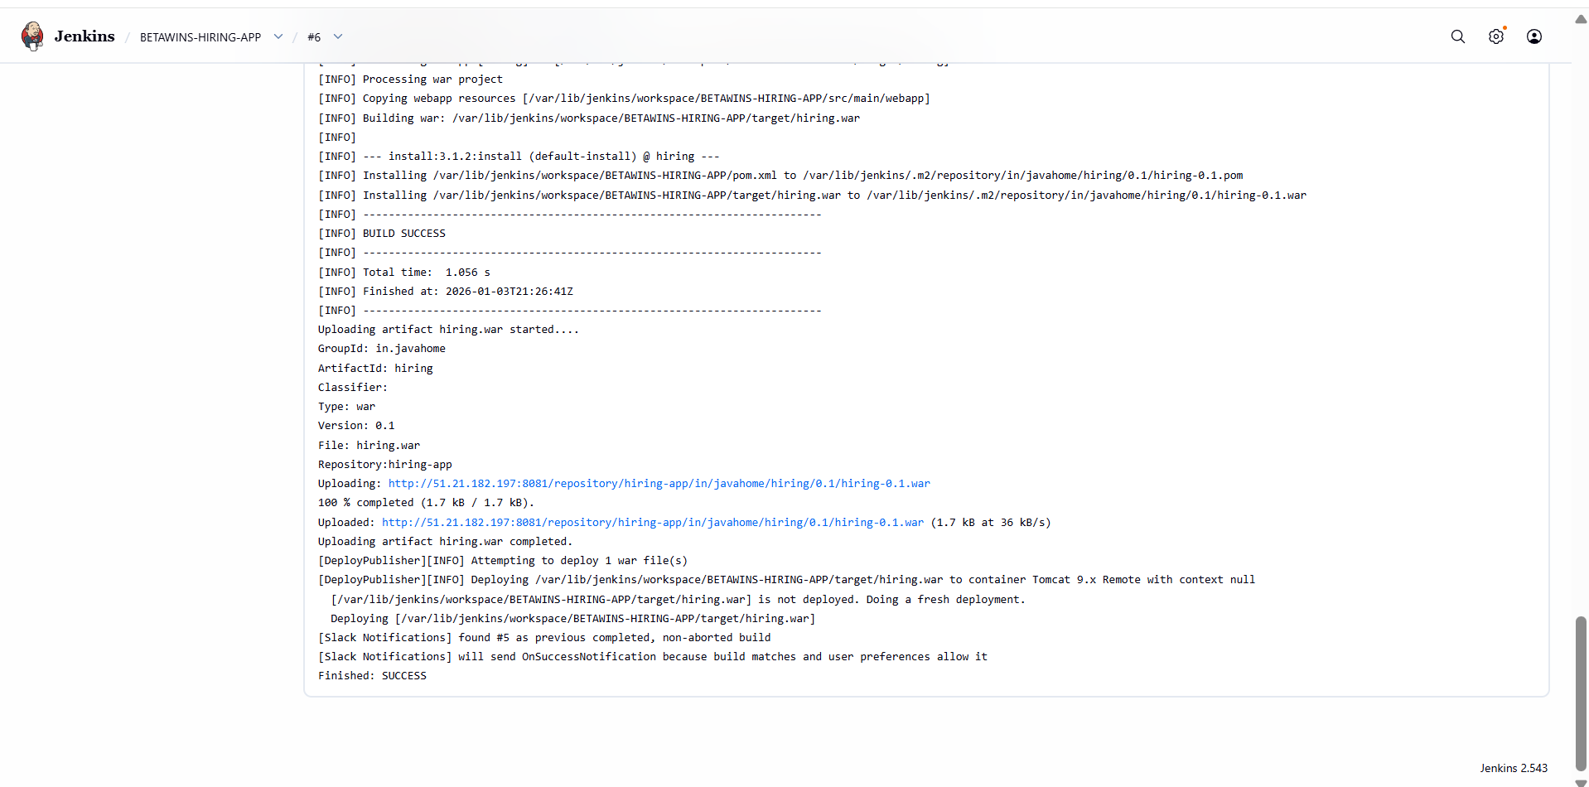

**Verify WAR Deployment on Server**

* SSH into Tomcat server

cd /opt/apache-tomcat-9.0.113/webapps

ls

* hiring folder and hiring.war are present



**Access Deployed Application**

* Open browser

<http://56.228.33.36:8080/hiring>

**Verify Application Output**

* Page displays:

Welcome to Techie Horizon

* Deployment confirmed successful

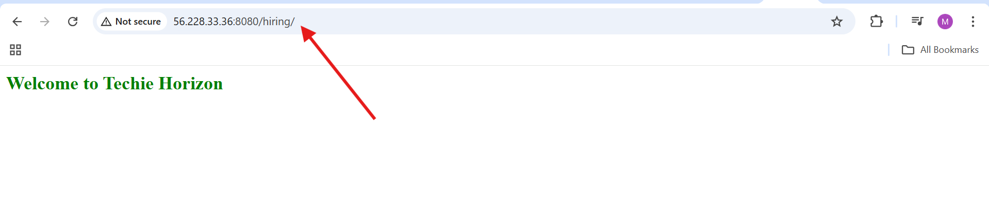

* Slack integration also succesfull

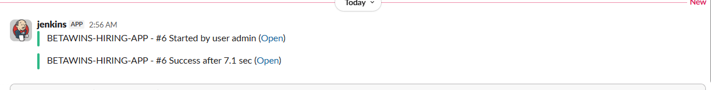

1. Setup a Jenkins CICD pipeline using Declarative pipeline using feature-1.1 branch. <https://github.com/betawins/sabear_simplecutomerapp/tree/feature-1.1>  
   stages:  
   Git Clone  
   SonarQube Integration  
   Maven Compilation  
   Nexus Artifactory  
   Slack Notification  
   Deploy On tomcat

* Opened **Jenkins** dashboard
* Clicked **New Item**
* Entered job name: **SIMPLECUSTOMERAPP**
* Selected **Pipeline** as the job type
* Clicked **OK**

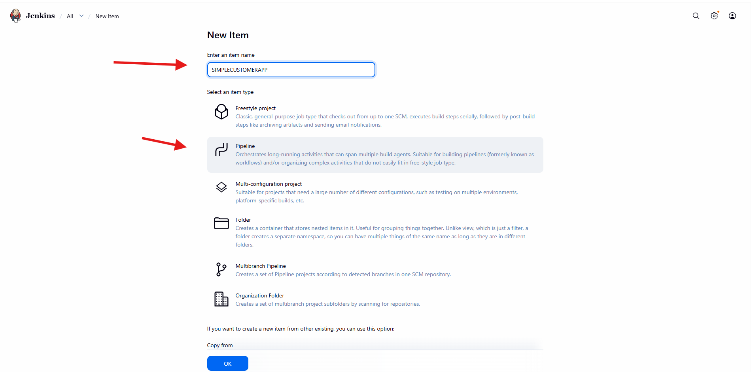

* Opened job **Configure**
* Navigated to **Pipeline** section
* Selected **Pipeline script**
* Added basic pipeline code with:
* agent any
* Single stage **Git Clone**
* GitHub repository URL
* Clicked **Save**

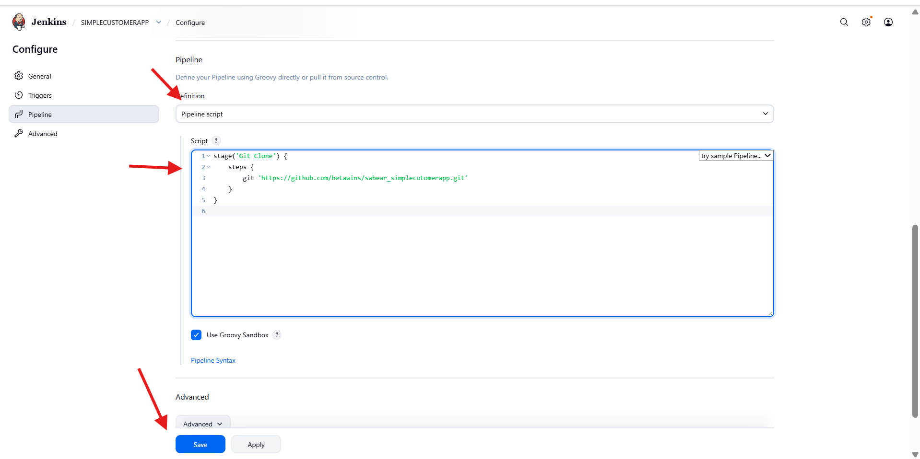

* Clicked **Build Now**
* Pipeline executed **Git Clone** stage
* Build **failed**

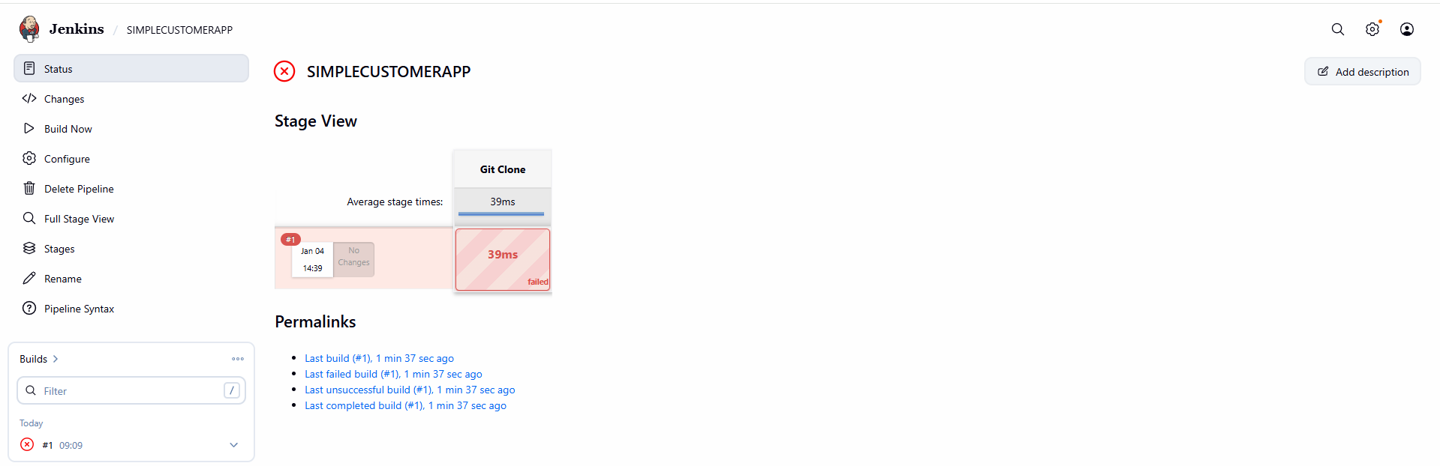

* Opened **Configure → Pipeline**
* Reviewed the Jenkinsfile syntax
* Ensured:
  + Proper pipeline {} block
  + Correct stages and steps
* Saved the corrected pipeline

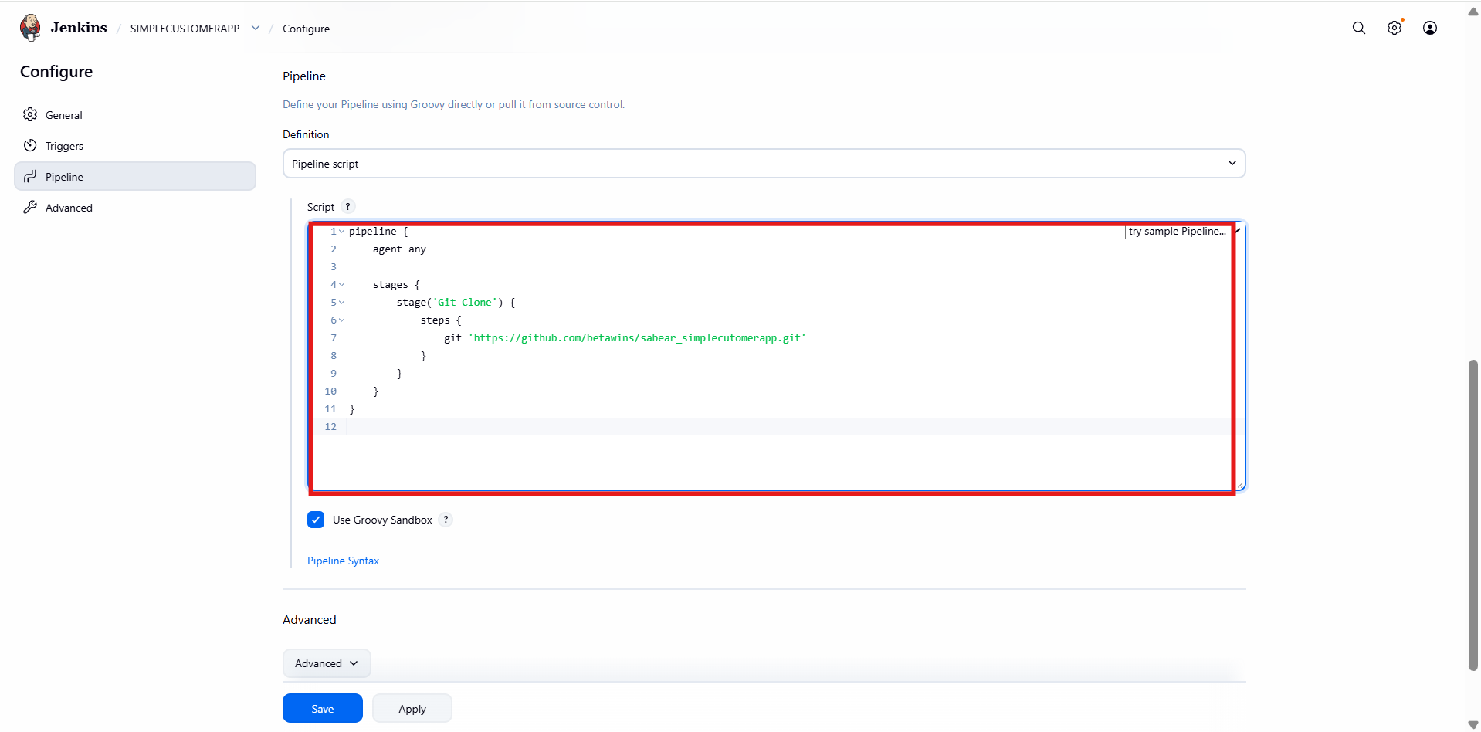

* Triggered **Build Now** again
* **Git Clone** stage executed successfully

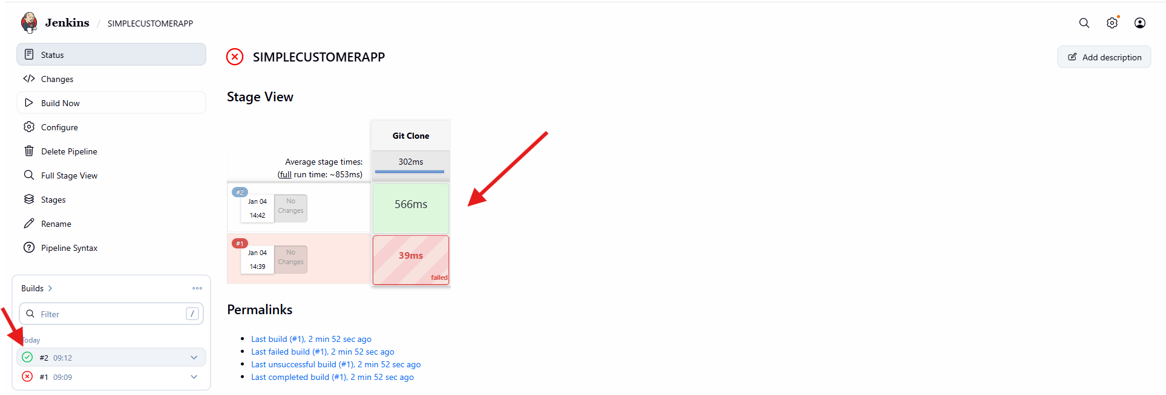

* Updated pipeline to include **SonarQube Analysis** stage
* Used:
  + withSonarQubeEnv('sonarqube-server')
  + Maven command with Sonar parameters
* Saved pipeline configuration

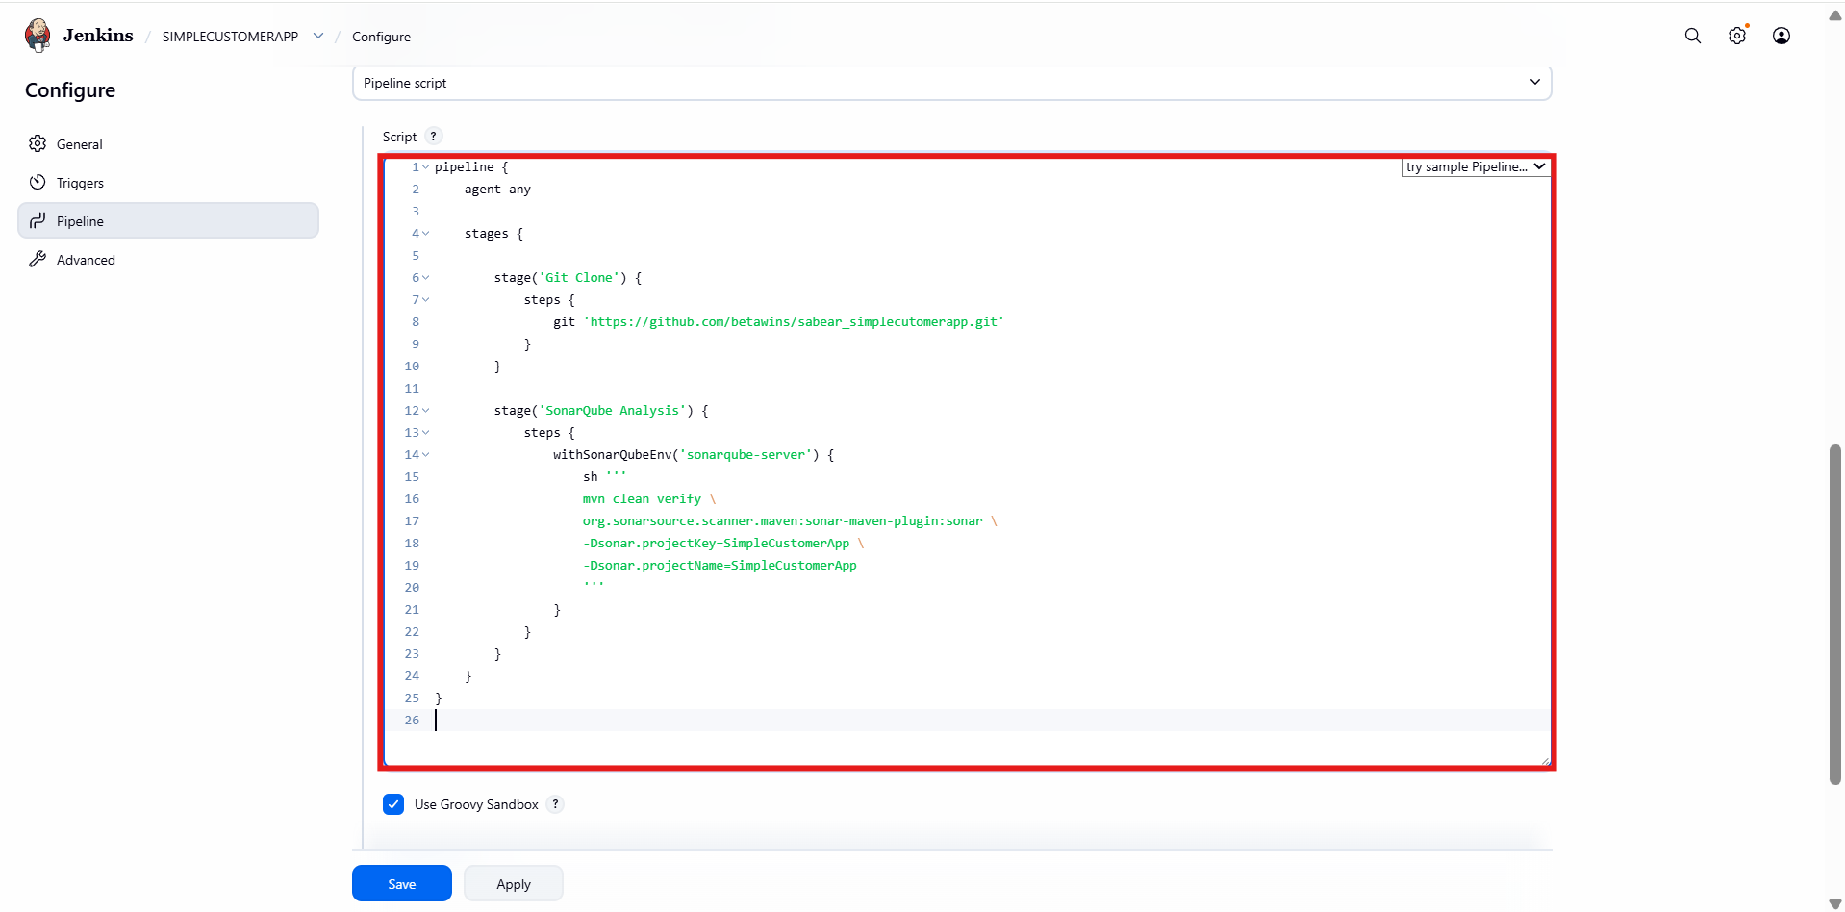

* Pipeline started successfully
* **Git Clone** stage passed
* **SonarQube Analysis** stage failed
* Error highlighted in red in stage view

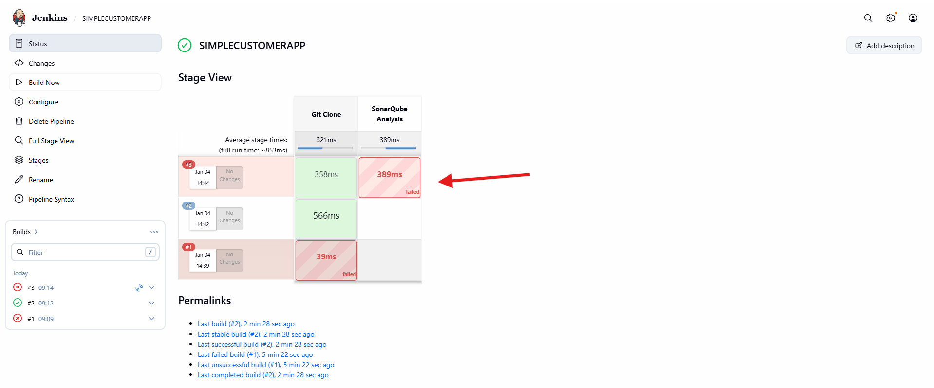

* Added **tools** section:
  + Maven configured
* Added **environment variables**
* Ensured:
  + SonarQube server name is correct
  + PATH is properly set
* Saved configuration

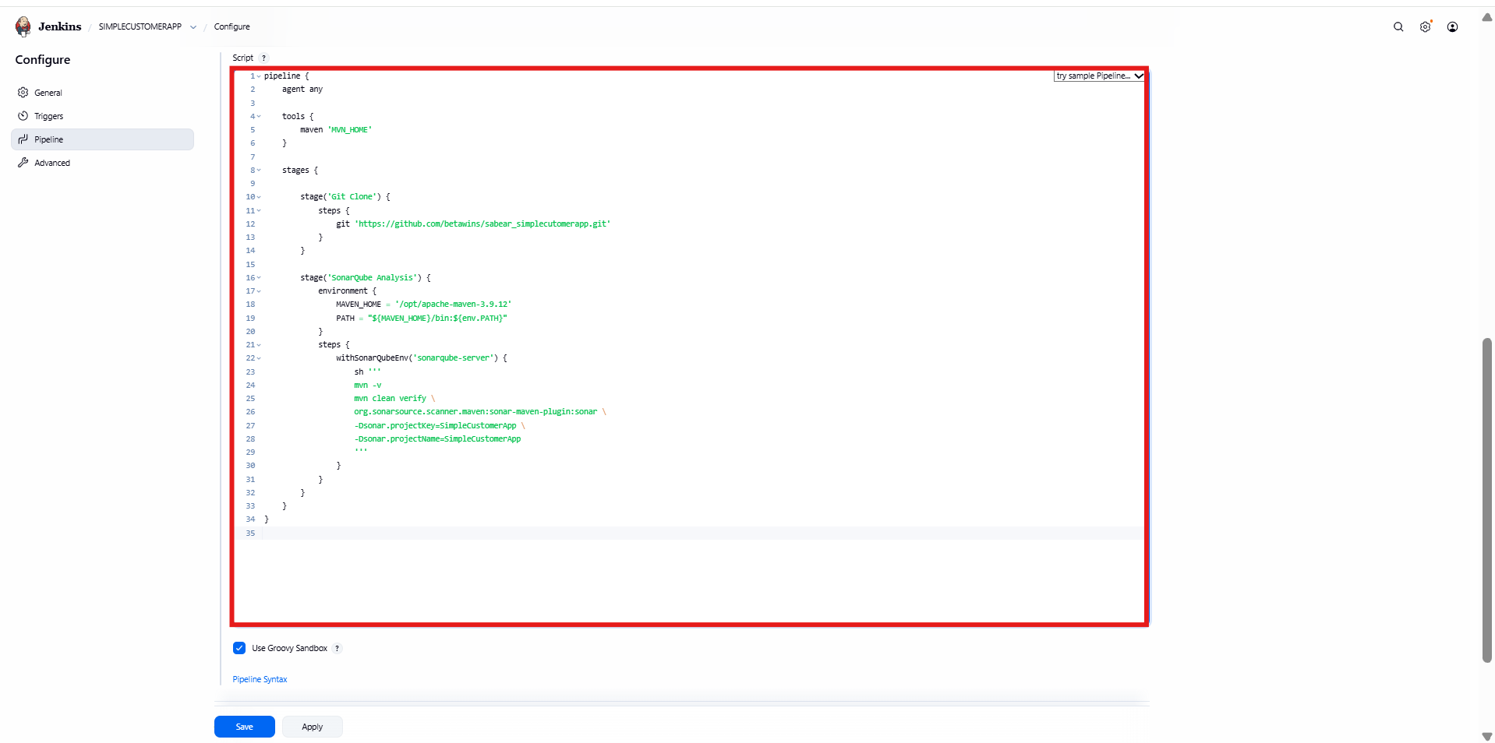

* Pipeline executed all stages:
* Declarative Tool Install
* Git Clone
* SonarQube Analysis
* All stages turned **green**
* Build marked **SUCCESS**

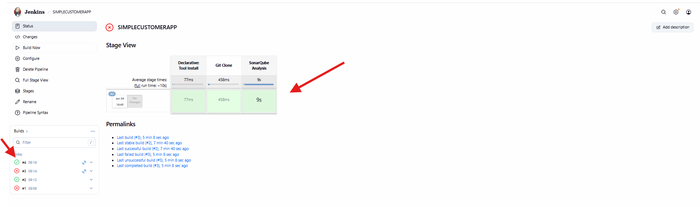

* Logged into **SonarQube**
* Project **sabear_simplecustomerapp** created automatically
* Quality Gate status: **PASSED**
* Bugs, vulnerabilities, and code smells analyzed successfully

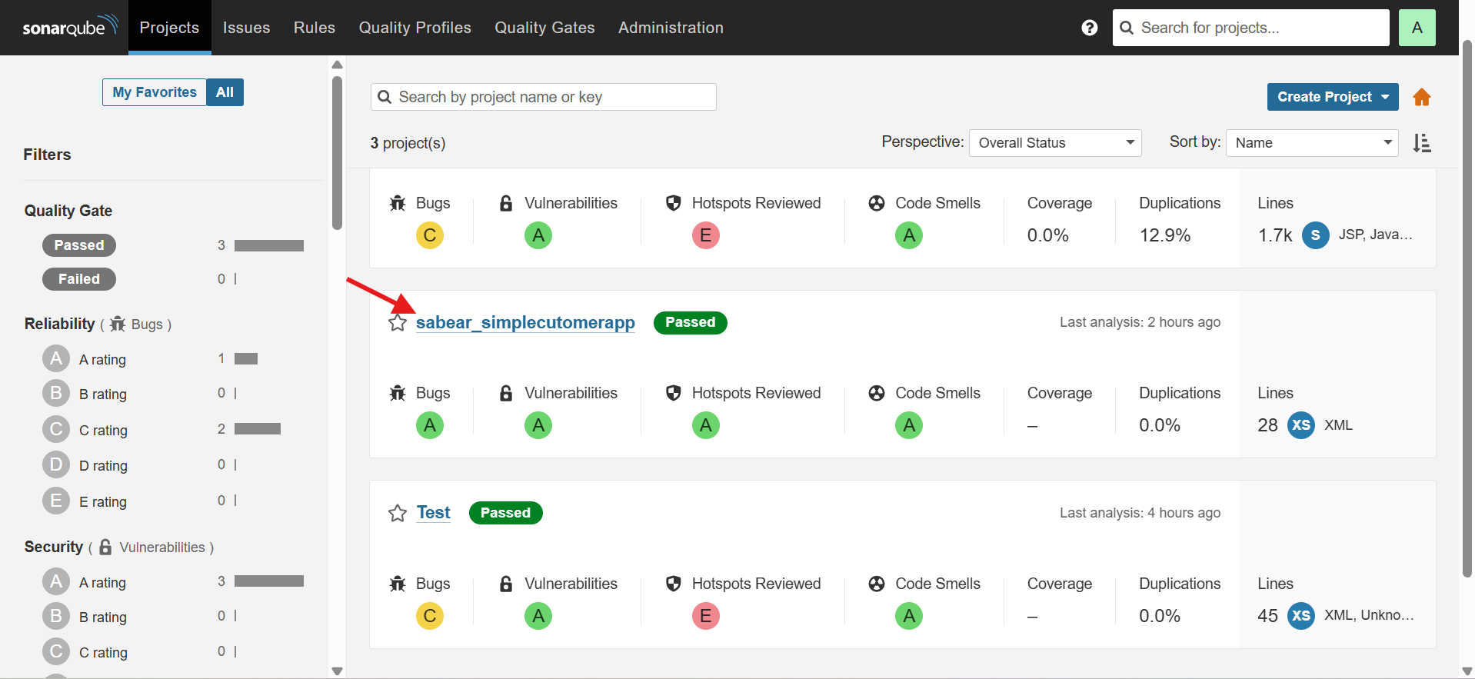

Opened **Jenkins → Job → Configure**

Defined a **Declarative Pipeline**

Added agent any

Configured **environment variables**:

* Maven home
* PATH
* Sonar project key and name

Defined stages:

* Git Clone
* SonarQube Analysis
* Maven Build

Saved the pipeline configuration

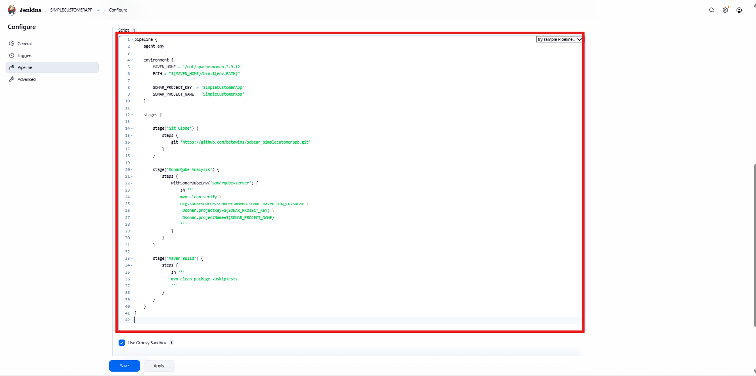

* Triggered **Build Now**
* Pipeline executed stages:
  + Git Clone
  + SonarQube Analysis
  + Maven Build
* All stages completed successfully (green)
* SonarQube Quality Gate shows **Passed**

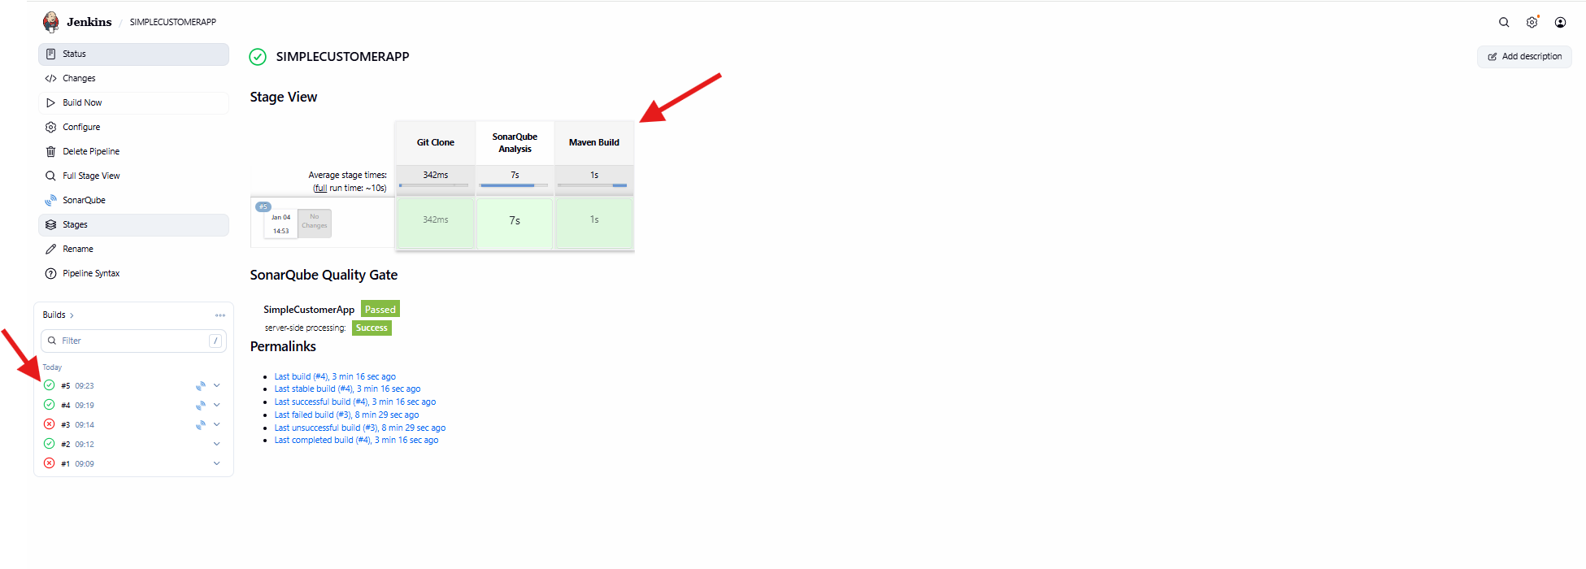

* Added new stage: **Nexus Upload**
* Used script {} block
* Captured generated artifact from target/
* Configured:
  + Group ID
  + Artifact ID
  + Version
  + Repository name
  + Nexus credentials
* Enabled artifact upload to Nexus Repository
* Saved pipeline

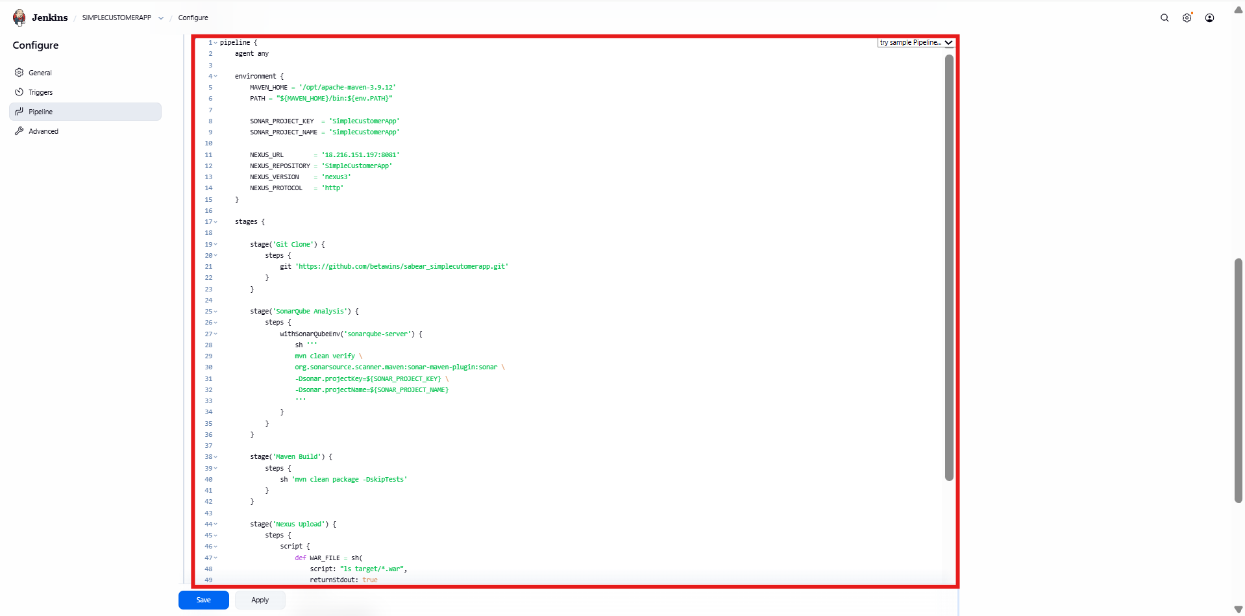

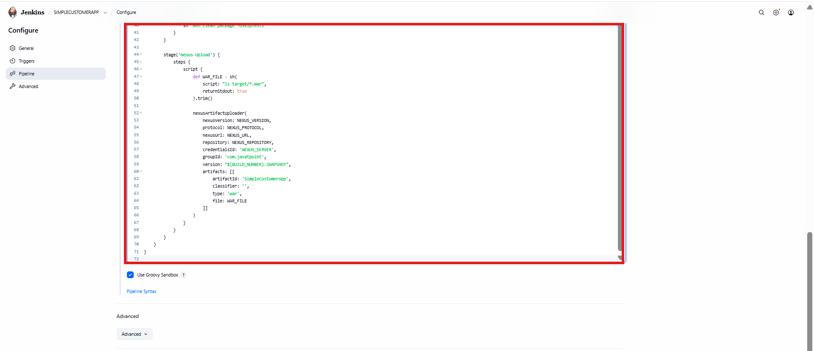

* Git Clone, SonarQube Analysis, Maven Build succeeded
* **Nexus Upload stage failed**
* Failure highlighted in red
* Indicates repository or credential issue

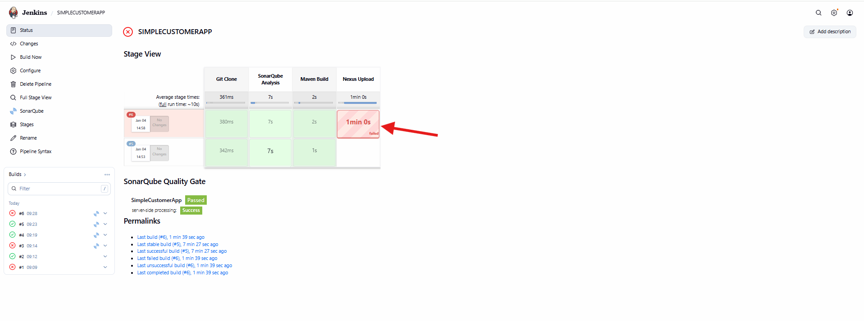

Logged into **Sonatype Nexus Repository Manager**

Opened **Settings**

Navigated to **Repository**

Selected **Repositories** section

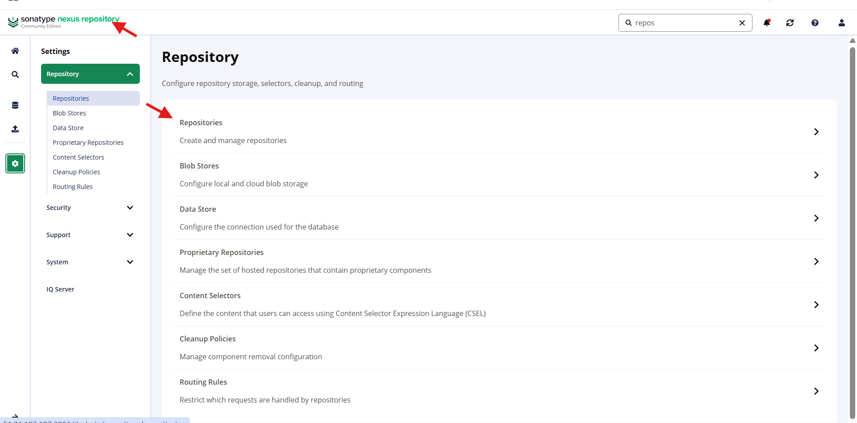

* Viewed list of existing repositories
* Clicked **Create repository**

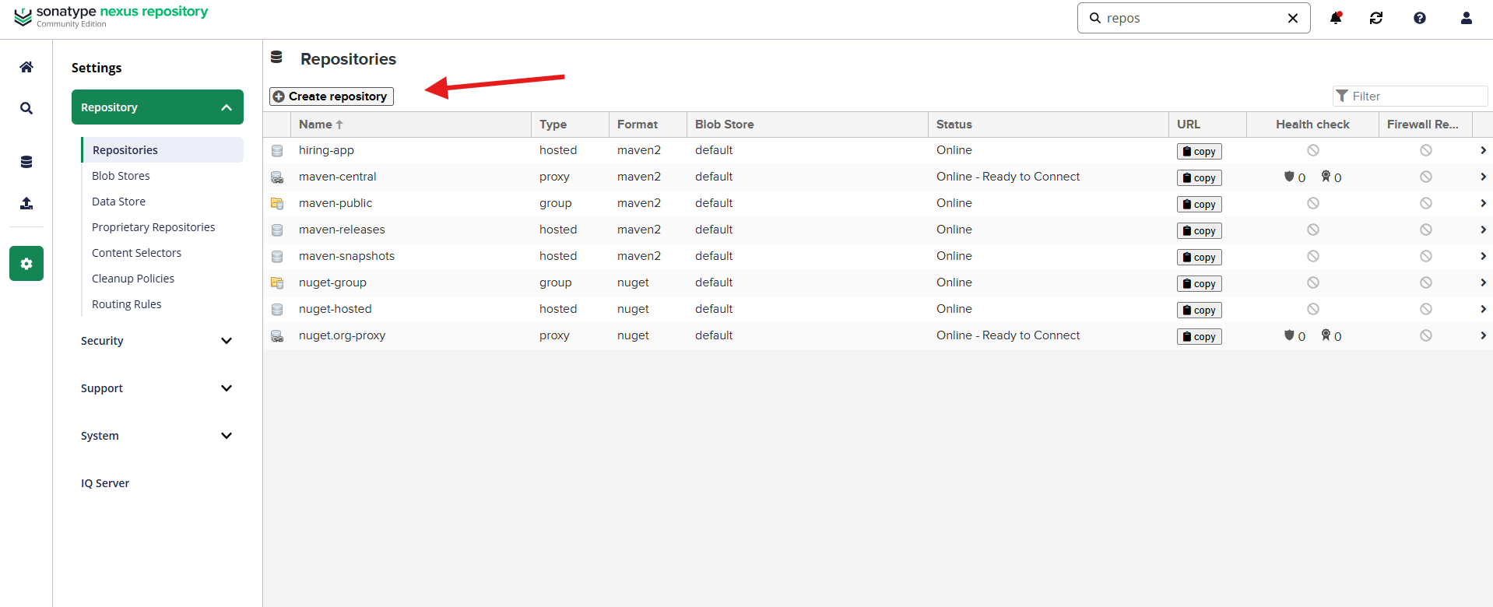

* Prepared to add a new hosted Maven repository
* Selected repository type: **maven2 (hosted)**
* Chosen for storing build artifacts
* Proceeded to repository configuration

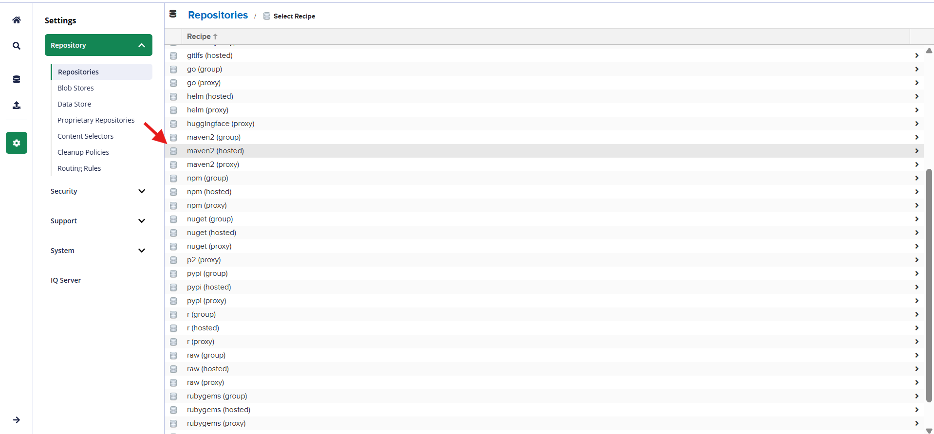

* Repository name: **SimpleCustomerApp**
* Version policy: **Snapshot**
* Layout policy: **Permissive**
* Blob store: **default**
* Deployment policy: **Allow redeploy**
* Saved repository configuration

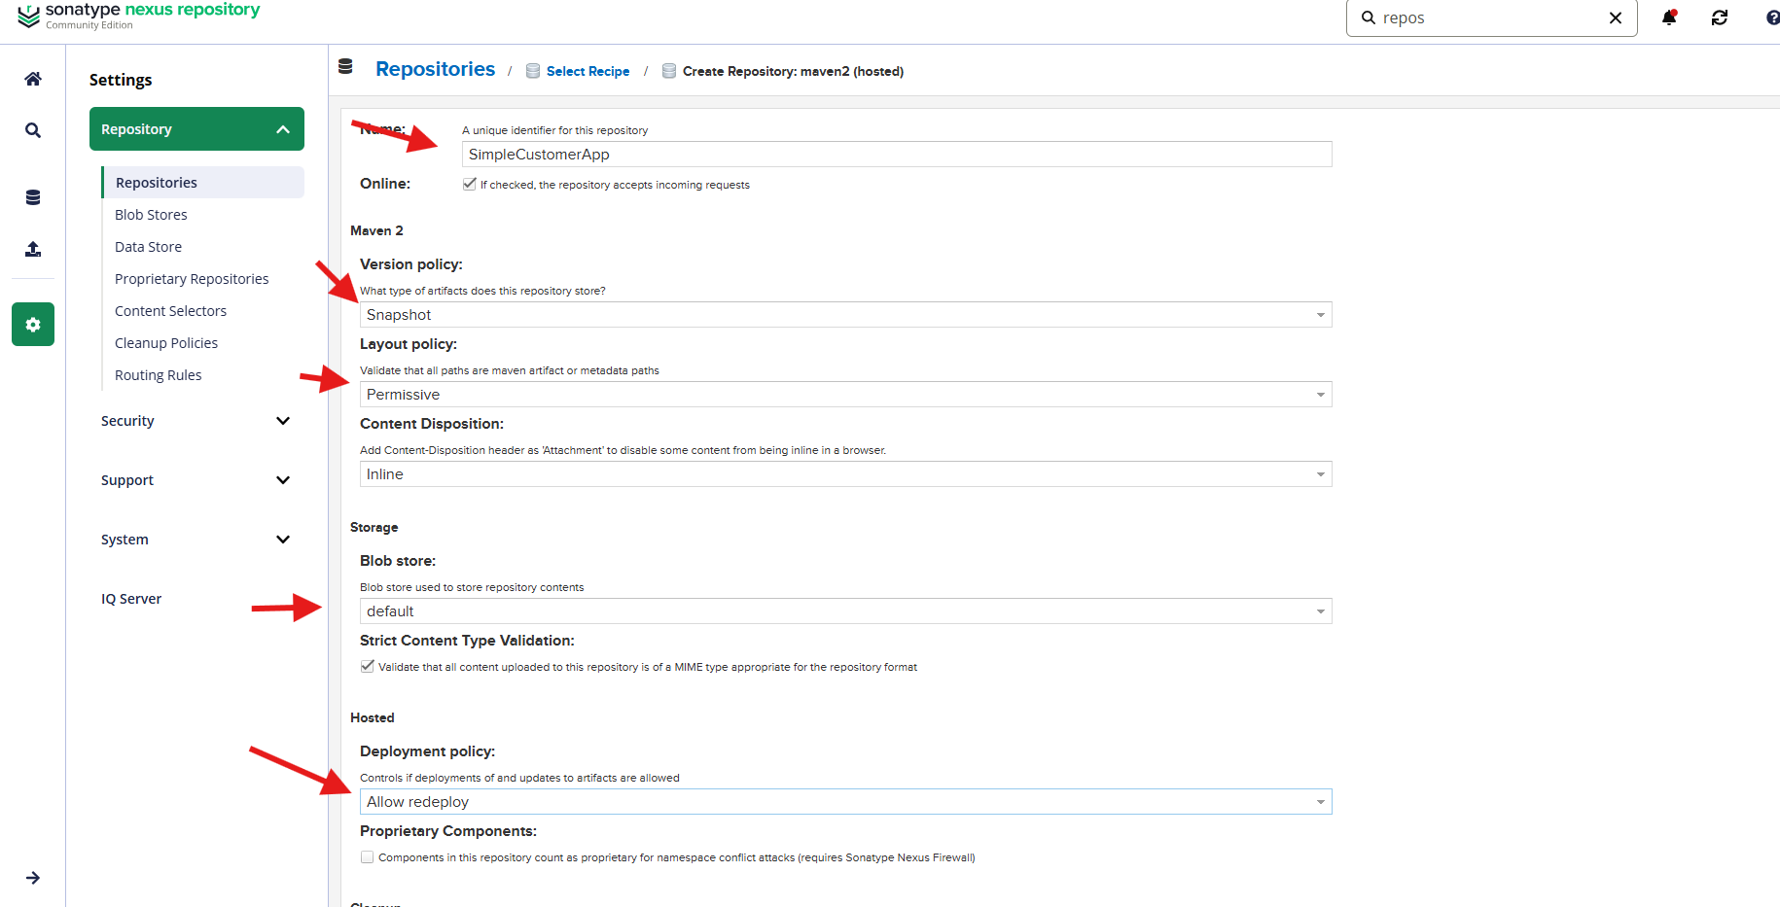

* Repository **SimpleCustomerApp** visible in repository list
* Status shows **Online**
* Repository URL generated
* Ready to accept artifacts from Jenkins

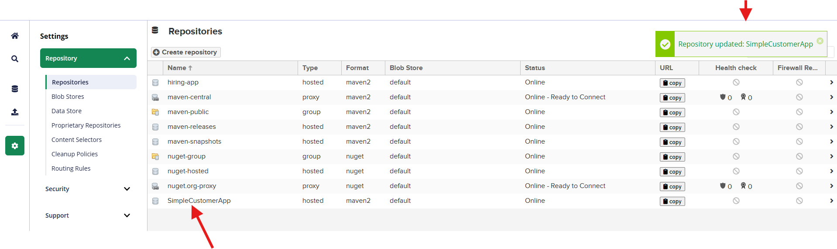

Pipeline stages executed:

* Git Clone
* SonarQube Analysis
* Maven Build
* **Nexus Upload stage succesfull**

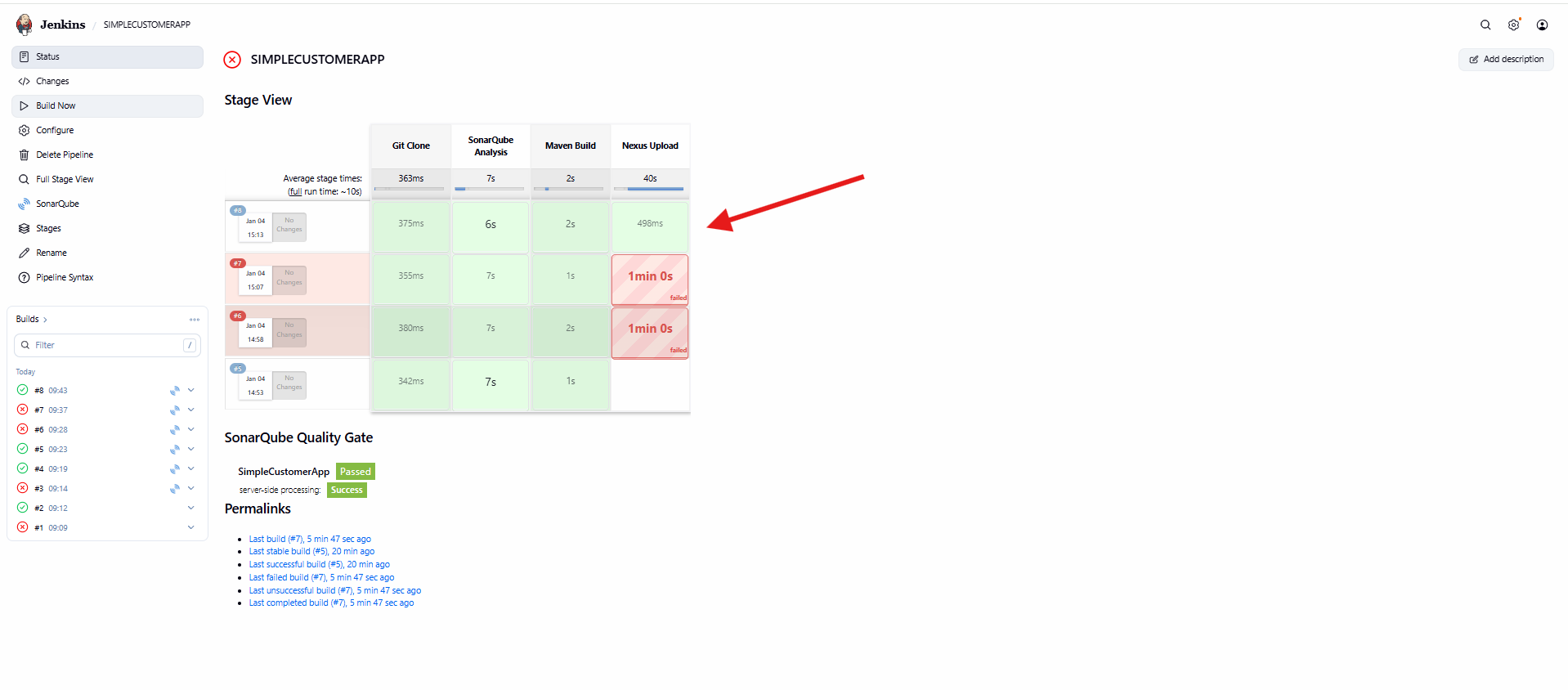

* Logged into **Sonatype Nexus Repository**
* Navigated to **Browse → SimpleCustomerApp**
* Snapshot artifacts visible:
  + Multiple *-SNAPSHOT versions
* Confirms artifacts are successfully stored in Nexus

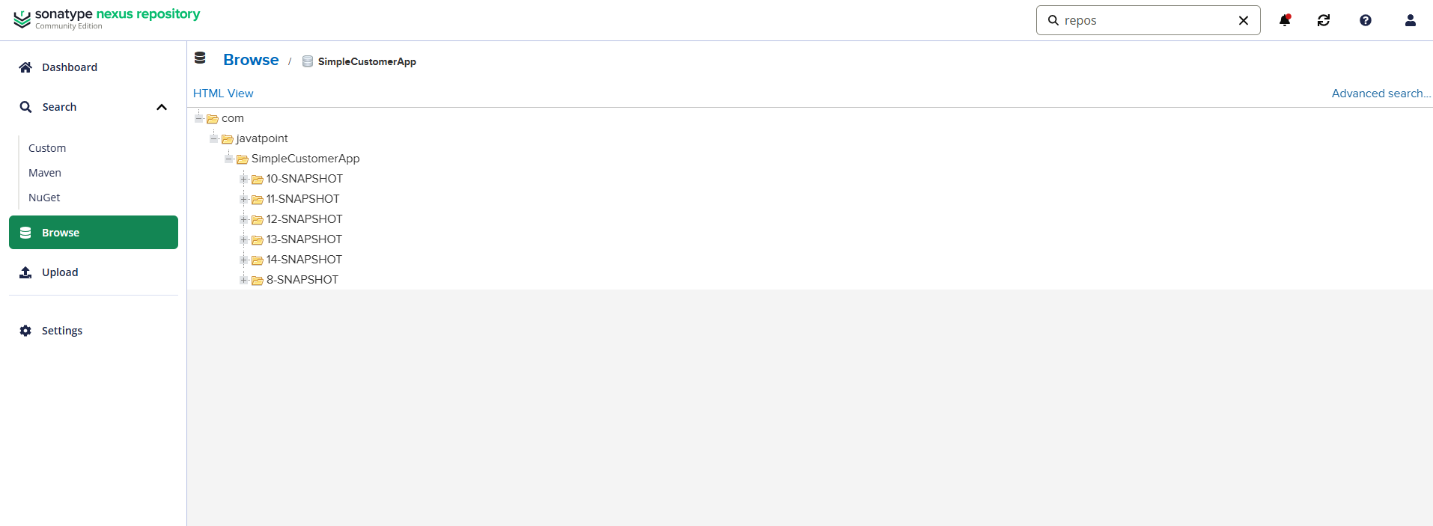

* Added post {} section in Jenkins pipeline
* Configured **Slack notifications**:
  + On **success**
  + On **failure**
* Messages include:
  + Job name
  + Build number
  + Build URL

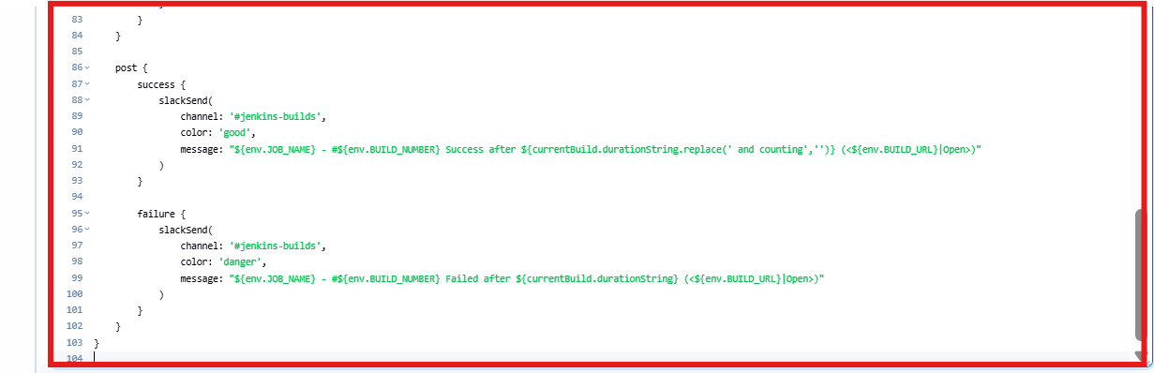

Pipeline stages now include:

* Notify Started
* Git Clone
* SonarQube Analysis
* Maven Build
* Nexus Upload
* Declarative: Post Actions

All stages completed successfully (green)

Slack notification triggered at the end

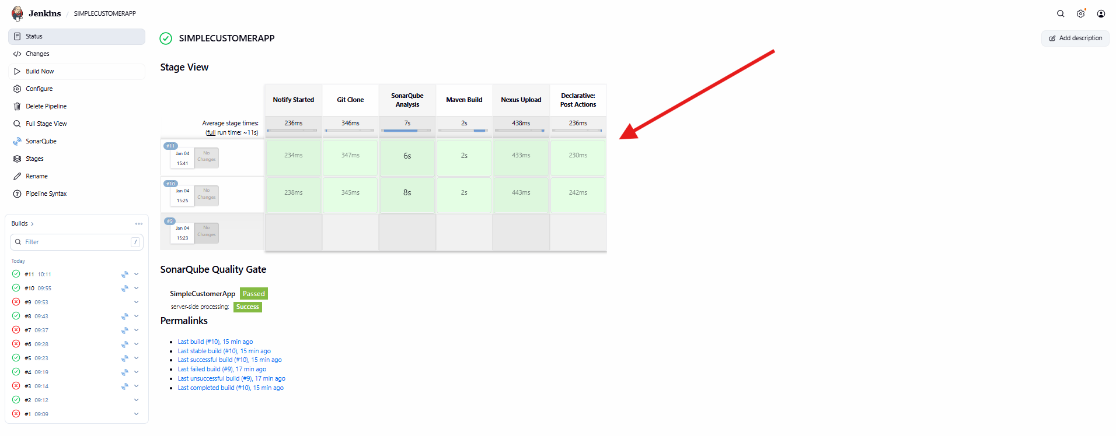

* Added new stage: **Deploy to Tomcat**
* Used shell/script block
* Prepared WAR file for deployment
* Stage added after Nexus Upload

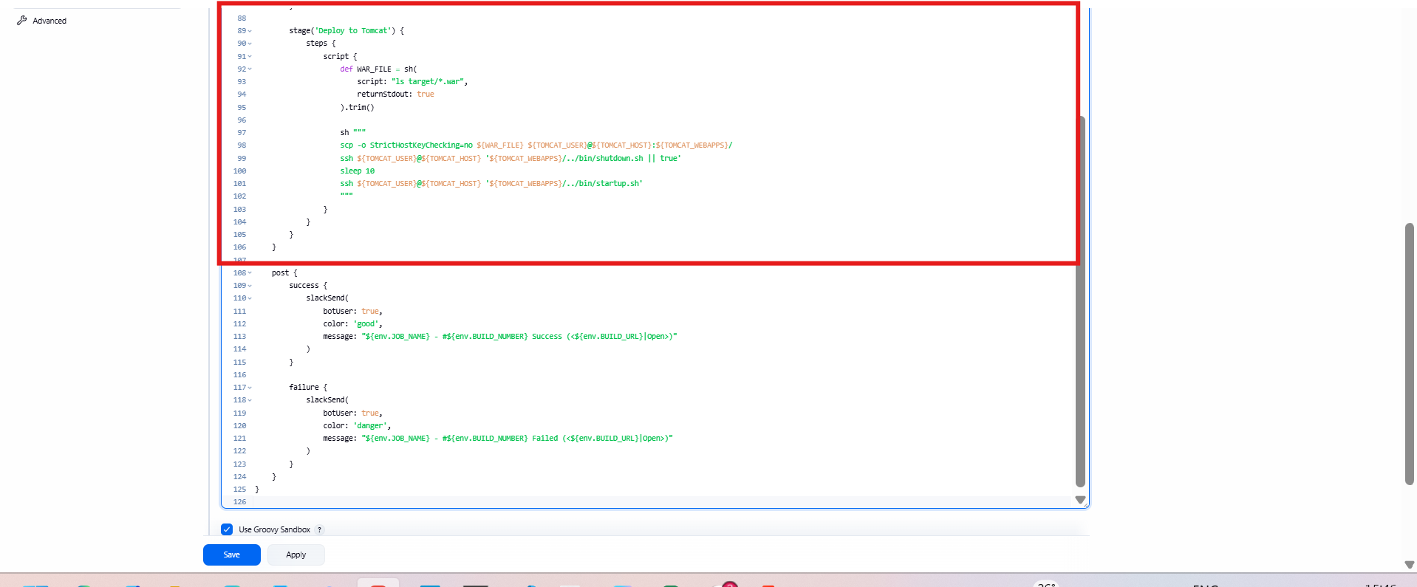

* Previous stages passed
* **Deploy to Tomcat stage failed** (red – ~652 ms)
* Indicates Tomcat URL or credentials issue

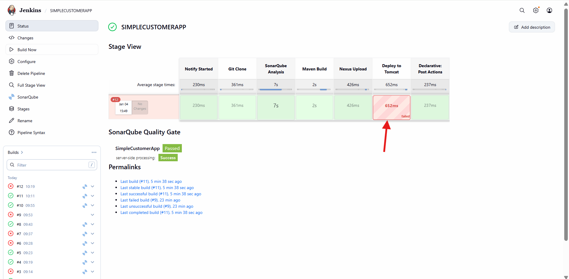

* Added environment variable:
  + TOMCAT_URL = http://<tomcat-ip>:8080
* Centralized Tomcat endpoint configuration
* Saved pipeline changes

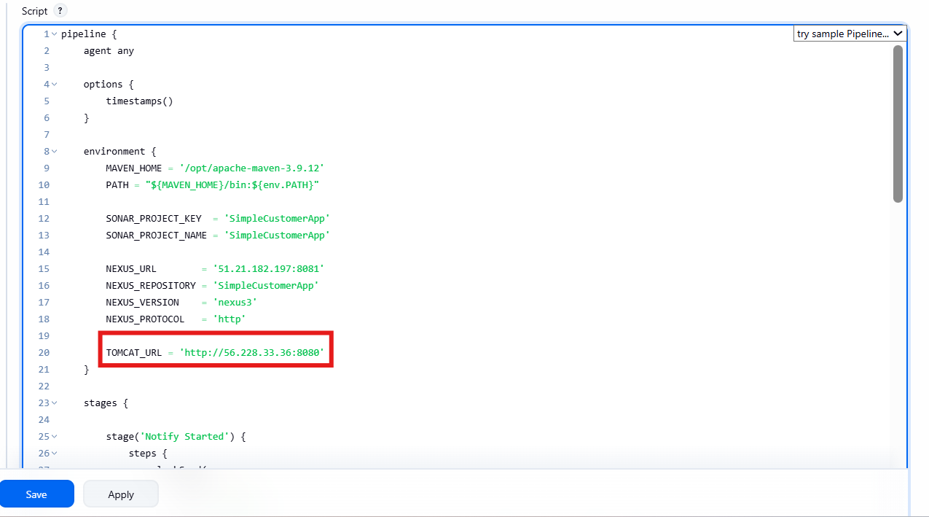

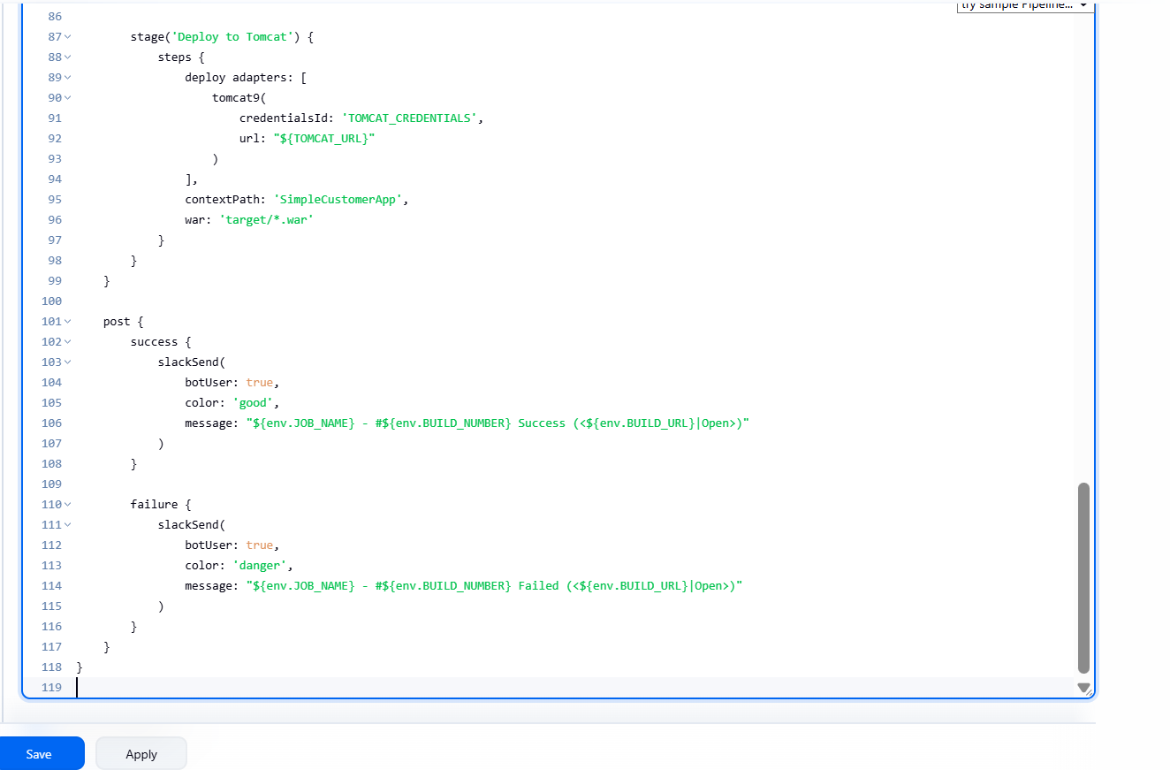

* Pipeline re-executed
* Deploy to Tomcat stage still failed
* Confirms issue not related to URL alone

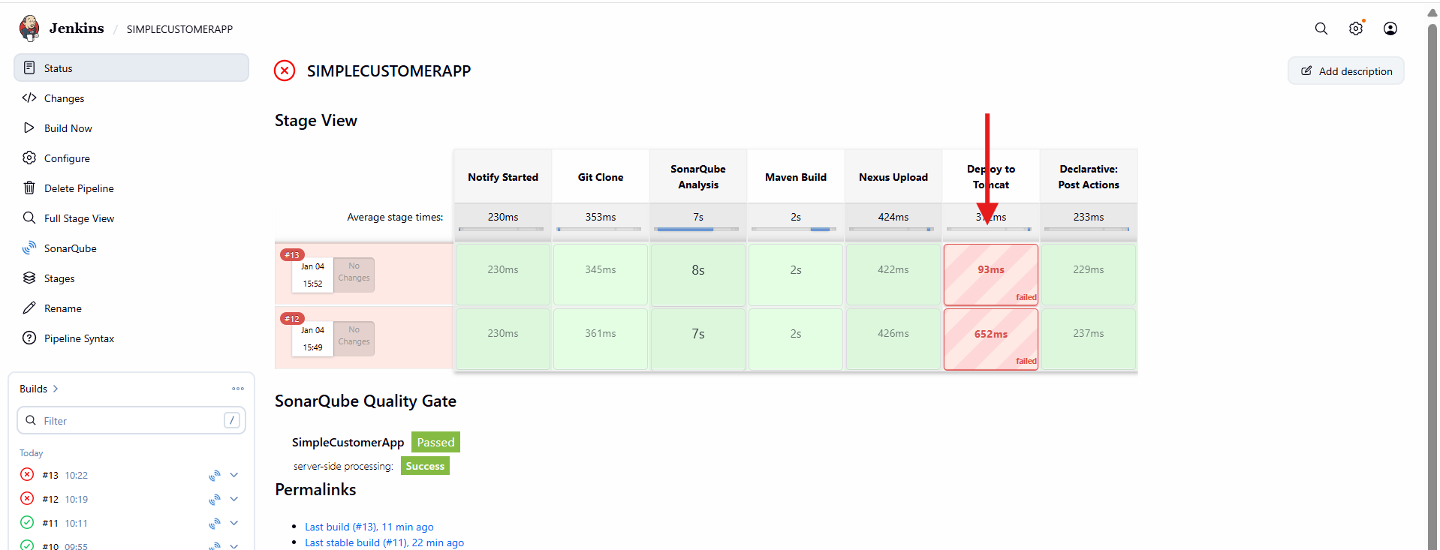

* Used deploy adapters block
* Selected **Tomcat adapter**
* Configured:
  + Credentials ID (Tomcat manager credentials)
  + URL using ${TOMCAT_URL}
  + Context path: SimpleCustomerApp
  + WAR file: target/*.war

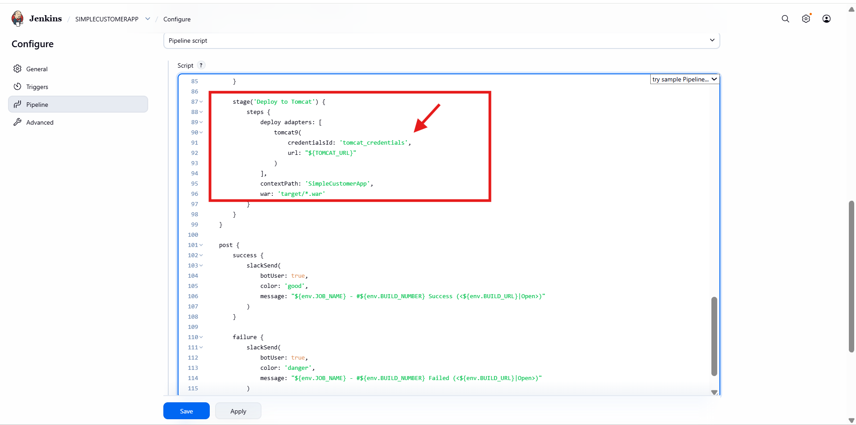

* Pipeline executed all stages successfully:
  + Notify Started
  + Git Clone
  + SonarQube Analysis
  + Maven Build
  + Nexus Upload
  + Deploy to Tomcat
  + Post Actions
* Build marked **SUCCESS**
* Application deployed to **Apache Tomcat**

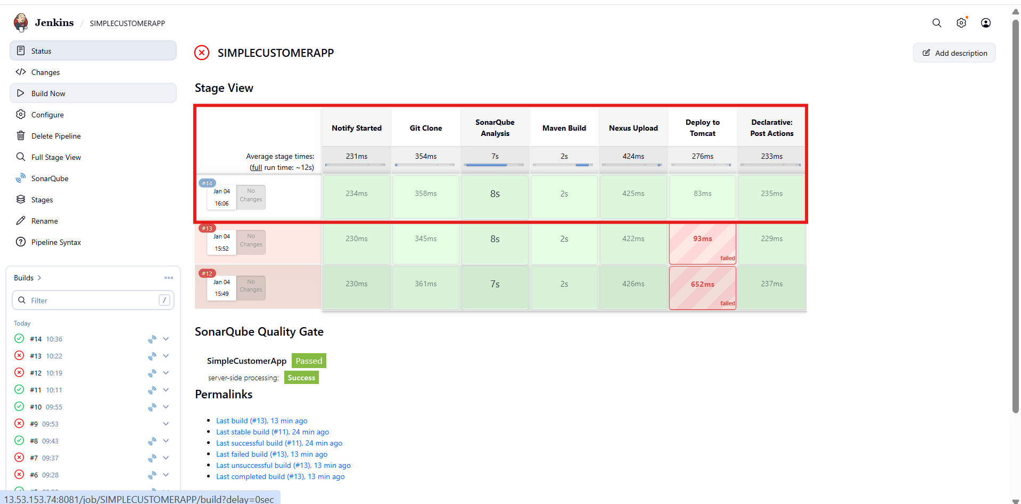

1. Setup a Jenkins CICD pipeline using Scripted pipeline using feature-1.1 branch. <https://github.com/betawins/sabear_simplecutomerapp/tree/feature-1.1>  
   stages:  
   Git Clone  
   SonarQube Integration  
   Maven Compilation  
   Nexus Artifactory  
   Slack Notification  
   Deploy On tomcat

* Opened **Jenkins → New Item**
* Entered job name: **scripted_pipeline**
* Selected **Pipeline**
* Clicked **Ok**

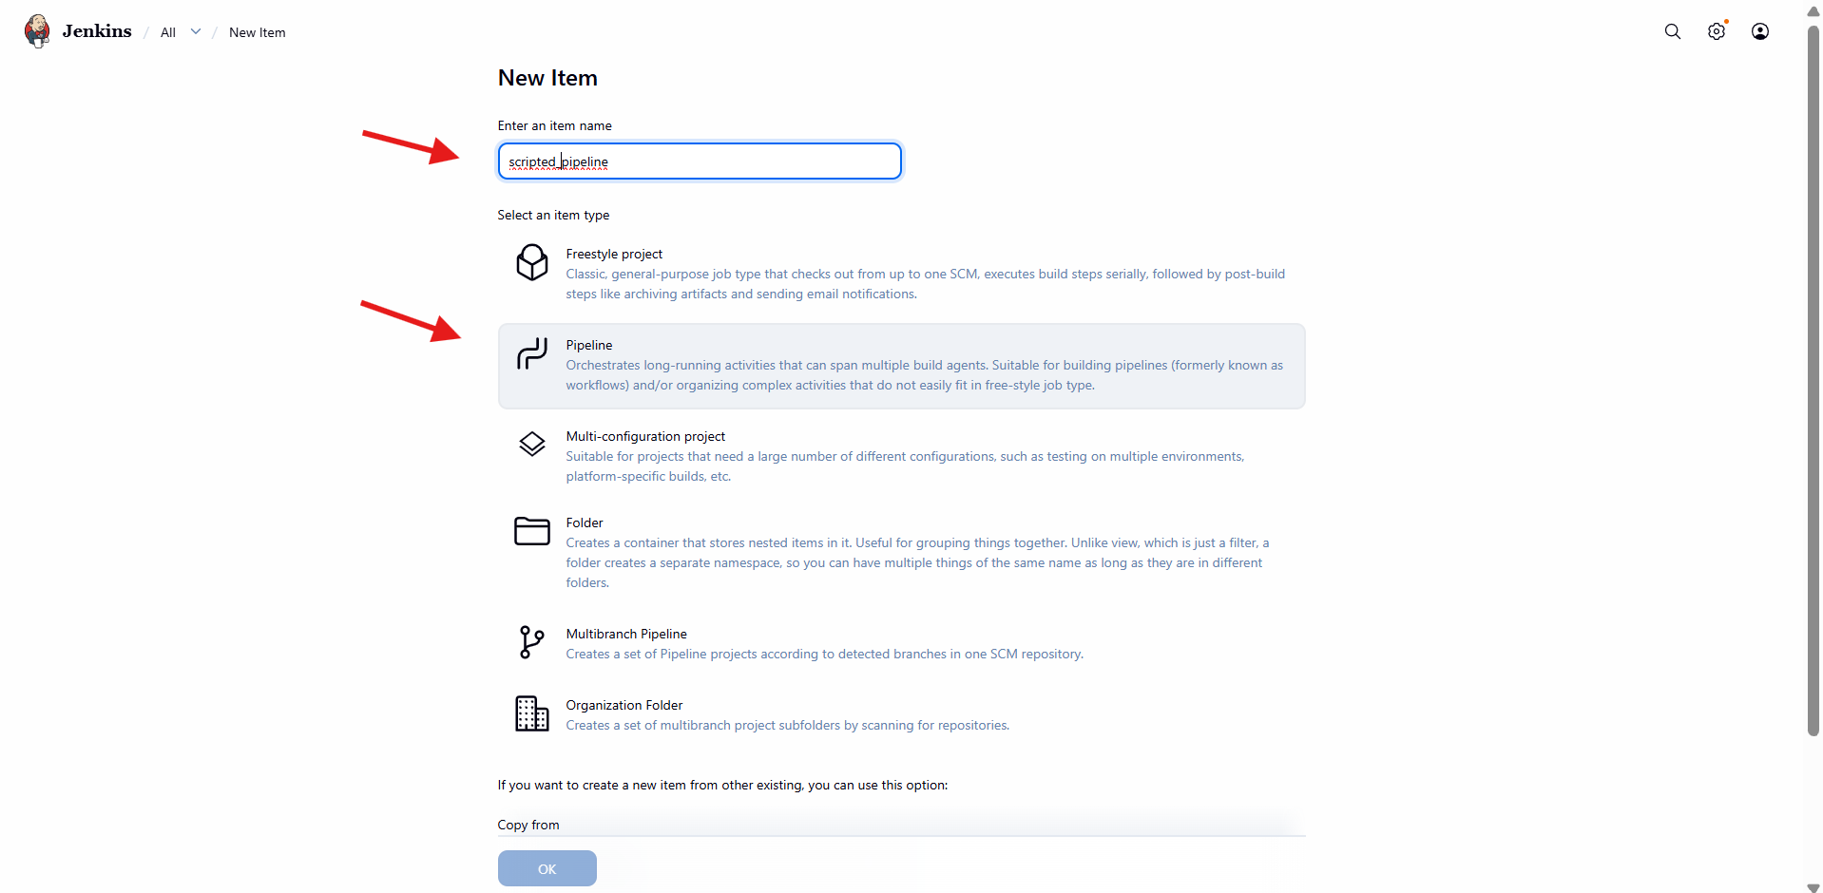

* Opened **Configure → Pipeline**
* Used **Scripted Pipeline** syntax
* Defined environment variables:
  + Maven home and PATH
  + Sonar project key and name
  + Nexus URL and repository
  + Tomcat URL
* Added **Slack notification – Start**
* Added **Git Clone** stage with GitHub repository URL

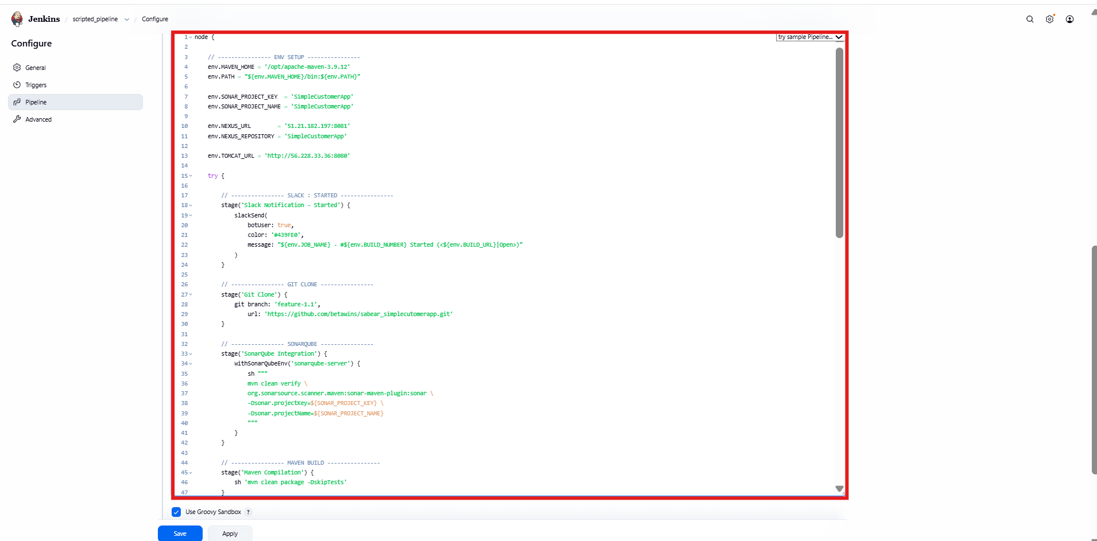

* Added **SonarQube Analysis** stage using Sonar scanner
* Added **Maven Compilation** stage
* Added **Nexus Artifact Upload** stage
* Configured:
* Group ID
* Artifact ID
* Version (SNAPSHOT)
* Nexus credentials

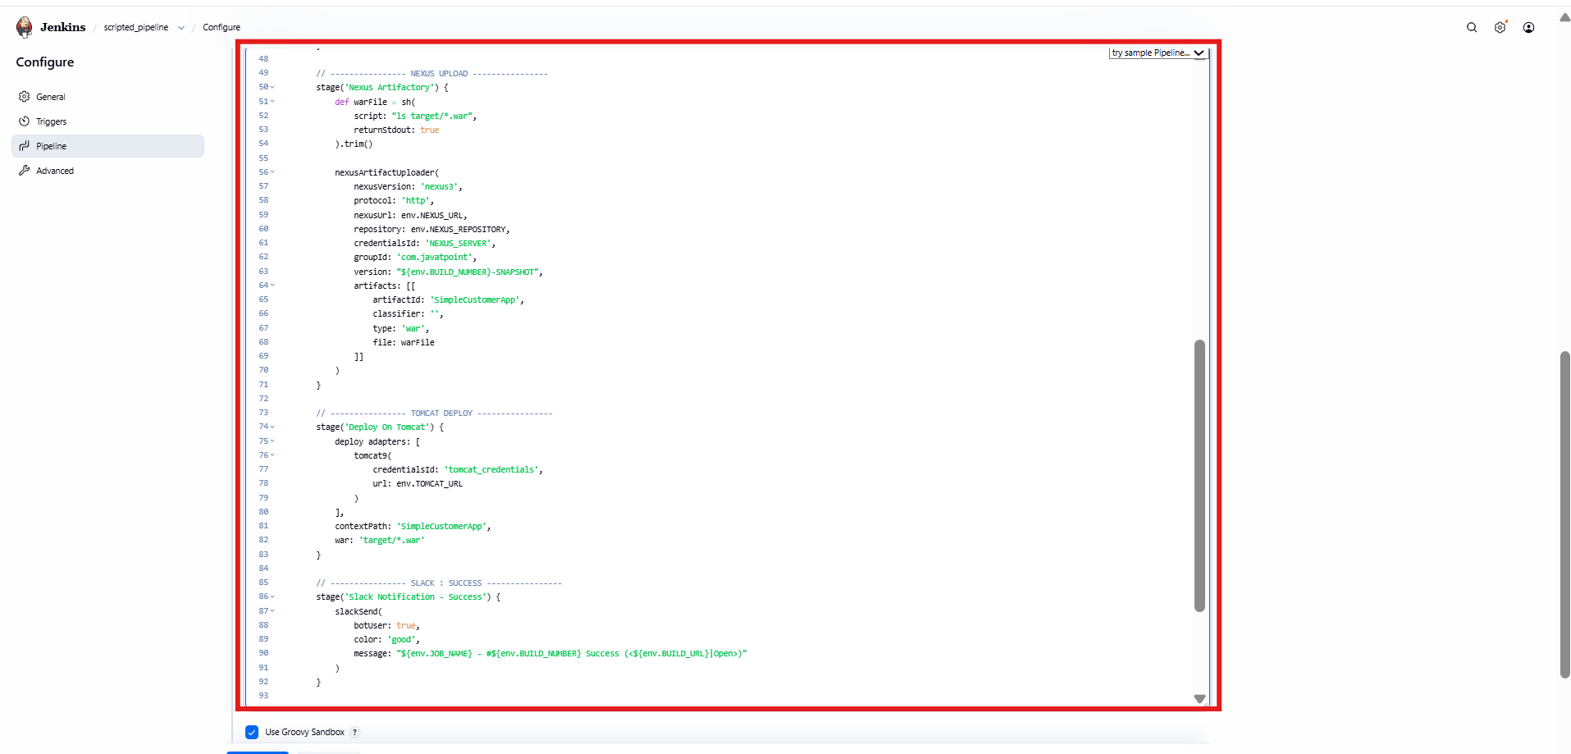

* Added **Deploy to Tomcat** stage
* Added **Slack Notification – Success**
* Added **Slack Notification – Failure**
* Wrapped pipeline inside try–catch block
* Enabled proper failure handling

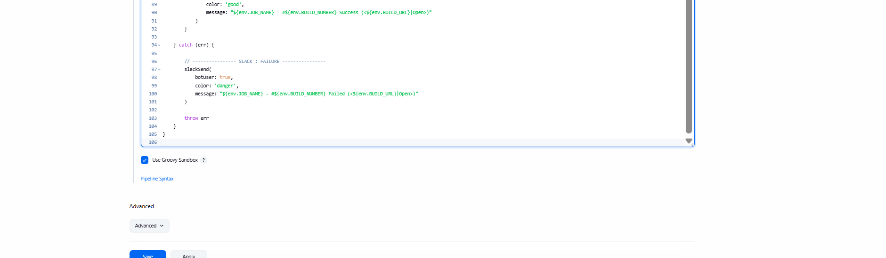

* Pipeline stages executed successfully:
  + Slack Notification – Started
  + Git Clone
  + SonarQube Analysis
  + Maven Compilation
  + Nexus Artifact Upload
  + Deploy on Tomcat
  + Slack Notification – Success
* All stages shown in **green**

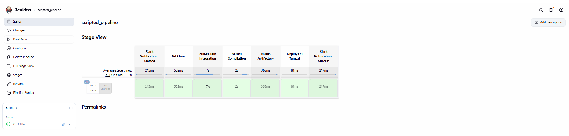

* Maven artifact built successfully
* Artifact uploaded to **Sonatype Nexus Repository**
* WAR file deployed to **Apache Tomcat**
* Context path: SimpleCustomerApp
* Pipeline finished with **SUCCESS**
* Slack failure message visible due to invalid Slack auth (non-blocking)

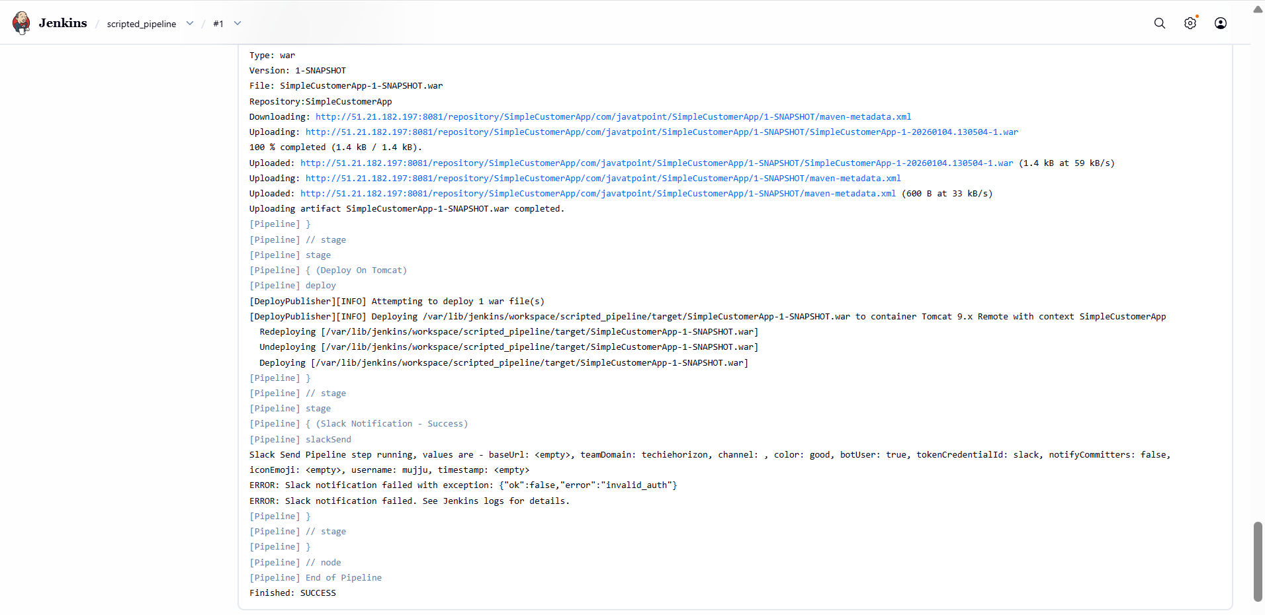

* Logged into Jenkins server via SSH
* Navigated to:
  + /var/lib/jenkins/workspace
* Verified directories:
  + SIMPLECUSTOMERAPP
  + scripted_pipeline
* Confirms Jenkins job workspace creation

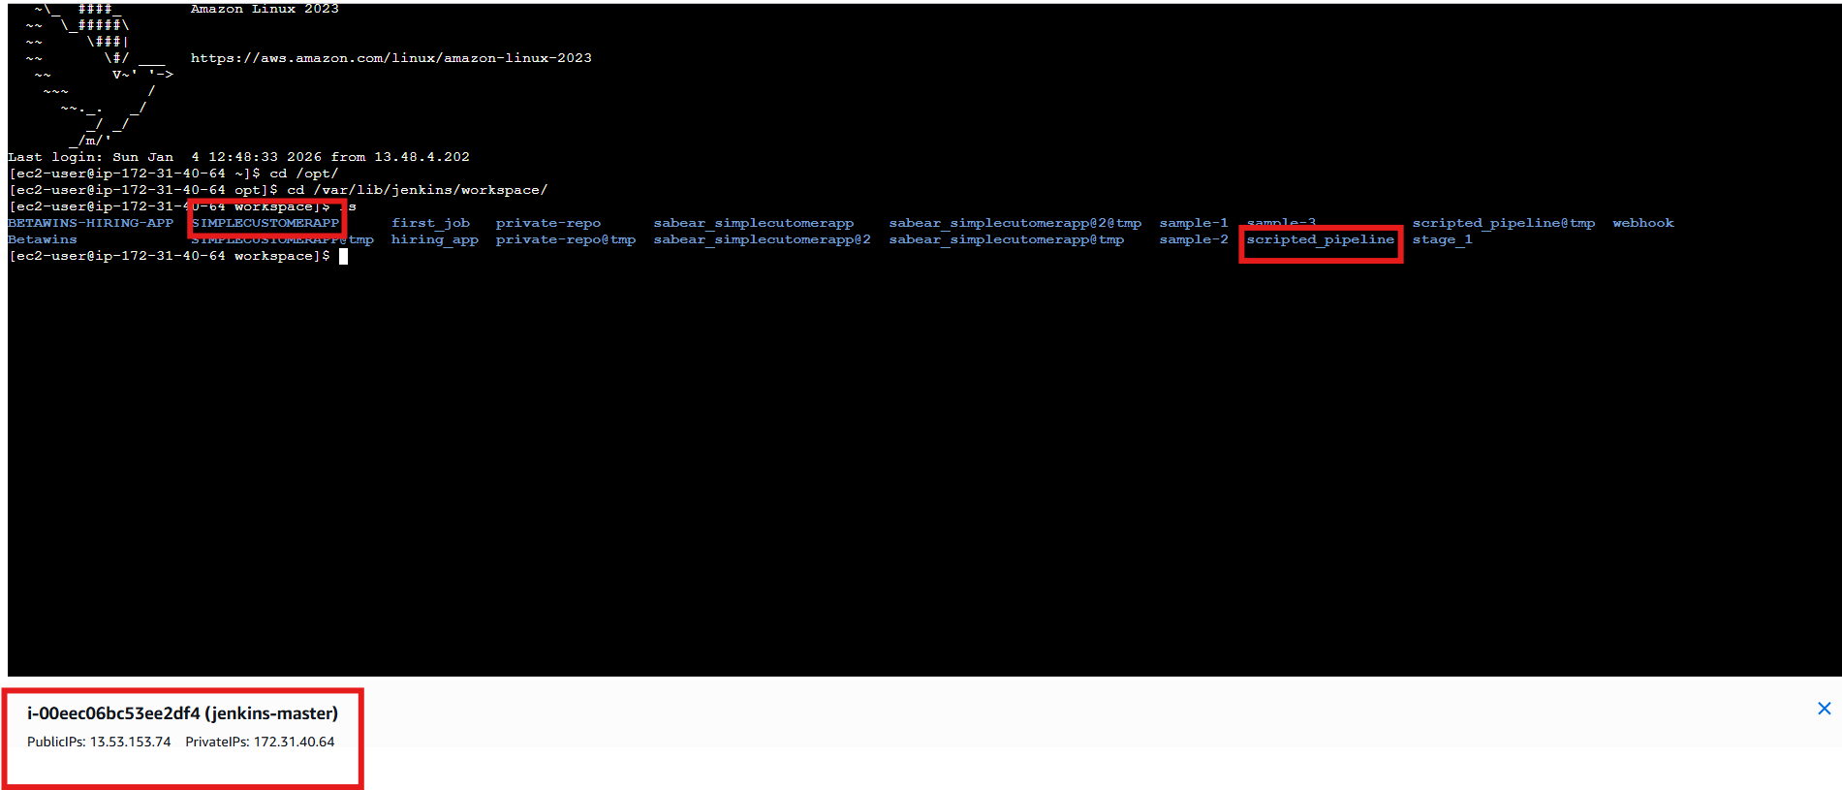

4. Write sample skeleton of pipelines.

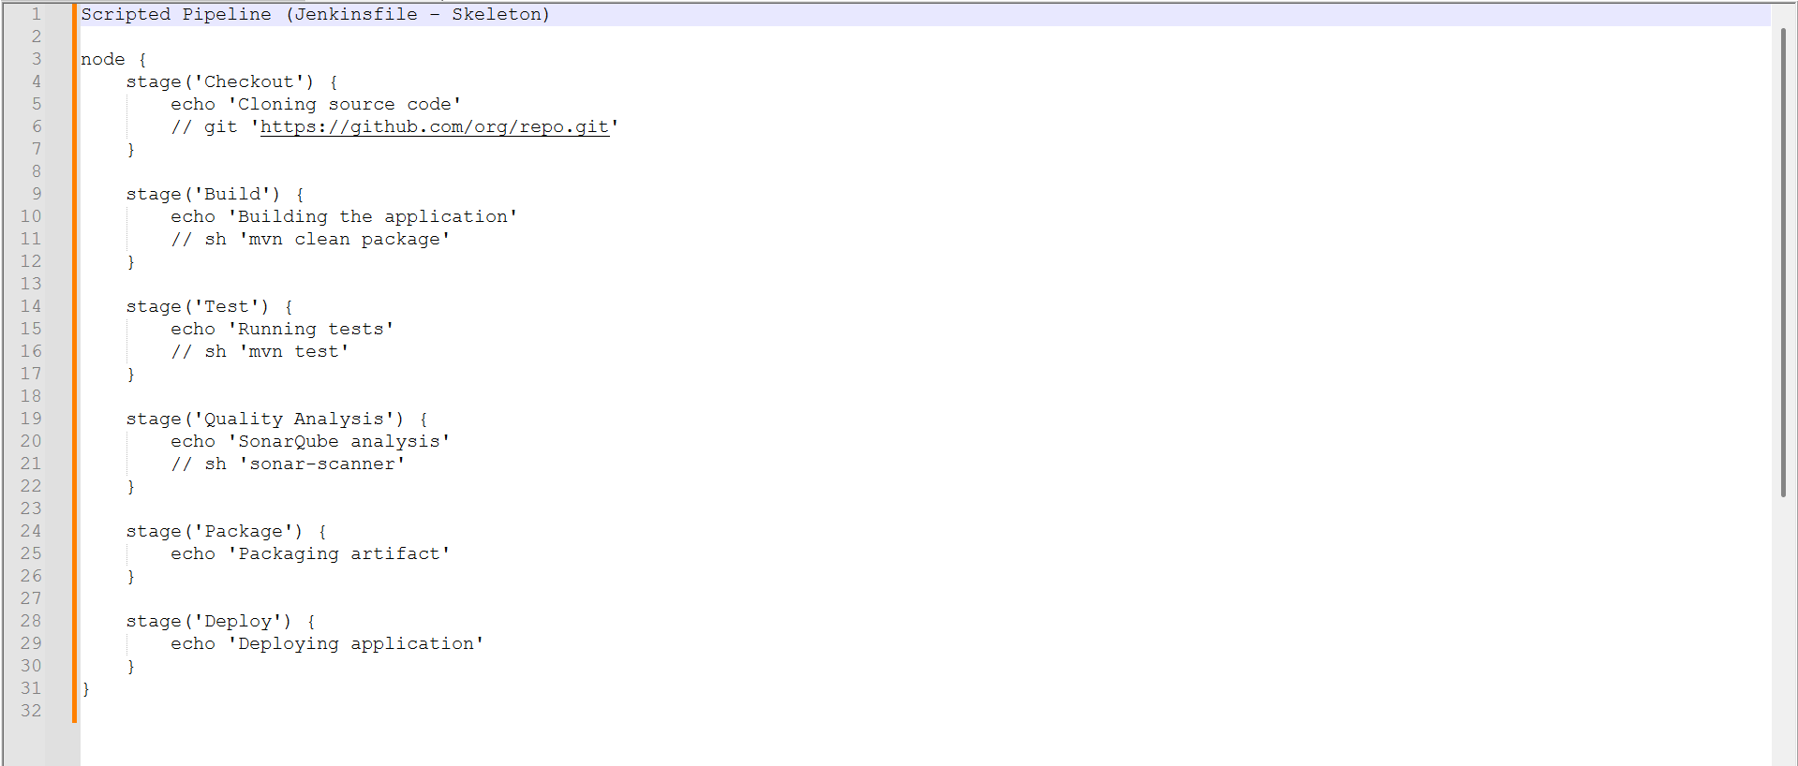

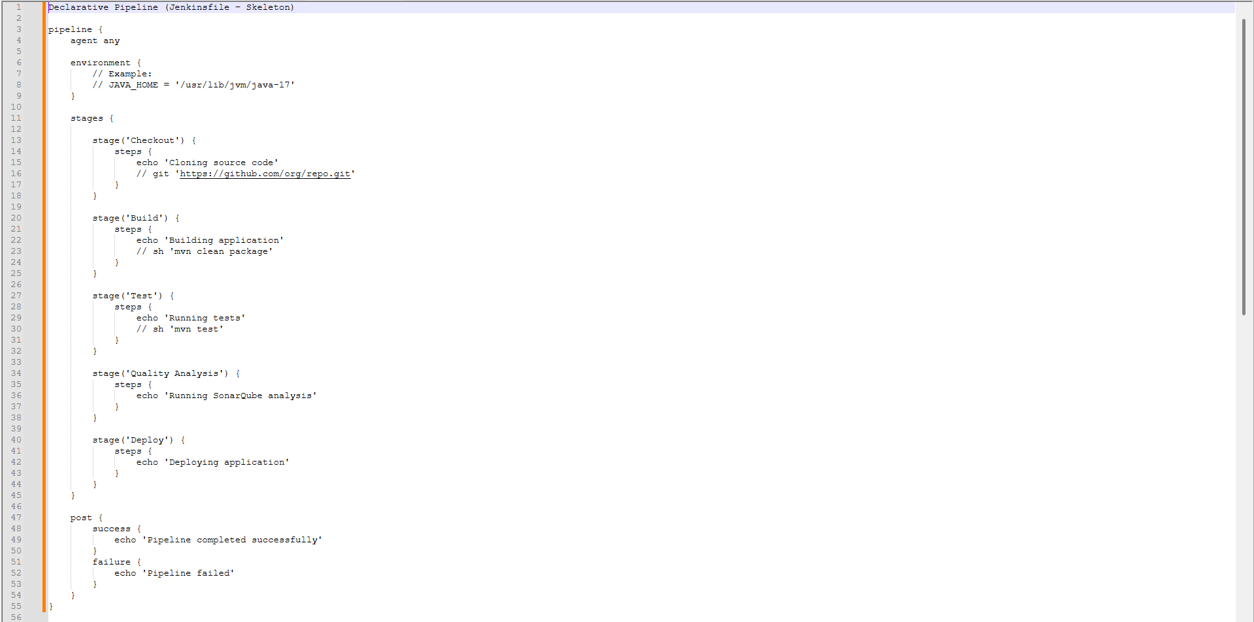

* Opened **Jenkins → New Item**
* Entered job name: **spring3-parameterized-job**
* Selected **Freestyle project**
* Clicked **OK**

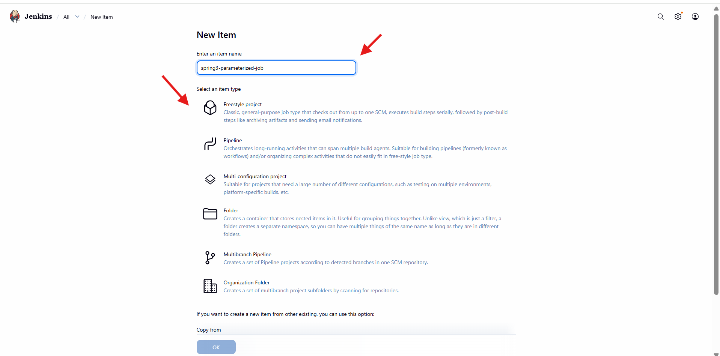

* Opened **Configure → General**
* Enabled **This project is parameterized**
* Added **Choice Parameter**
* Parameter name: ENV
* Choices added:
* dev
* qa
* prod
* Saved parameter configuration

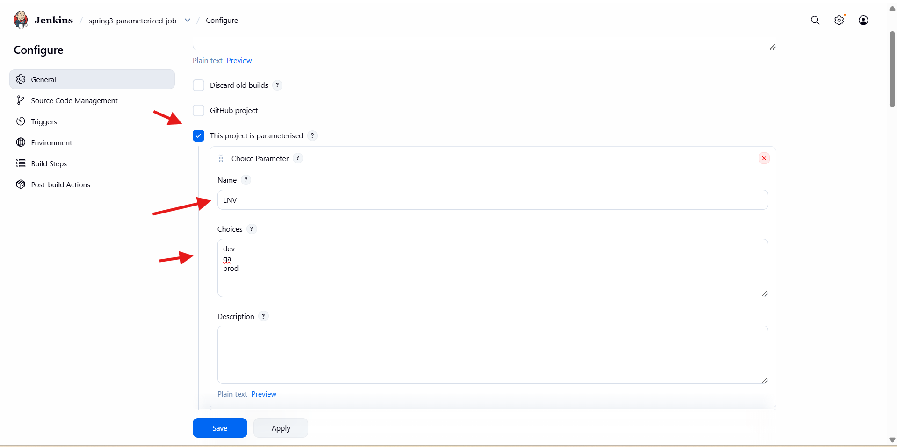

* Added **String Parameter**
* Parameter name: GIT_BRANCH
* Default value: master
* Description: *Git branch to build*
* Used to dynamically select Git branch

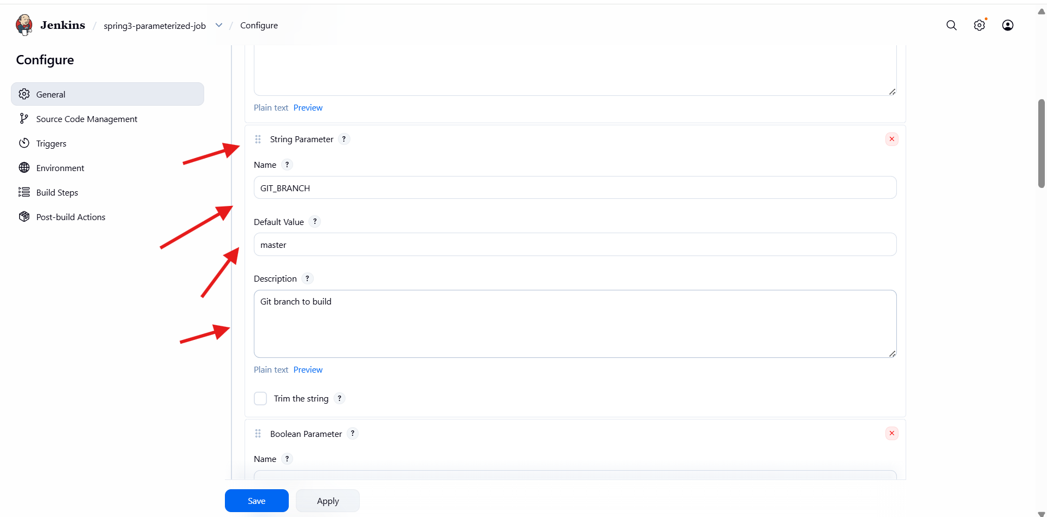

* Added **Boolean Parameter**
* Parameter name: SKIP_TESTS
* Checked **Set by default**
* Description: *Skip unit tests*
* Allows skipping tests during Maven build

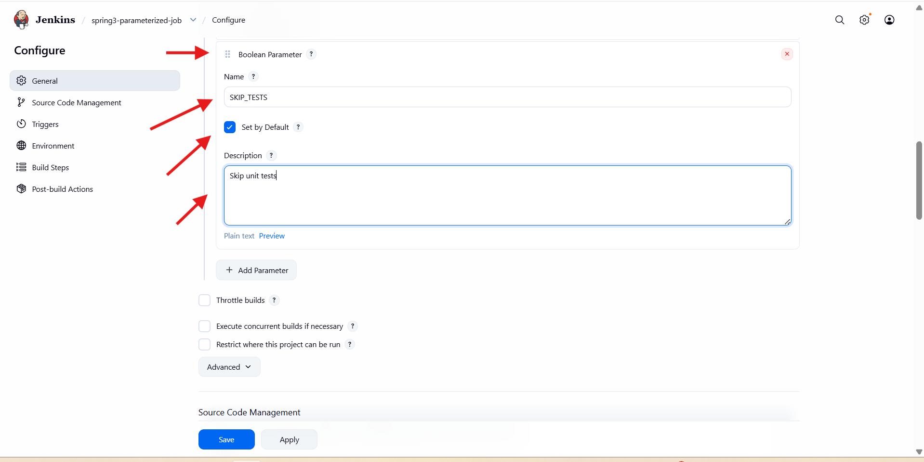

* Opened **Source Code Management**
* Selected **Git**
* Added repository URL:
* Spring Maven GitHub repository
* In **Branches to build**, entered:
* */${GIT_BRANCH}
* Enabled branch selection using parameter

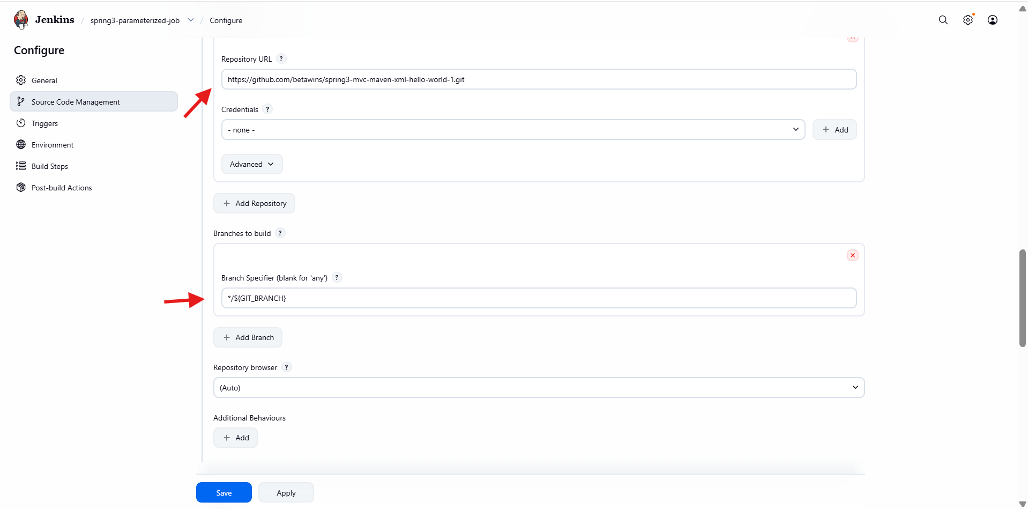

* Opened **Build Steps**
* Added **Invoke top-level Maven targets**
* Selected Maven installation: MVN_HOME
* Maven goals configured:
  + clean package -DskipTests=${SKIP_TESTS}
* Build behavior controlled via parameters
* Opened **Post-build Actions**
* Added **Slack Notifications**
* Enabled:
  + Notify Build Start
  + Notify Success
* Linked Jenkins job notifications to Slack

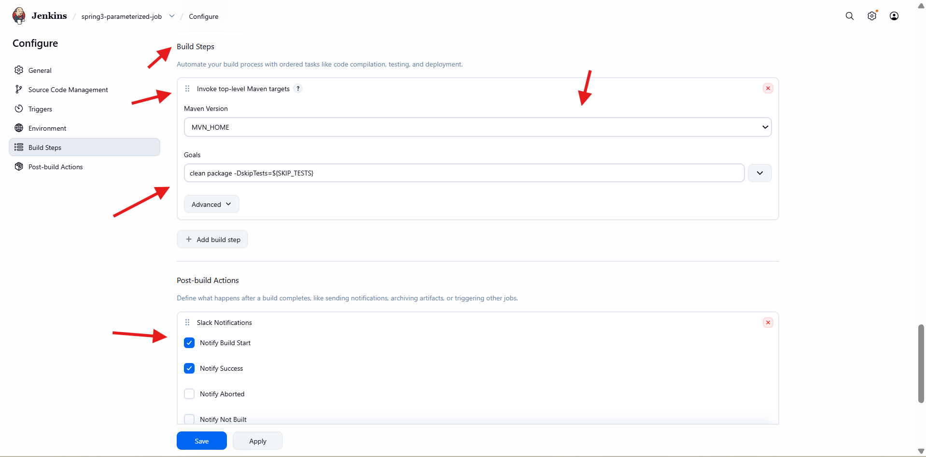

* Job created successfully
* **Build with Parameters** option visible
* No builds executed yet

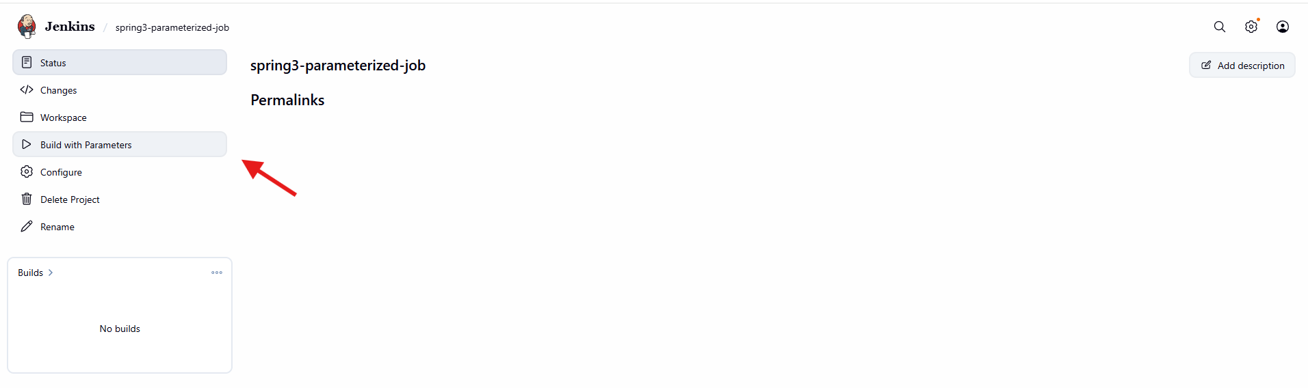

* Clicked **Build with Parameters**
* Selected:
* ENV = dev
* GIT_BRANCH = master
* SKIP_TESTS = true
* Clicked **Build**

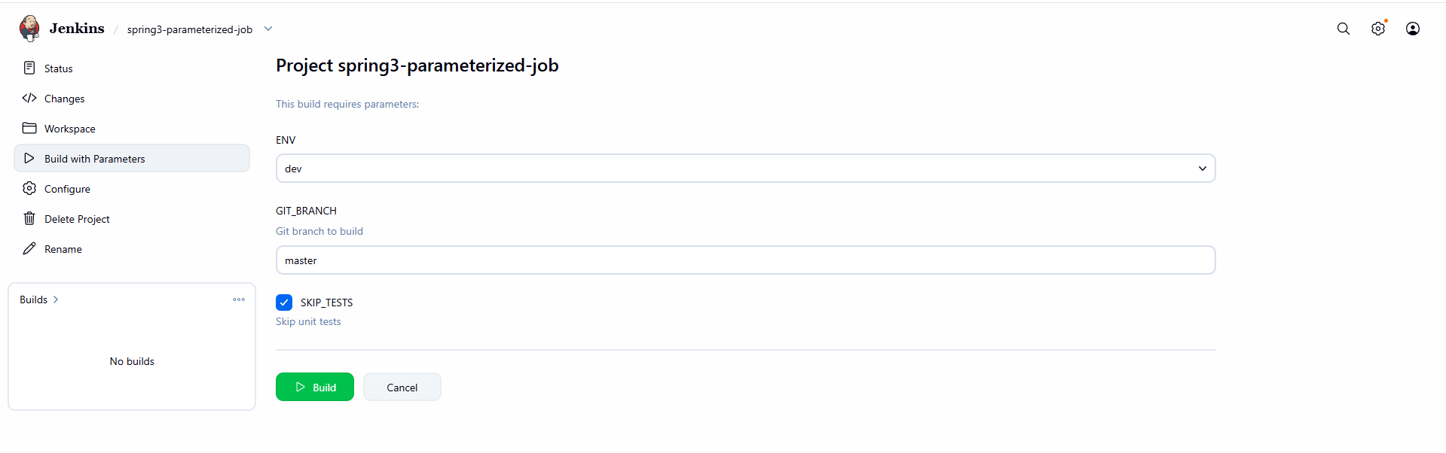

* Slack message received:
  + Job name
  + Build number
  + Triggered by user
* Confirms Slack integration is working



6. Setup one slave machine for Jenkins.

* Logged into **Amazon EC2** console
* Opened **Instances**
* Verified two running instances:
* jenkins-master
* slave-01
* Connected to **slave-01** instance
* Installed Java using command:
* yum install java-17-amazon-corretto -y
* Verified Java installation
* Confirms Java is available for Jenkins agent execution

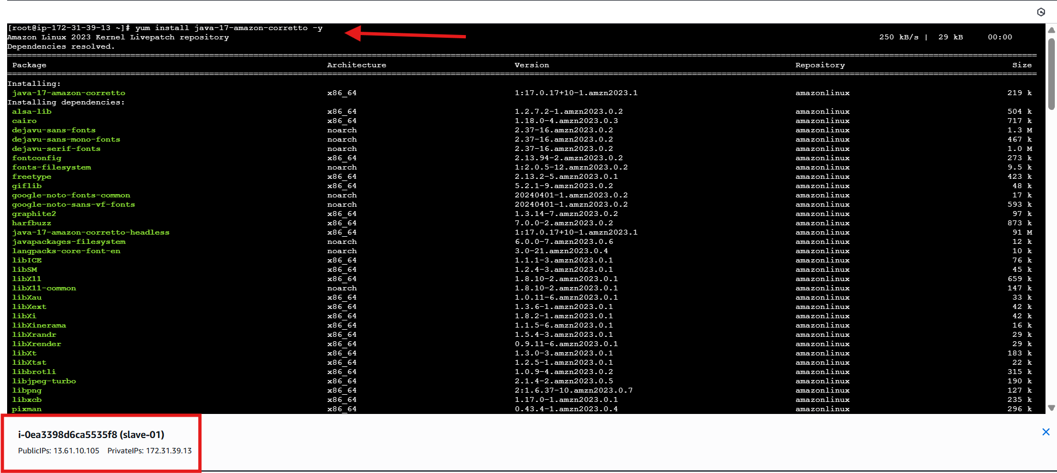

* Ran ssh-keygen on **slave-01**
* Generated:
  + id_rsa (private key)
  + id_rsa.pub (public key)
* Created .ssh directory if not present
* Set permissions:
  + chmod 700 ~/.ssh

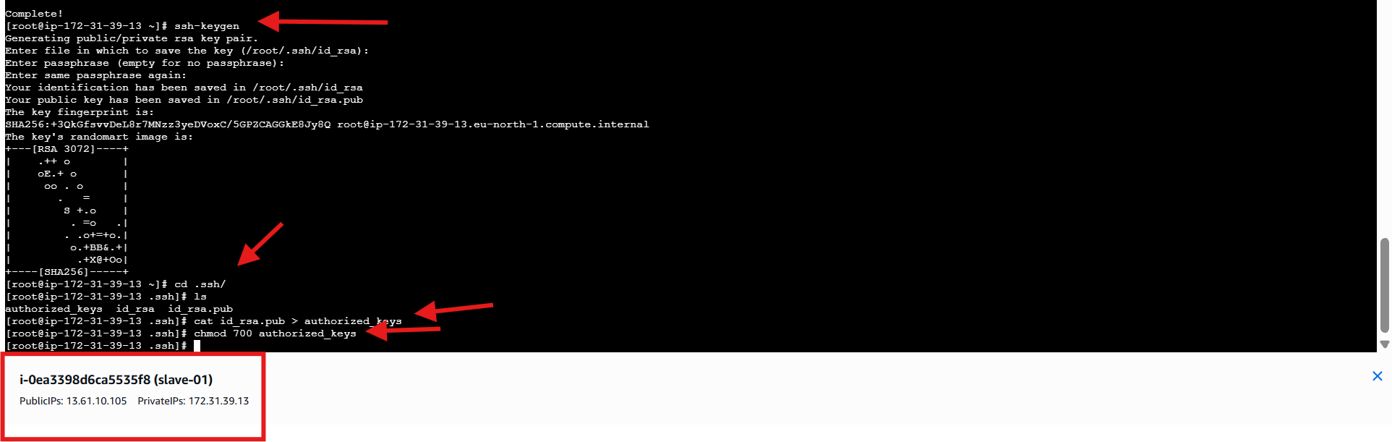

* Copied public key to:
  + ~/.ssh/authorized_keys
* Set permissions:
  + chmod 700 authorized_keys
* Enabled password-less SSH access
* Verified SSH setup on slave node
* Logged into **jenkins-master**
* Added slave host key to:
* /var/lib/jenkins/.ssh/known_hosts
* Used ssh-keyscan to avoid SSH prompt
* Ensured Jenkins user trusts slave node

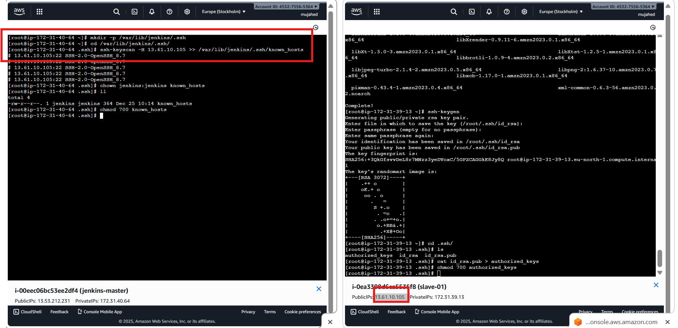

* Opened **Jenkins**
* Navigated to **Manage Jenkins**
* Selected **Nodes**
* Prepared to add a new agent

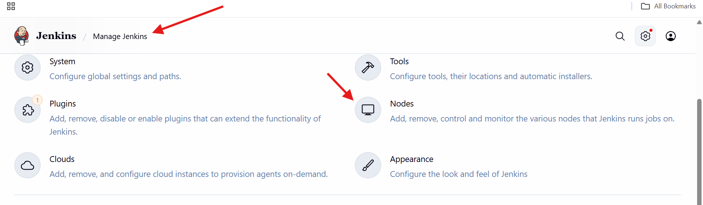

* Clicked **New Node**
* Entered node name: **slave-01**
* Selected **Permanent Agent**
* Clicked **Create**

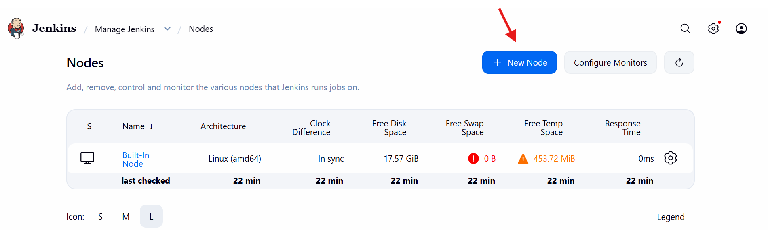

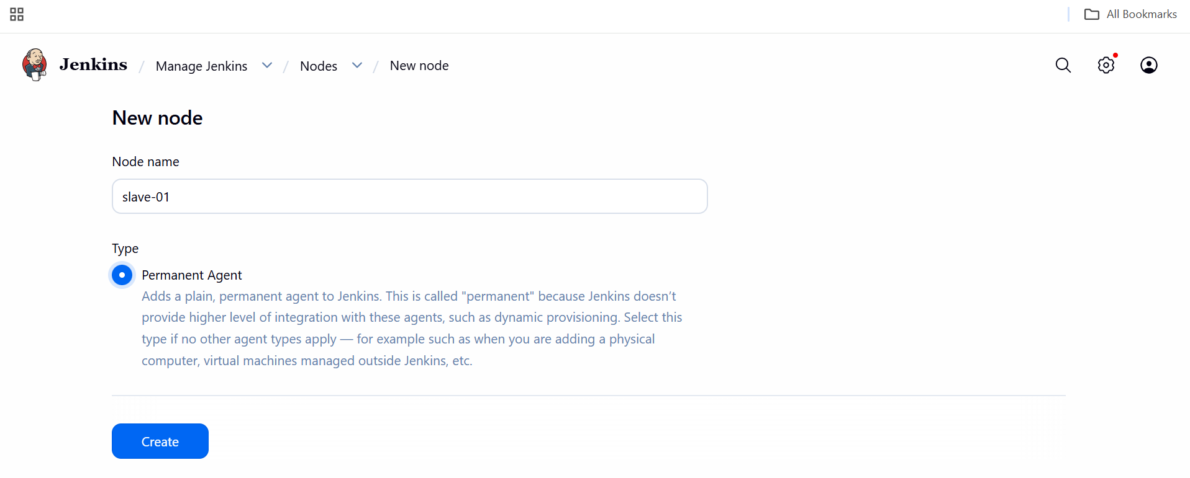

* Node name: slave-01
* Number of executors: 2
* Remote root directory: /root
* Labels: java
* Usage:
  + Only build jobs with matching labels
* Saved configuration

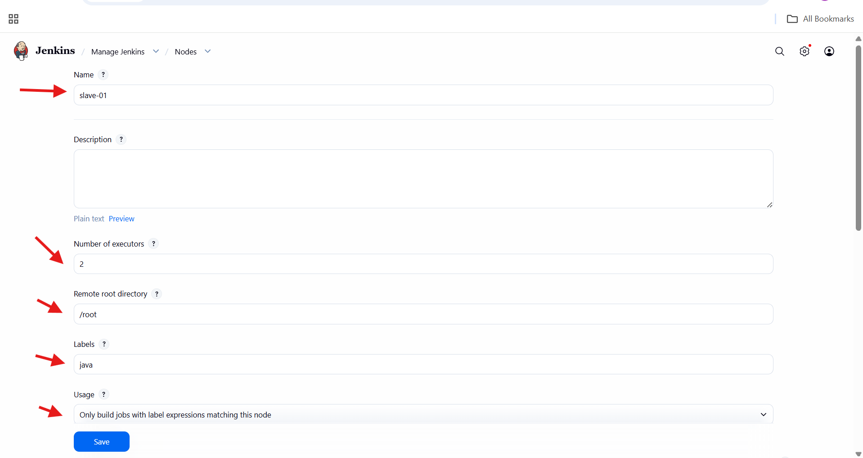

* Selected **Launch agents via SSH**
* Entered Host:
* 13.61.10.105
* Noted missing credentials warning
* Selected **Known hosts file Verification Strategy**

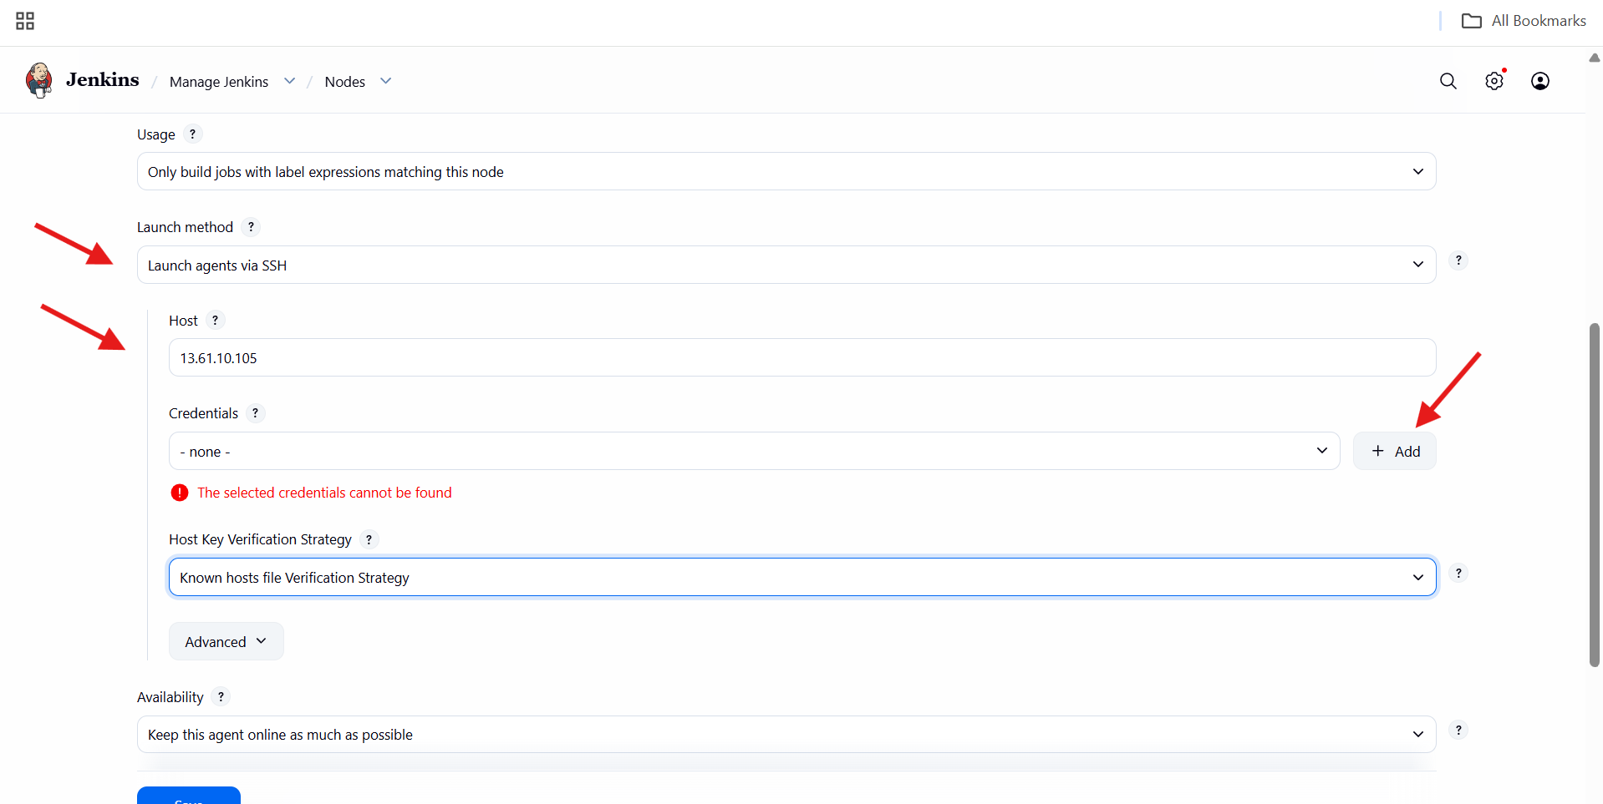

* Clicked **Add Credentials**
* Selected **SSH Username with private key**
* Scope: Global
* ID: slave-01
* Username: ec2-user
* Added private key (from slave)
* Saved credentials and selected them for node

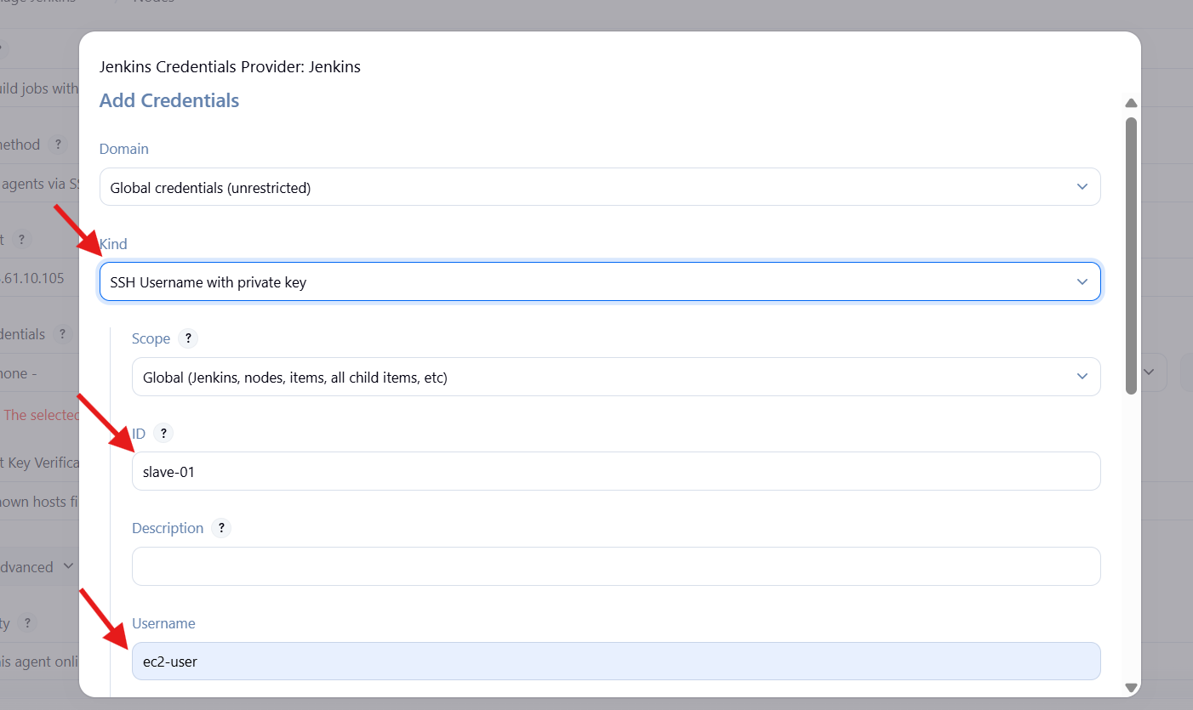

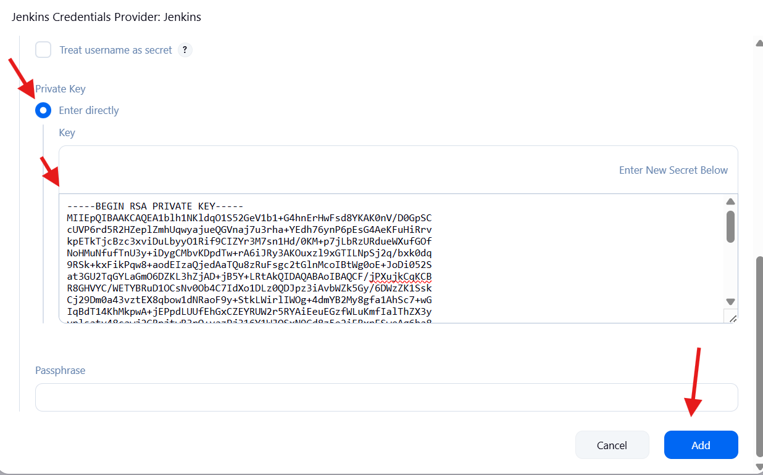

* Opened **Jenkins → Nodes → slave-01 → Log**
* SSH connection attempt is visible in logs
* Authentication succeeds but agent status shows **offline**
* Indicates remote root directory issue on agent

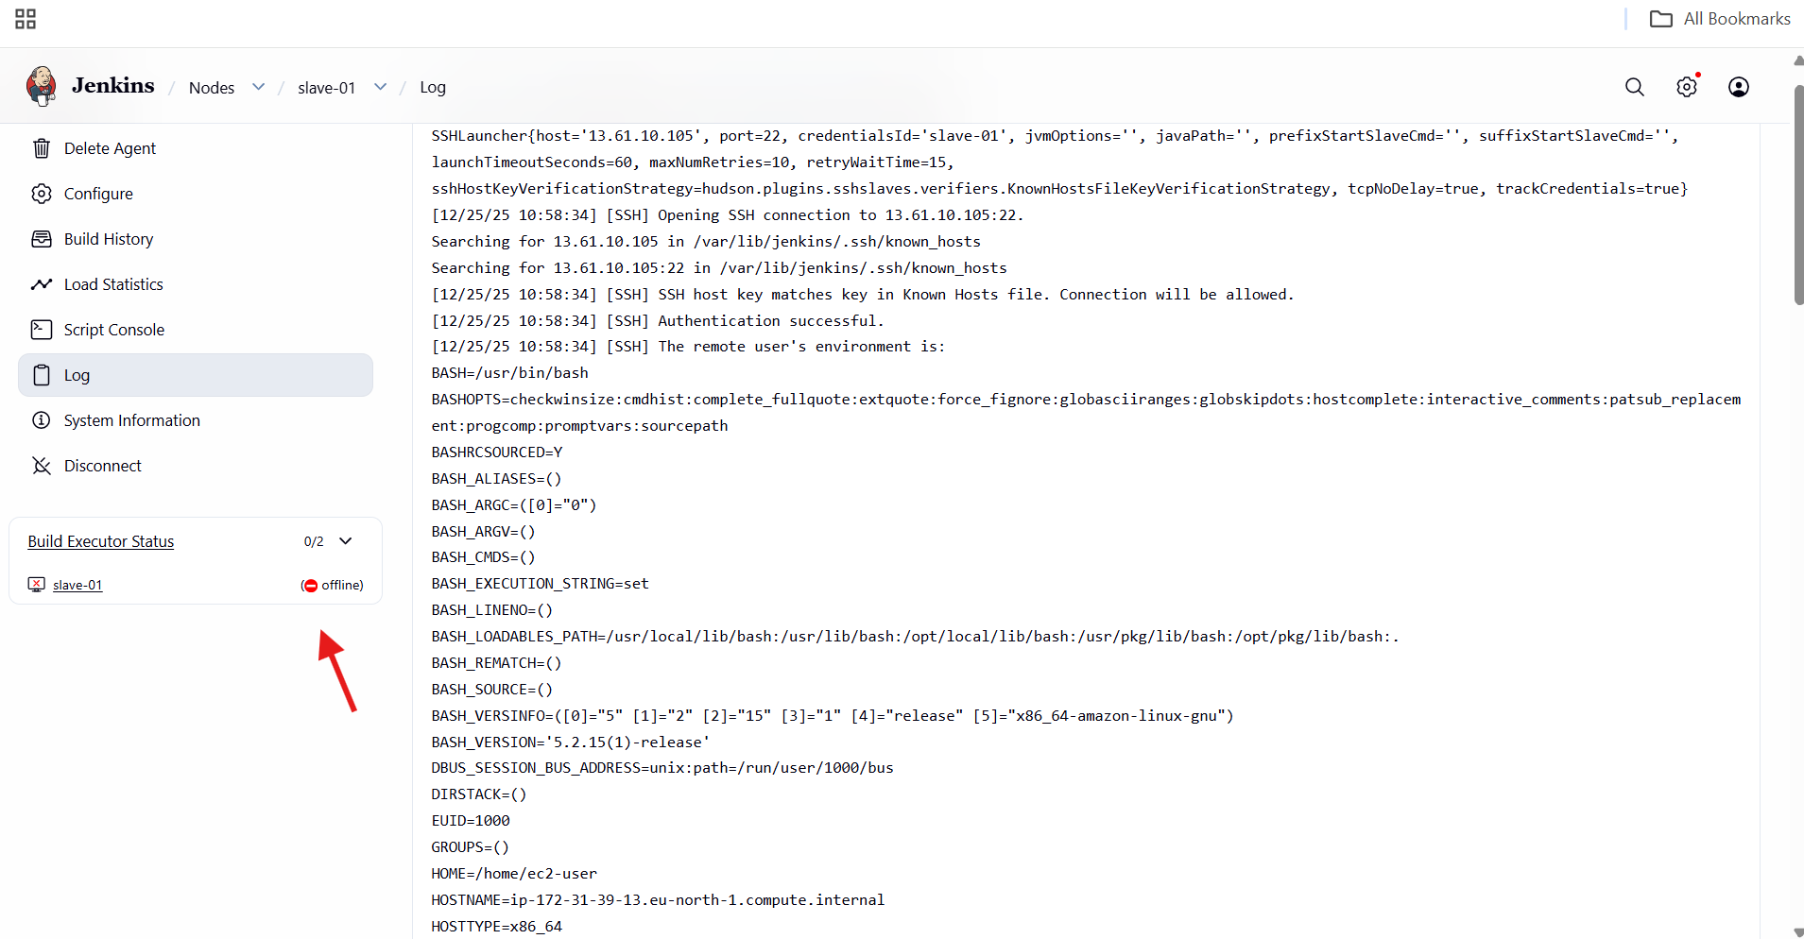

* Logged into **Amazon EC2** instance slave-01
* Created Jenkins workspace directory:
* /home/ec2-user/jenkins
* Changed ownership to Jenkins SSH user:
* ec2-user:ec2-user
* Verified directory creation
* Confirms required remote directory exists

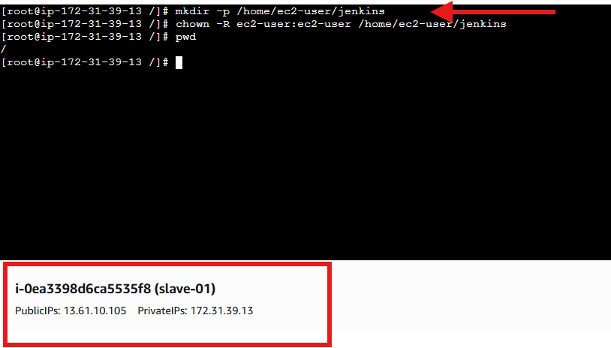

Opened **Jenkins → Nodes → slave-01 → Configure**

Updated **Remote root directory** to:

* /home/ec2-user/jenkins

Labels kept as java

Saved configuration

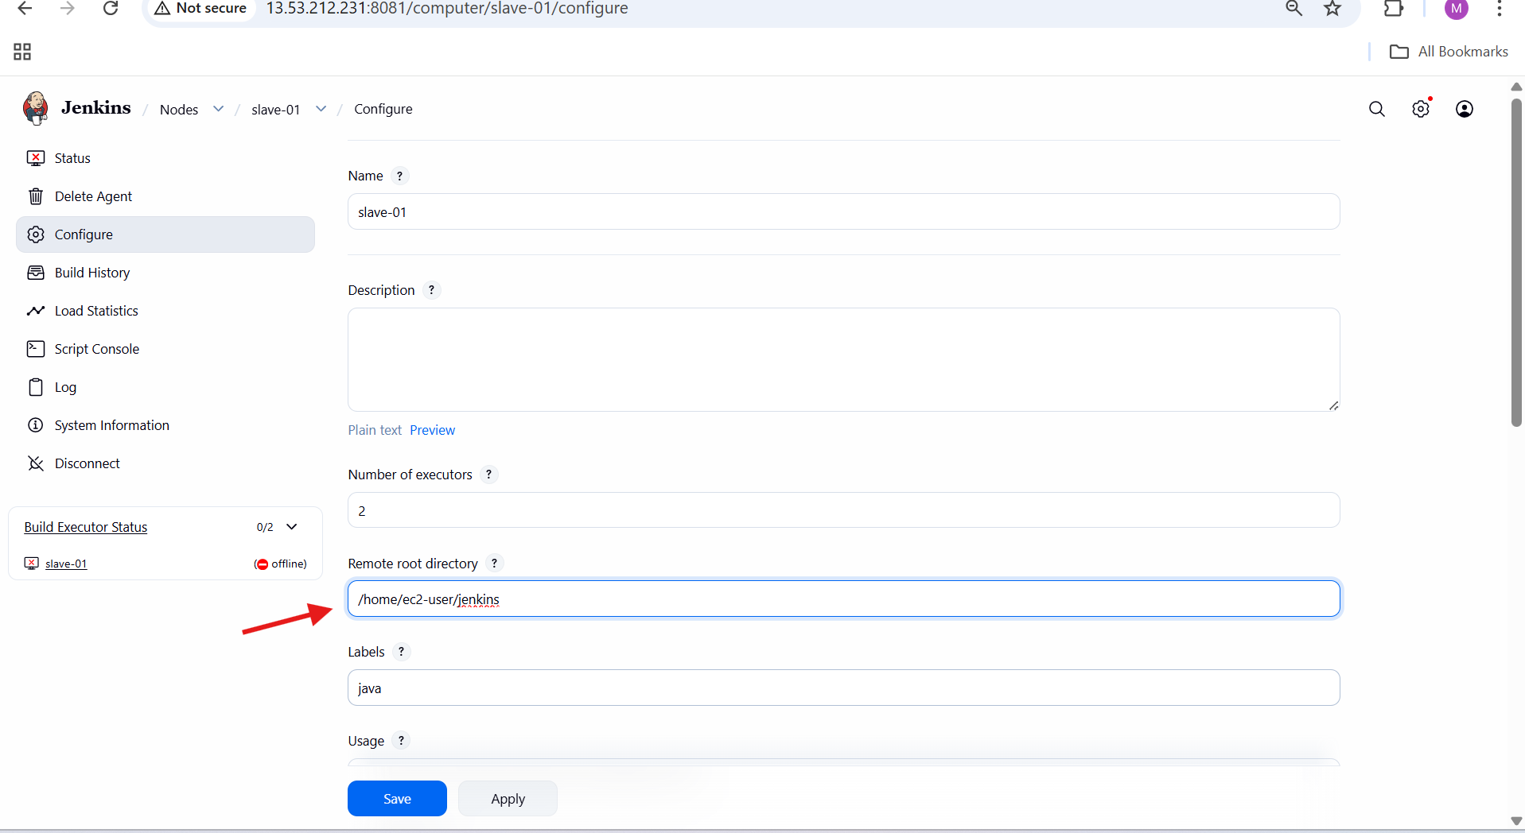

* Navigated to **Manage Jenkins → Nodes**
* Both nodes visible:
  + Built-in Node
  + slave-01
* slave-01 status shows **online**
* Disk space and response time are updated
* Confirms agent connected successfully

